**SPECIAL SELECTBOARD MEETING**

**Friday, September 9, 2022, at 4:00 PM @ Town Hall Upstairs and via Microsoft Teams per Senate Bills S-0172, S-0222 and S-0223**

**and as an ADA accommodation.**

**Further ADA Accommodation available, Call Town Hall during business hours.**

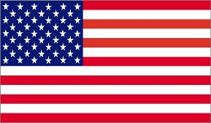**Link to meeting:** [Click here to join the meeting](https://teams.microsoft.com/l/meetup-join/19%3ameeting_ZWY2Zjk1YzUtNGJkNi00MTlkLWI5ZTEtZTM4NDQ1YzJlMzg3%40thread.v2/0?context=%7b%22Tid%22%3a%22ef1ee2de-322f-4530-b045-e3a14523d017%22%2c%22Oid%22%3a%22408cae20-3fe1-4244-9f06-e5df655a5c15%22%7d)

1. Call to order
2. Adopt Agenda
3. Meeting of Town Administrator Hiring Committee with Applicants. Interviews to be done in Executive Session.
4. Enter into Executive Session 1 VSA 313 (a)(1)(B) “labor agreement employee” and (3) “appointment or hiring of employee”
5. When interviews are completed, exit Executive Session.
6. Next Regular Meeting – Monday September 19, 2022. @ 6:00 PM
7. Adjourn

Meeting is viewable live at: Falls Area Community Access TV: <https://www.fact8.com/>