**SPECIAL SELECTBOARD MEETING**

**Monday, July 25, 2022, at 3:30 PM @ Town Hall Upstairs and via Microsoft Teams per Senate Bills S-0172, S-0222 and S-0223**

**and as an ADA accommodation.**

**Further ADA Accommodation available, Call Town Hall during business hours.**

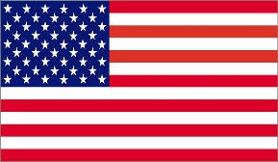**Link to meeting:** [Click here to join the meeting](https://teams.microsoft.com/l/meetup-join/19%3ameeting_M2ZiMzliNDctYmM4MC00NDVmLTg3ZjYtNzZhZTg4OTRmNzE1%40thread.v2/0?context=%7b%22Tid%22%3a%22ef1ee2de-322f-4530-b045-e3a14523d017%22%2c%22Oid%22%3a%22408cae20-3fe1-4244-9f06-e5df655a5c15%22%7d)

1. Call to order
2. Adopt Agenda
3. Contract terms, scope of work, for the ADA remodel of the Town Hall, discuss alternatives, decide on what should be included, and not, in the Contract, communicate that to Chris Cole of Cole Engineering who will prepare the contract for Selectboard review at its Regular Meeting on August 1, 2022.
4. Next Regular Meeting – Monday, August 1, 2022 @ 6:00 PM
5. Adjourn

Meeting is viewable live at: Falls Area Community Access TV: <https://www.fact8.com/>