Grafton, VT

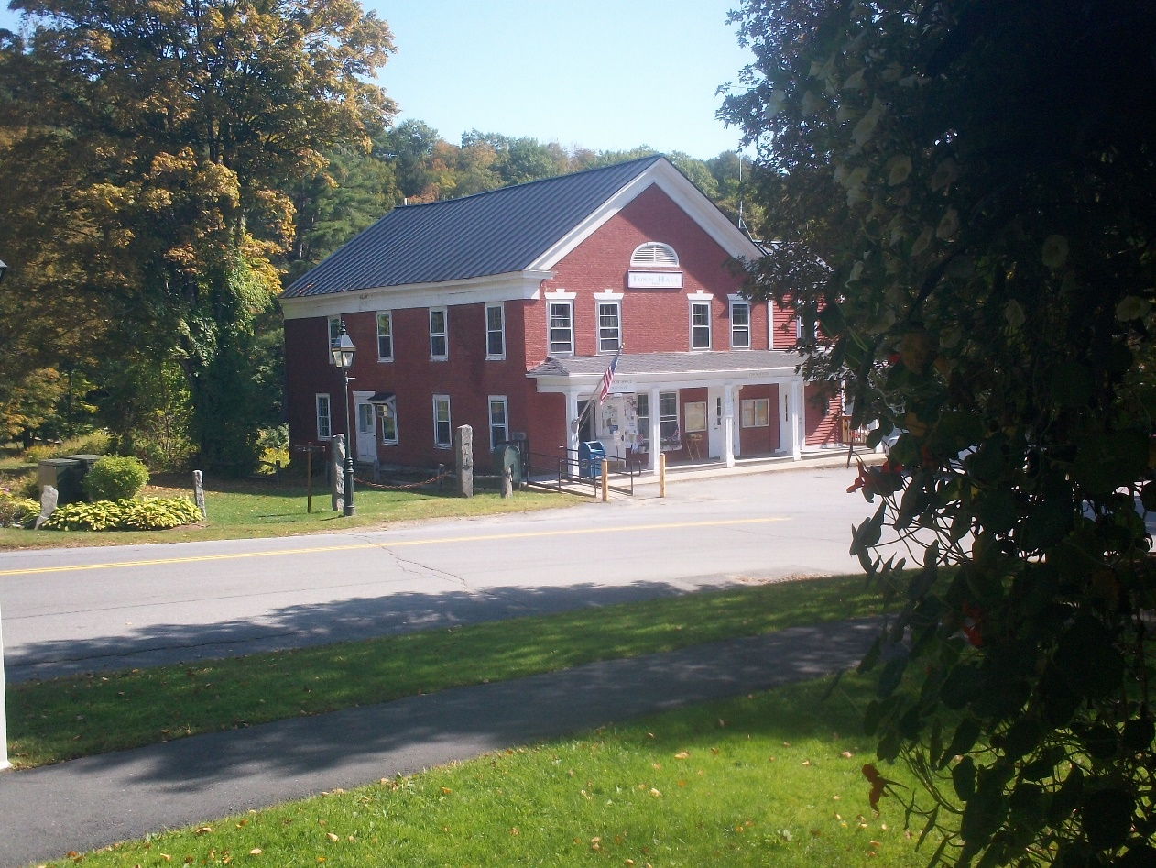

2020-2028

Town Plan

Approved by Selectboard December 12, 2019

Adopted by Town Registered Voters by Australian Ballot January 13, 2020

Table of Contents

INTRODUCTION 4

Grafton’s History 4

Purpose 5

Organization 6

Implementation 6

1. LAND USE 8

Land Description 8

Land Use Classifications 9

Desired Future Land Uses 10

Goals, Policies & Recommendations 11

2. HISTORIC, CULTURAL AND NATURAL RESOURCES 14

Historic Resources 14

Cultural Resources 15

Natural Resources 16

Goals, Policies & Recommendations 21

3. THE ECONOMY 24

Desired Types of Economic Development 24

The Grafton Brand 25

Grafton’s Economy and Vermont’s Public Utility Commission 25

Goals, Policies & Recommendations 26

4. ROADS AND TRANSPORTATION 28

Public Roads System 28

Public Transportation 29

Transportation and Economic Development 29

Goals, Policies & Recommendations 29

5. ENERGY 32

Introduction 32

Grafton’s Estimated Current Energy Use 33

Grafton’s Energy Resources, Constraints, & Potential for Power Generation 36

Grafton’s Energy Targets and Conservation Goals 39

Goals, Policies & Recommendations 46

6. EDUCATION 50

K-12 Education System 50

Educational Opportunities for Adults 52

Goals, Policies & Recommendations 53

7. HOUSING 55

Home Ownership 55

Rental Properties 59

Conclusion 60

Goals, Policies & Recommendations 60

8. RECREATION 61

Goals, Policies & Recommendations 62

9. TOWN GOVERNMENT AND SERVICES 63

Town Government 63

Protective Services 64

Other Services 66

Goals, Policies & Recommendations 67

10. FLOOD RESILIENCY 72

Background 72

History of Flooding 72

Regions of Vulnerability 73

Vermont’s River Management Program 74

Green Infrastructure / Low Impact Development 75

Goals, Policies & Recommendations 76

11. GRAFTON AND ITS NEIGHBORS 78

Goals, Policies & Recommendations 79

12. RESPONSE TO VERMONT PLANNING GOALS 80

APPENDICES 86

Appendix I – Grafton Population 86

Appendix II – Grafton Property Taxes 88

Appendix III - Town Officials 90

Appendix IV – List of Historic Sites 91

Appendix V - Maps 92



# INTRODUCTION

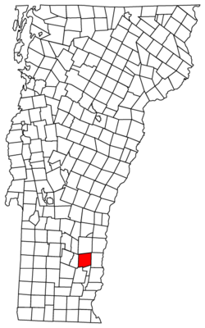**Grafton, VT** is a rural hill town of 24,650 acres or approximately 36 square miles in northern Windham County, Vermont. Its population numbered 679 in the 2010 census, reflecting continued a slow, steady growth over the last three decades. Grafton’s population grew at the rate of 7.8 percent or a net gain of 47 new individuals between 2000 and 2010, which is comparable to many other towns in our region.

The average age of Grafton residents continues to increase, as it has all throughout the region. Grafton is getting older with fewer young people living in the community.

Rugged topography and distance from commercial or resort centers have kept the town small and have forestalled, thus far, the pressures for rapid growth and large-scale development affecting many nearby towns. Its value to permanent and seasonal residents and visitors alike depends on continued maintenance of its scenic rural character. Although modest growth in population is expected to continue, the Town intends to accommodate the resulting needs for housing and other facilities and services without detracting from its present character.

## Grafton’s History

Originally named Thomlinson, the first charter for the Township of Grafton was established as one of British Governor Benning Wentworth’s “New Hampshire Grants” in 1754.  Grafton’s present charter was issued in 1763 after the 1754 charter lapsed ‘for failure to comply’.

The first permanent settlement in Thomlinson was made in the spring of 1780. By 1791 when Vermont was admitted to the Union as the fourteenth state, the population was 561. In that same year, local residents cut the last tie with the colonial past by abolishing the name Thomlinson. The privilege of renaming the town was decided by auction and Joseph Axtell, the successful bidder, named it in honor of his former hometown of Grafton, Mass.

The original boundaries of the township form an approximate square, six miles on each side, and have not changed except for the annexation in 1816 of a portion of Avery’s Gore to the south, previously assigned to the Town of Athens.

##### At mid-nineteenth century, the Village had two doctors, two law offices, two churches, 12 schools serving the town’s twelve school districts, a pharmacy, three general stores, two manufacturing plants and several small shops, a flourishing hotel and livery, and regular stage service to Bellows Falls. Downstream, the Saxtons River was harnessed with six dams within the town limits, furnishing power for as many busy mills. This section was known as Mechanicsville, a name no longer appropriate and no longer used. At Cambridgeport, on the Rockingham town line, there was a soapstone finishing mill and a warehouse. To the northwest, on the road to Londonderry, the hamlet of Houghtonville had a school, a store, a post office, a sawmill and a blacksmith shop. The valleys and many of the hillsides were cleared to pasturage, orchards and cultivated farmland. Population rose to 1,482 in 1820 but after the Civil War it began to decline, as a result of the country’s westward movement.

Nevertheless, Grafton retained its strong sense of individuality, tradition, pride and will. It also retained a reputation as an attractive place for summer relaxation, thanks to the country hospitality of the tavern, the unhurried tempo of village life and the natural beauty of the countryside. This helped to offset the decline, at least seasonally.

Since 1940, the population trend has reversed, very slowly at first, but at an accelerating rate as more of the old places have been purchased and restored, originally for summer living and subsequently for permanent residence. The Town has responded to the trend with a quickened pace and a resurgence of economic vitality, new building construction and modernization. Farming, sugaring and lumbering are reminders of the agricultural past. Better roads and modern communication have made it possible for residents to find employment in neighboring communities and beyond without giving up their Grafton homes. Businesses established in or near the Village have included the cheese factory, specialty shops, bed and breakfasts and small home industries.

One of today’s concerns is how to handle growth and modernization without spoiling yesterday’s character and charm. Thus far this has been accomplished to a remarkable degree. In addition to the old homes, many of the old landmarks have been preserved in outward appearance while being vastly improved inside. The Village store, rebuilt after the 1991 fire, still faces the street with its original pillared and planked platform, though automobiles draw up at the entrance where horse-drawn carriages and carts were formerly hitched. The Grafton Cornet Band still occupies the second floor of the old firehouse. A new modern firehouse was completed in 1992 for the fire-fighting equipment. One fine old mansion serves as the Town’s well-endowed public library. The balconied Old Tavern, looking much as it did in photographs of a century ago, has been enlarged, modernized within and authentically furnished. It is widely acclaimed today as one of the most attractive hostelries in New England. The old Barrett store, purchased by the Town in 1857, is still the Village center, housing the Town Hall, Town offices and post office.

Many people have contributed to the making of the new “old Grafton.” Public-spirited organizations such as Grafton Cares, the Women’s Community Club, the Grafton Improvement Association, the Grafton Historical Society, the Grange and the Nature Museum have dedicated their efforts to these goals. Since 1963, special credit is due to the interest and generosity of The Windham Foundation, which has made possible many of the projects, which could not have been realized through individual enterprise and resources. Individual initiative and appreciation for the beauty of traditional Grafton and public cooperation can assure the same high standards in meeting the challenges of the future.

## Purpose

This Plan has been prepared by the people of Grafton to set a direction for the Town’s future and to address changing needs through a continuous planning process. The Planning Commission obtained input from the many organizations in Grafton, which provide services to its residents. It has held public meetings on the Plan and has received advice and assistance from the Windham Regional Commission (WRC), Vermont League of Cities & Towns (VLCT), and others.

The plan will serve as the foundation for existing and future by-laws or ordinances, which may be adopted. It is meant to be a guide for the Selectboard, the Planning Commission and other town officials both in their routine business and in their consideration of proposals, which would have an impact on the Town. Under § 6086 (a) (10) of Title 10, Chapter 151 (Act 250), this Plan will serve as a guide for Grafton’s Development Review Board and the District Environmental Commission in reviewing proposals for development and subdivision, which come under its jurisdiction. Under Section 248 Title 30, Chapter 6 (Energy) of this Plan will also serve as a guide during Vermont Public Utility Commission’s proceedings for reviewing the siting of public utilities in the Town of Grafton.

Beyond its legal function, the Plan should serve as a source of information about Grafton and the objectives of its townspeople, and about the opportunities and limitations for prospective developers and investors.

## Organization

The Town Plan sets goals for the future, policies to achieve the goals, and recommendations for action to be taken by the Town during the next eight years.

The Plan is divided into the following chapters:

1. **Land Use**: To maintain the historic pattern of compact village with surrounding rural countryside.
2. **Historical, Cultural, and Natural Resources**: To protect and preserve important natural and historic features and to maintain and improve quality of air, water, wildlife and land resources.
3. **The Economy**: To provide a strong and diverse economy; to encourage and strengthen agricultural and forest industries; and to provide efficient use of natural resources.
4. **Roads and Transportation**: To provide a safe and convenient transportation system.
5. **Energy**: To encourage efficient use and conservation of energy resources, and development of renewable energy sources.
6. **Education**: To provide access to education and vocational training opportunities.
7. **Housing**: To ensure availability of safe and affordable housing.
8. **Recreation**: To maintain and enhance recreational opportunities.
9. **Town Government and Services**: To plan for, finance and provide an efficient system of public facilities and services.
10. **Flood Resiliency**: To identify flood hazard areas and mitigate the risks to the public.
11. **Grafton and its Neighbors**: To cooperate with neighboring towns in addressing mutual concerns.
12. **Responses to the Vermont Planning Goals**: To address the specific goals of Title 24 V.S.A., Chapter 117 found in § 4302 (c).

## Implementation

Effective implementation of the Plan requires careful consideration and action by the townspeople, the Selectboard, the Planning Commission, and other local organizations. Among the many available methods which should be considered, are the following:

1. The primary strategy for the success of this Plan is the implementation of the Goals, Policies and Recommendations given at the end of each chapter.
2. Review of Plan and Capital Budget. The Selectboard and other concerned parties should evaluate and report on progress toward implementing recommendations.
3. Land Use Regulations. At the local level these are most effective when directed to public health and safety, protection of water quality and highly valuable natural resources, and regulations affecting septic systems. Grafton has in place Subdivision Regulations, a Flood Hazard By-Law, and a number of ordinances.
4. Land Acquisition. Purchase in fee simple, lease, the acquisition of easements or development rights, and by gift are the most certain methods for protecting and assuring controlled public use of valuable recreational, scenic and other lands. This strategy must be balanced with the idea that each piece of property purchased by the Town lowers the tax base.
5. Capital Budgeting. The Capital Budget and Program is based on projected needs and the Town’s ability to fund improvements. It enables the Town to impose impact fees on developments that go beyond planned levels; it also increases the efficiency and economy of town government by foreseeing and planning needed capital expenditures well in advance.
6. Taxation. Appraising land according to its use encourages the maintenance of undeveloped land and open space for public recreation, farming and forestry.
7. Volunteering. The following voluntary actions could be used to implement the Plan:
   * + privately-agreed restrictive covenants binding on purchasers of land;
     + special attention given by private landowners to the objectives of the Plan and its policies when they decide to build or subdivide;
     + formation of non-profit conservation land trusts to acquire resource lands;
     + use of community land trusts for creating or maintaining affordable housing units;
     + participation in the Act 250 review process by abutting landowners; and
     + participation in the town planning process and in organizations concerned with the future of Grafton. Voluntary action cannot, of course, be legislated; but it may be the best insurance that the Plan will be carried out. The Grafton Planning Commission can assist by coordinating the actions of concerned groups and individuals, and by providing information and guidance.

# 1. LAND USE

## Land Description

##### Because of its rough topography, Grafton is still relatively undeveloped, with most development being residential homesteads established long ago. Most of the land is in resource-related or low-intensity uses of various kinds. With a few exceptions, the off-road backlands have remained undeveloped since the middle of the nineteenth century.

##### Current data shows that residential land use is mostly single-family, both permanent and vacation. Commercial and agricultural land is quite limited.[1] Comparable to the agricultural downtrend in most southern Vermont hill towns, Grafton’s commercial agricultural land use has declined, thus making it very important to keep what agricultural land there is available. Grafton’s remaining land is mostly forested or open. Forest-related land use is a significant part of Grafton life, including commercial and non-commercial logging, hunting, fishing, hiking, horseback riding, bicycling, and winter sports, or just for general recreation and scenic pleasure.

##### At the center of this rugged terrain is the historic village, which looks today much like it did 150 years ago. Most structures in the village were built before 1850 and, thanks to efforts of its residents and the Windham Foundation, have been restored to their original beauty. Some notable structures include the Grafton Inn, the White Church, the Brick Meeting House, the Kidder Hill Covered Bridge, the library, and many of the residential homes. Other more modern or more modest structures in the village have conformed to orderly, neo-classical design standards. The organization of the village structures was not a result of early town planning but rather the result of the social and economic patterns and necessities of a rural New England farming village. There appears to be little interest among townspeople in the expansion of the village and with the topography and location of the village, expansion would be difficult. The designation of growth centers or cluster housing in the town boundaries could help achieve responsible growth while maintaining the rural character of Grafton.

##### There are four access corridors into the Grafton Village; Route 121 from Bellows Falls and points east, Townshend Road from the south, Chester Road from the north, and Route 121 from Windham and points west. All four of these corridors contain acres of open agricultural soils and meadows. Keeping these lands open and in agricultural use along with the aesthetics associated with these open spaces is critical to the continuance of the quality of life that the Town of Grafton offers to its community and visitors alike.

### Zoning Regulations

##### Currently the only zoning laws in Grafton are in the flood plains. However zoning regulations related to waste water in the village have been looked into in the past, most recently in 2006, but not adopted. Zoning was researched due to concerns raised from the results of a wastewater and water system feasibility study conducted by Otter Creek Engineering for the village during that same year. A complete list of present zoning and ordinances can be found in Appendix IV – Ordinances and By-Laws.

## Land Use Classifications

##### The land classification system set forth in this Plan reflects Town Plan policies.

##### The proposed land use categories described below align with Windham Regional Commission’s Regional Plan definitions and represent a vision for the use and future development of the lands in Grafton. The Proposed Land Use Map[2] graphically depicts the land use categories described. The map was developed through the review of a wide variety of maps supplied by the Windham Regional Commission and VT’s Agency of Natural Resources’ Biofinder Maps,[3] as well as community input.

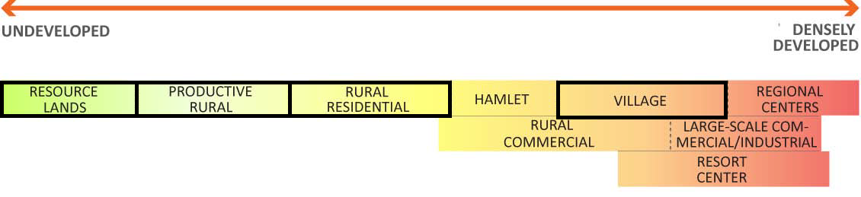 Windham Regional Commission’s Representation of Land Use Categories

##### The Windham Regional Commission (WRC) originally identified nine land use categories, as shown in the graphic above. They have since considered adding a tenth category, to the left of Resource Lands, called Critical Resource Lands. Grafton’s Proposed Land Use Map[4] will use the following five of the ten categories.[5]

##### **Villages** are less densely populated and smaller than Regional Centers, but offer many of the same residential, civic, commercial and light industrial uses.

##### **Critical Resource Areas** are key sites that are particularly sensitive and should be given maximum consideration for protection. Although there are no specific zoning regulations or ordinances prohibiting development on private land, it is the expressed desire of the Town that NO development occurs in Critical Resource Areas.

##### **Resource Lands** are dominated by lands requiring special protection or consideration due to their uniqueness, irreplaceable or fragile nature, or important ecological function. Resource Lands can be actively worked and used, but future development should be weighed against the desire to preserve the area.

##### **Rural Residential** ischaracterized by low and very low density housing, includes areas that are already committed to residential development or are in proximity to already developed lands.

##### **Productive Rural Lands** include forestlands, active agricultural lands, sand/gravel/mineral deposits, and high-value forest and agricultural soils that, when in productive use, contribute to the working landscape and have significant economic value.

##### For reference, the WRC’s remaining land use definitions are:

* **Large-Scale Commercial/Industrial Centers** consist of areas where existing and future commercial and industrial activities are encouraged, including new development, redevelopment, and conversion of previously non-industrial uses.
* **Regional Centers** are the region’s core downtowns, plus their surrounding mixed-use neighborhoods, which accommodate high density commercial, institutional, and housing services. Windham County’s two identified Regional Centers are Bellows Falls and Brattleboro.
* **Rural Commercial Areas** are concentrated along US 5, VT 9, VT 30, and VT 100 and include areas of mixed-use development built in a spread out pattern. Typically dominated by commercial service industries, the intent of this land use category is to transform these areas into higher density, compact, mixed-use settlements through infill and redevelopment.
* **Resort Centers** are developments that are associated with large-scale recreational facilities, which in this region are concentrated around ski area facilities.
* **Hamlets** are smaller than villages and are typically concentrated residential settlements in rural areas that may or may not provide minor commercial and civic services.

## Desired Future Land Uses

##### A map of the following five land use areas can be found on the Proposed Land Uses Map in Appendix VI – Maps.

### Grafton’s Village Area

##### The Grafton Village is the only area designated as a Village Area in the Town. The Village is the most densely settled part of the Town. The current mix of retail uses, public facilities and institutions, and residential uses should be continued and supported as much as possible. A major portion of Grafton’s economic development should occur in the Village, as it is centrally located, and historically has been the Town's economic center. Appropriate reuse of vacant or underused existing structures or infill development is the preferred means by which new growth should be accommodated. Infill development should respect the historic character and function of the area. Efforts to enhance the pedestrian-friendly character are encouraged. The existing density should be maintained or even increased in order to support its function as the heart of the Town.

##### In order to support a healthy future of its historic village center, Grafton intends to apply for a Village Center Designation, in conformance with 24 VSA Chapter 117 4302(c) (1). The Village Center Designation will support the efforts to revitalize the existing historic village center of Grafton and link with the statewide goals of “…planning development so as to maintain the historic settlement pattern of compact village and urban centers separated by rural countryside.”

### Grafton’s Critical Resource Areas

Grafton has several areas specifically identified as Critical Resource Areas.

* The Turner Wildlife Management Area is identified as a Critical Resource Area for its historic, ecological and cultural significance.
* Publicly owned lands include three state forests, (Mollie Beattie, Putnam and Dorand), the Grafton Town Forest and the Village Park.
* There are six locations where rare, threatened, or endangered species occur.
* The headwaters of the many tributaries to the Saxtons River are fragile ecosystems and development could have negative impacts including flooding and pollution downstream.

### Grafton’s Resource Lands

##### A large portion of Grafton, including most of the southern and western areas, has been identified as Resource Lands for several reasons. All of the Resource Lands are identified as “Highest Priority Connectivity Block” and most of the area is also identified as “Highest Priority Interior Forest Block”.[6] This area has also been identified as prime bear habitat and wintering areas for deer. Finally, much of the terrain in this area has slopes of over 25%, which makes development problematic.

##### The flood plains of Grafton are also designated as Resource Lands. Development in the flood plains should be avoided whenever possible. If development is to occur, steps should be taken to ensure that the development will not negatively affect the flood plain and water flow.

### Grafton’s Rural Residential Land

There are three areas designated as Rural Residential Land in Grafton. These are all less densely populated than the Village, but more densely populated than the rest of the town. No services are presently available in any of the three areas. These three areas are Houghtonville, Cambridgeport and the northern section of Eastman Road.

### Grafton’s Productive Rural Land

The remainder of Grafton is considered Productive Rural Land. This includes the corridors into and out of the village, excluding the flood plains, the area between Hinkley Brook, Cabell and Houghtonville Roads, and the northeast quadrants of the Town.

## Goals, Policies & Recommendations

### Goals

1. Maintain Grafton’s land use patterns including the central historic Village surrounded by a sparsely populated countryside.
2. Incentivize business growth that utilizes the land in ways that support and complement Grafton’s quality of life, targeting specific sectors including, but not limited to tourism, agricultural and forest products, telecommuting, small scale manufacturing and the service industries.
3. Maintain and improve the quality of air, water, wildlife, forest and other land resources, including preserving Grafton’s large forest blocks and habitat connectors.

### Policies

1. Water supply, sewage disposal, and traffic and pedestrian flow must be taken into consideration when any new structure within the Village is planned.
2. Grafton’s existing pattern of development, the location of public services, utilities, commercial facilities, and the existing road network must be taken into consideration when new development is proposed.
3. Lands adjacent to public or quasi-public facilities, services or properties will be planned and used in a manner that will safeguard public investment that will not jeopardize or interfere with the public use, enjoyment of or access to the facility, services or property, including highways, Town owned buildings, and recreational facilities.
4. Support the creation and growth of appropriate small-scale businesses throughout the Town.
5. New development must be planned carefully so as to avoid strip development, unreasonable burdens on town roads and services and other undue adverse impacts, such as, but not limited to, aesthetics and community character.
6. Use conservation methods and river easements consistent with Act 171 guidance for the protection of habitat for wildlife and to promote flood resiliency.
7. Grafton’s forestlands should be managed so as to maintain and improve forest blocks and habitat connectors.
8. Landowners, foresters and loggers shall utilize the sound practices specified in the Vermont Water Quality, Acceptable Management Practices, Manual for Logging Professionals, VT – 2019 and as amended, and Grafton shall adopt a policy requiring compliance with those practices.

### Recommendations for Action

1. Designate areas within town boundaries, which are appropriate for significant growth and those areas to be preserved.
2. Submit an application for a Village Center Designation in conformance with 24 VSA Chapter 117 4302(c) (1) and Act 59. The Village Center Designation will support the efforts to revitalize the existing historic village center of Grafton and link with the statewide goals of “…planning development so as to maintain the historic settlement pattern of compact village and urban centers separated by rural countryside.”
3. Investigate solutions and create a plan to solve the potential water supply/wastewater issues within the Village, seeking Town’s approval for any additional financial burden on the Town. With the Town’s approval, investigate installing a Grafton Village wastewater treatment center to enable the growth of small businesses and to ensure the health and safety of Village residents.
4. Conduct workshops to promote land owner education that encourages land stewardship practices to preserve wildlife habitat and forestry blocks. Work with land owners to inform them of opportunities in land stewardship and conservation easements.
5. Examine lands adjacent to waterways and river corridors. Update the Town’s maps to include the most recent accurate data on flood zones. Identify priority areas to promote conservation of natural resources and use of conservation easements..
6. Encourage use of lands adjacent to town boundaries that will be compatible with neighboring town plans.
7. Promote the use of locally-grown agricultural and forest products.
8. Encourage voluntary action to ensure Plan implementation, including:
   1. privately-agreed restrictive covenants binding on purchasers of land,
   2. use of existing non-profit land trusts to acquire or hold conservation easements on resource lands,
   3. participation in Act 250 review process by abutting landowners, and
   4. participation in the town planning process by residents and property owners.

# 2. HISTORIC, CULTURAL AND NATURAL RESOURCES

\

## Historic Resources

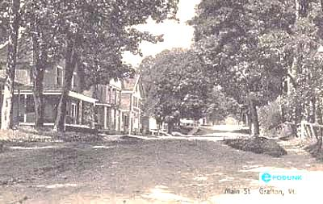

The historic character and scenic landscape of Grafton with traditional New England settlement patterns and architectural designs are of critical importance to the community and an important consideration in the planning and design of future development for the Town.

Grafton’s historic resources include existing structures, sites of significant events in the history of the Town and the State, ruins and remains of the Town’s history, and the evidence of earlier settlement and transportation patterns. There has been little destruction of historic structures. To the contrary, in the past 50 years Grafton has seen the Windham Foundation, non-profit groups and private residents take the initiative to authentically renovate and preserve their holdings and new purchases. Although economic necessity rarely requires destruction of historic sites or structures, there is a concern that a lack of public support in the future may discourage renovation, reconstruction, maintenance and preservation of these resources.

In 2003, historic resources listed in the National Register of Historic Places were the Grafton Congregational Church and Chapel (listed 1979, currently known as the Brick Meeting House and the Grafton Community Chapel); the Kidder Covered Bridge (listed 1973); Milldean and Alexander-Davis House (listed 1990).

Since then, through the efforts of the Grafton Historical Society and the Vermont Division for Historic Preservation, several historic buildings and districts have been added to the National Register of Historic Places, including: Grafton District Schoolhouse #2 (listed 2005); Butterfield House (listed 2005, Library): Grafton Post Office (listed 2005); Park Farm (listed 2003); and the Middletown Rural Historic District (listed 2011); Mechanicsville Historic District (listed 2010); Houghtonville Historic District (listed 2015); and the Grafton Historic District (listed 2010).

The Vermont State Register of Historic Places includes over 100 historic properties, which includes all the properties listed in the National Register of Historic Places.

The architecturally significant Grafton Congregational Church (Brick Meeting House) has been structurally stabilized through the efforts of the Grafton Historical Society. Beautiful interior restorations are under way. The Congregational Church Chapel (Grafton Community Chapel) has been renovated and stabilized through the efforts of Grafton Community Church, Grafton Cares and numerous volunteers.

The Grafton Village Historic District, the Mechanicsville Historic District, and the Houghtonville Historic District are also listed on the National Register of Historic Places. There are community efforts to preserve Middletown, Howeville, Old Town Farm, and Serpentine Rock for future consideration in the national historic register.

The Vermont State Register of Historical Sites includes over 100 historic sites within Grafton. They are all designated historic sites under the Vermont Division of Historical Preservation. In addition, numerous stone walls, foundations, mill sites, ruins and hiking trails testify to the Town’s pattern of settlement and lifestyle in the late eighteenth and early nineteenth centuries.

An important part of Grafton’s rich history is the story of the Alec Turner family. Alec Turner was an escaped slave who fought with the Union Army before settling in Grafton in 1872. He worked as a logger and sawmill worker until he saved up to buy 150 acres on a Grafton hilltop. There he built a home where he was to raise 13 children together with his wife, Sally Turner, a freed slave. The Turner homestead is no longer standing, but the Windham Foundation is working with the Preservation Trust of Vermont to preserve the nearby Birchdale Camp, which the Foundation owns.

## Cultural Resources

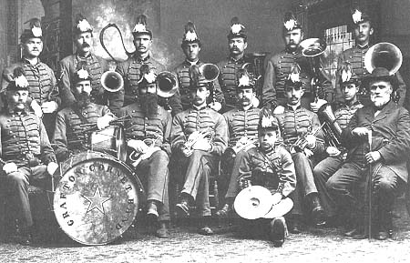

Grafton Cornet Band, 1885

##### Grafton prides itself on the unusually high number of cultural resources within a town of its size. Some have been around for generations while others began just recently.

##### Organized in March, 1867, The Grafton Cornet Band is still going strong today. The band's membership and traditions have been handed down from generation to generation. The band played in the Grafton Memorial Day Parade for the first time on May 30, 1868 and has played at it every year since.

##### Because of Grafton’s unique setting, there are a variety of locations in town that attract high-quality cultural performances. Just south of the village, Grafton Trails includes a large, flat, groomed field with Grafton Ponds and Bear Hill in the background. This setting is ideal for special events such as the annual Vermont Symphony Orchestra (VSO) performance. Other sites include The Grafton Community Church, with its famed sanctuary acoustics, the Grafton Library Lawn, Phelps Barn, and many others.

##### The Nature Museum at Grafton allows visitors to examine Vermont wildlife up-close with interactive exhibits, hand-painted dioramas, and mounted specimens. Its hands-on exhibits allows guests to crawl through an underground bear den, dig for fossils, dress up as a variety of creatures, and watch the resident honeybees at work in their glass hive. The museum extends to the outdoors with a pollinator garden, a pond and hiking trail. A highlight of the year is always the Annual Fairy House Festival, which has taken place every September since 2008.

With 250 years of artifacts, Grafton's past is on display in the award winning Grafton History Museum. Visitors learn about the many people and families that built the community, the many historic structures, sites and industries, an extensive soapstone collection, and much, much more.

Located across from the Grafton Inn, The Turner Interpretive Center was established in 2107. The self-guided information center brings to life the story of Alec Turner’s family as told by his daughter, the renowned Vermont storyteller, Daisy Turner. Along with the Turner’s homestead site, the Turner Interpretive Center serves as southern Vermont’s gateway to the African American Heritage Trail.[7]

Vermont Museum of Mining and Minerals displays Vermont's own state gems, rocks and minerals that have contributed to Vermont's economic history plus spectacular minerals from around the world. A miniature village made entirely of Vermont marble, slate and granite is on display, as well as one of the world's largest ammonites, fluorescent minerals, a special children's exhibit, and a gift shop.

The Grafton Public Library continues to serve as an important cultural gathering spot for the community. In addition to offering a traditionally wide selection of books, they also offer other services and materials including computers with internet access, free wi-fi, printing services, help in researching, and much, much more.

##### This strong historic cultural foundation has attracted artisans and craftsmen to the community over the years. Today Grafton hosts a variety of art and craft related businesses including The Gallery North Star, Jud Hartmann Gallery, The Painted Cupboard, Mercantile and Dover House Antiques, Grafton Forge and Moose Creek Adirondack Chairs.

## Natural Resources

### G:\My Drive\Personal\Grafton\Town Planning Commission\Town Plan\2 - Historic Resources\Serpentine Rock.png

Serpentine Rock, Pre-1917

### Historic Overview

The modern ecological history of the land we now call Grafton essentially began with the retreat of the glaciers roughly 14,000 years ago. Throughout time Grafton was predominantly an unbroken forest of large trees. From above, small, scattered beaver flowages would have been the only distinguishable landscape feature. A function of topography, water would have traveled the same streams it does today. There is no evidence that Grafton was occupied or influenced by humans, including Native Americans, before the arrival of European settlers to North America in the 1600’s.

Until recently, beavers were likely always part of the post-glacial landscape. Their predictable habitats of basins on small streams are permanently or intermittently occupied, and dams are maintained or re-built. Grafton does not have trees that can grow in standing water, so flowages become distinct, open patches in the forest. Between the late 1600s and 1950 beavers were virtually eliminated. Early in that process, flowages drained and became forested. It’s possible that some specialized plants and animals dependent on these habitats became extinct during this time. As an example, the New England bulrush barely survived. Fortunately, beavers have recently returned, drowning the tree interlopers and re-establishing their forest openings.

Beginning with the appearance of the first Euro-American settlers in Vermont during the 1700s, the next big change was the removal of the ancient forests for wood products and to create fields. Continued heavy cutting, and widespread grazing by sheep, diminished the forests during the 1800s. In the early 19th century, Grafton’s population peaked at around 1,500 residents. Not entirely coincidentally, this was also the low point of the town’s wildlife population. To name a few examples, beavers, wolves, mountain lions, moose, fishers, and turkeys were almost completely eliminated. Countless other species, especially wetland-dependent ones, would have been rare at best. Waterfowl like wood ducks, hooded mergansers, and Canada Geese may have been present only as they flew by while migrating.

During this time of settlement and expansion, there was little-to-no conservation efforts, including no regulatory authority limiting the volume of killing or the types of animals being killed. Conservation efforts have significantly improved over time, both at the state and federal levels, including the protections of some species since the early 1900’s.

The combination of conservation efforts, a 75% reduction of the human population between 1840 and 1940, and the recovery of forests and wetlands over the last century has led to the return of many native species and a substantial growth in overall wildlife populations. Notable exceptions are wolves, mountain lions, and now-extinct animals like passenger pigeons. In the meantime, coyotes, which didn’t exist east of the Mississippi before European settlement, have moved in to partly fill the vacant, large-carnivore niche.

Grafton’s scenic landscape, including its gravel roads and trails, open lands, surface waters (including streams and ponds) and other wetlands, is widely appreciated by residents and visitors alike and is a valuable economic resource. Conservation of scenic resources need not prevent development nor cause economic hardship: rather it should be an important consideration in the planning and design of all development.

### Forest Resources

Vermont is called the Green Mountain State for a reason. The forests are lush. As a vegetative unit they have proven incredibly robust over the centuries. Seventy percent of Vermont was de-forested 100 years ago. As evidenced all around us, the forests have recovered rapidly from the heavy cutting and the sheep industry of the past. Forests contribute to carbon sequestration that helps mitigate climate change. Many forest landowners are in Vermont’s Use Value Appraisal Program, more commonly known as “current-use program”[8] and hire consulting foresters to help manage their timber harvest.

Today, human activity poses a limited threat to our forests. However, indirect human activity elsewhere, including the continued introduction of exotic pathogens, insects, and plants to North America, does. This has already caused the loss, largely or completely, of butternut, elm, and chestnut trees. Other exotics, including Hemlock woolly adelgid, Asian longhorn beetle, and the emerald ash borer, are presently infesting the forests of the Northeast. Unfortunately, there is likely to be a constant onslaught of these types of foreign invaders in the future.

Grafton’s forestlands should be managed so as to maintain and improve existing forest blocks and habitat connectors. Forest blocks are those contiguous areas of forest in any stage of succession and not currently developed for non-forest use. Forest blocks may include recreational trails and wetlands or other natural features that do not themselves possess tree cover. Habitat connectors are sections of land, water, or both, that link patches of wildlife within a landscape, allowing the movement, migration, and dispersal of animals and plants and the functioning of ecological processes.

### Surface Water Resources – Rivers, Streams, Ponds, Semi-Permanent & Vernal Pools, and Wetlands

All Grafton streams are classified as upland streams with Class B waters suitable for swimming, recreation, irrigation, and good fish habitat. Stormwater that discharges into these waters should be controlled with settlement ponds and diversions. All wastewater, even conventionally treated waste discharges, are prohibited from being discharged into streams and other waterways by current state standards.

The State of Vermont is looking into possibly reclassifying at least three local streams shared with towns of Townshend and Windham; they are the Stiles Brook, Willie Brook, and Howe Brook. The streams are closely related: they are long, parallel each other, flow northwest to southeast, and take sharp, northeast turns when they reach the south branch of the Saxtons River. The watersheds of the three streams, which drain from the “Grafton-Windham Wildlands” (GWW), are undeveloped and mostly forested. The biggest exception to this is the power line, which nevertheless is largely “vegetated.” Together, the three streams represent about nine stream-miles with the only roads being narrow and rarely used, such as logging roads and the power line’s maintenance road that either parallel or intersect the brooks. As relatively small streams, they also were not, throughout most of their length, badly damaged by the massive floods we have had in recent decades. By contrast, our largest streams, including the two branches of the Saxtons River which merge into main stem as it drains east, were deeply scoured by the Tropical Storm Irene floods and clean-up work afterwards. Consequently, the Saxtons River, once an excellent trout stream, is now a relatively sterile and structurally impoverished habitat.

Riparian buffers can be defined as a zone of interaction and influence between aquatic and terrestrial ecosystems along streams, rivers, lakes, wetlands, and other waterbodies.[9] They provide a vegetated, protected zone which, if undeveloped, will contribute to the well-being of the biota both in and adjacent to the body of water. This is an important resource worth recognition and protection.

Manmade ponds, beaver-created wetlands, semi-permanent pools, vernal pools, or flowages, are the only water bodies in Grafton. Looking from an aerial view, Grafton is distinctive for its lack of lakes. Even during dry periods, Grafton contains an enormous amount of water, but most of it is not ponded; it is on the move, in streams.[10]

Areas with routine flood hazard potential can be found along the Saxtons River, South Branch of the Saxtons River, Hinkley Brook, Kidder Hill Road, and Fisher Hill Road. It should be recognized that many smaller streams have potential for local flooding, flash flooding, and washouts.[11]

### Prime Agricultural Soils

Soil characteristics impact farming, forestry, mineral extraction, and commercial development. Prime agricultural soils that are rated high for crop production potential are very limited in Grafton. Since most primary agricultural soils are flat and well drained, these soils are targets for development.

### Soils for Sewage and Water Systems

Residents of Grafton depend upon ground water wells for their domestic water supply. The amount and quality of ground water appears to be adequate for continued rural growth, but problems of supply and quality may well occur in the densely settled areas. Places of concern include Grafton Village, Houghtonville and Vermont Route 121 East near Cambridgeport. The Town of Grafton has a septic tank pump ordinance in place for those areas and encourages water testing.

### Mineral Resources

Gravel - A 12-year Land Use Permit was issued in 2013 to the one privately-owned commercial gravel pit in Grafton.  It allows for the extraction of sand, gravel and crushed gravel on 16.3 acres of a 20.1 acre parcel located off Eastman Road.  There was an existing access road and an estimated 20,000 cu yards will be extracted annually, with a maximum of 30,000 cubic yards in any given year. Typical activities are loading, excavating, screening, stockpiling and sorting with periodic crushing. Drilling, blasting and extraction of bedrock are not proposed. There is a reclamation plan and a sound barrier of wood wall 6’-8’ in height.

Soapstone Resource – Soapstone (also called soap stone or steatite) is a popular building stone, often used for counter-tops, wash basins, and old-fashioned soapstone sinks. Valuable soapstone quarries have been worked in New England since the early nineteenth century. Looking southward from Grafton, in the distance is Bear Hill, once home to the largest soapstone quarry in the East. The thriving industry—along with sheep farming (the town had 10,000 sheep at one point), sawmills, cider mills, and wool mills along the Saxtons River—led to a minor boom, with the population swelling to almost 1,500 just prior to the Civil War. By the end of the 19th century, the quarry was no longer mined.

### Natural Areas, Fragile Areas, and Wildlife Resources

The recently designated Turner Hill Wildlife Management Area in Grafton and Athens conserves upland forests and wetlands, including a federally endangered Northeastern bulrush that requires beaver-flooded wetlands such as those found on the property. The bulrush was first brought to the attention of biologists from the Fish & Wildlife Department by local citizens of Athens. The Wildlife Management Area (WMA) was created through collaboration with The Nature Conservancy, which purchased one of the tracts, and with VELCO, which donated the land for roughly half of the 600-acre property.

Small, headwater streams are unique habitats that host some sensitive, highly specialized species like the dusky, two-lined, and spring salamanders. These animals require very stable, clean, cold, relatively steep, highly oxygenated, and largely fish-free streams. Streams with these characteristics typically begin on mountainsides and have watersheds that are road-free and fully forested. These habitats can be found in many sections of Grafton, but, not surprisingly, most examples are in the undeveloped west. The craggy mountains southwest of Houghtonville are particularly dense in streams of this nature. Here, there is a rare example of a headwater stream that is over a mile long, amongst many others.

### Ridgelines

The most important and widespread component of the viewscapes of Vermont are its mountains. In the anatomy of a mountain, the skyline may offer even greater value to esthetic sensibilities than do mountainsides. In a mountainous community like Grafton, whose quality of life and economy is defined by its natural beauty, the skyline is a precious commodity. Relative to valleys, or even hillsides, towers, houses, and clear-cuts on ridges are widely visible, disturb the natural skyline, and have a disproportionately negative effect on the scenic value of an area. Any development and road construction could also pose a risk to the fragile ecosystem, wildlife, and headwaters in the mountains

Much of Grafton is still relatively wild and undeveloped due to prohibitive costs of developing on steep terrain. Population density drops as the terrain becomes more rugged. Because of the limited development, the mountains are a refuge, particularly for larger, shyer (in most instances, and particularly during the hunting season) animals like moose, bear, and deer. Mountains are also a refuge for naturalists, and the more “wild” among us. For hunters, they also represent freedom from human confines and areas where rifles can be used safely.

### Air Quality

Air quality problems come from outside wood boilers (installed before State regulations) and the backyard burning of inappropriate materials.

### Scenic Resources – Noise and Light Pollution

Noise pollution at certain levels can dramatically alter the character of the neighborhood. The town should be aware of the noise levels of its own activities, and should work to establish appropriate noise thresholds. Problems related to noise include hearing loss, stress, high blood pressure, sleep loss, distraction and lost productivity, and a general reduction in the quality of life and opportunities for tranquility. Noise pollution can be created through a variety of activities including kennels, construction equipment, manufacturing processes, automobiles, and utility scale wind facilities. It is important to specify the difference between noise pollution and “disturbance of the peace” which is regulated by state statute Chapter 13, Title 19 Breach of the Peace: Disturbances.

The lack of manmade light-glow between sunset and sunrise is an important aspect of Grafton’s quality of life. The Town of Grafton recognizes that inappropriate and poorly designed or installed exterior lighting can cause unsafe or unpleasant conditions and limit the ability to enjoy the night-time sky.

### Plantings for Streambanks and Floodplains

##### Fluvial erosion can be greatly reduced using a variety of natural remedies. When a river or stream overflows, certain types of plants can greatly mitigate serious erosion. Above the ground’s surface, plants can reduce the velocity of the water flow. The rate of water flow has a direct impact on the amount of the erosion that occurs from a flood. Below the surface, plants with strong, deep roots can help hold the soil in place during the flooding. Plantings will also provide more shade over time and discourage invasive plants such as Japanese Knotweed.

## Goals, Policies & Recommendations

### Goals

1. Identify, protect and preserve important historic sites and landscape features including structures, bridges, stonewalls, foundations, mill sites and ruins.
2. Continue to have a vibrant cultural community including visual and performing arts.
3. Plan for and protect land, water and wildlife resources.
4. Maintain and improve the ecological integrity of intact forest blocks and functionality of habitat connectors

### Policies

1. Land adjacent to or including areas of natural, historical, educational, cultural, scientific, architectural, or archeological value should be used in a manner that will not reduce or destroy their value.
2. Support access to sensitive archeological areas by qualified researchers to Grafton’s historic, cultural, and natural resources such as Middletown Upper Village, Howeville, the Old Town Farm, the soapstone quarries, and Serpentine Rock.
3. Encourage the preservation of the significant structures, viewsheds and landscapes so they will continue to be visual assets to the whole town.
4. New development as well as improvements to existing structures should be compatible with Grafton’s architecturally and historically significant sites so they will continue to be preserved as visual and cultural assets to the community.
5. Development shall be strongly discouraged on lands that possess a limited capacity to support development or have high resource value.
6. Developers of all new development shall abide by the Vermont Stormwater Management Manual, enacted by VT Department of Environmental Conservation (DEC).
7. Protect ground and surface water resources by recommending the restriction of development within the following areas:
   1. Watersheds characterized by steep slopes (15 percent) or by shallow or excessively wet soils
   2. Drainage areas of upland streams (as classified by VT DEC ANR), which are characterized by the soil conditions mentioned above, in order to prevent siltation of streams, eutrophication of streams and ponds, soil erosion, and pollution or contamination of ground and surface waters.
   3. Areas with significant water storage potential for fire protection, recreation, or wildlife purposes.
   4. Riparian buffer zones along some water ways to provide scenic, recreational and habitat areas
   5. Encourage river and stream conservancy
8. Maintain streams in a natural state where practical and retain existing public access.
9. Manage the floodplain by enforcing community Flood Damage Prevention Regulations which are compliant with the National Flood Insurance Program.
10. Ensure that the scenic and recreational value and environmental quality of stream banks and shorelines are maintained.
11. Discourage clear-cutting unless as part of a forest management plan. Minimize cutting of trees on stream banks. When appropriate, remove logging debris from watercourses.
12. Biomass harvesting should be done on a sustainable basis in accordance with a forest management plan.
13. Maintain a natural viewscape and undeveloped skyline, by discouraging development along ridgelines.
14. Encourage thermal motion activated lighting for security lighting.
15. Limit use of luminaries that are on permanently at night, and/or to total horizontal cut-off to neighbors.
16. Installation of any new wood furnaces must meet state standards.
17. Encourage a systematic testing of water supply in the Village on a regular schedule, particularly at public venues.
18. Protect agricultural soils for agricultural purposes.
19. In compliance with State regulations, manage the use and disposal of pesticides.
20. Work with Vermont Fish & Wildlife Department and local enforcement to ensure that hunting and fishing are conducted in compliance with State regulations.
21. Prime agricultural soils should remain free from development. Only the peripheral edges of those lands should be developed, leaving the large interior as open space for traditional agricultural purposes.
22. Encourage the use of conservation and river easements consistent with Act 171 guidance for the protection of habitat for wildlife and to promote flood resiliency.
23. Conservation easements should be pursued to discourage development along VT121 west of Houghtonville. This is a high value natural resource corridor.

### Recommendations for Action

1. In cooperation with the Grafton Historical Society, the Grafton Improvement Association, the Vermont Division for Historic Preservation, the Windham Foundation, land owners, and other groups; the Town of Grafton will continue to identify and catalog historic settlement patterns (i.e., the historical record on land use), historic sites & structures, archeological sites, ancient roads, old cellar holes, and stonewalls within the Town and assess the need for further protective measures.
2. Encourage the formation of voluntary groups to help find, identify and preserve historical patterns and structures within the community.
3. Identify the farm and forest parcels requiring attention.
4. Work with The Nature Museum at Grafton and the Grafton Improvement Association to identify and catalog all sites that may need protection.
5. Create a systematic water supply testing schedule, particularly for public venues.
6. Encourage residents to learn to identify and then report invasive species to vtinvasives.org.[12]
7. Collaborate with the State Department of Environmental Conservation in the possible upgrading of the classification of brooks such as Willie, Howe, and Stiles Brooks.
8. Educate property owners about protecting rivers and streams by river conservancy easements.
9. Encourage plantings of willows, dogwoods, sumac, and viburnum along the town’s waterways to strengthen river banks, improve flood control, and combat the spread of invasive plant species.
10. Conduct workshops to promote land owner education that encourages land stewardship practices to preserve wildlife habitat and forestry blocks.
11. Pursue a planning project that examines lands adjacent to waterways and river corridors. Update the Town’s maps to include the most recent data on flood zones.
12. Promote conservation easements by identifying priority conservation of natural resource areas and informing land owners of opportunities in land stewardship and conservation easements.
13. Consider amending the Subdivision Regulations to enhance the habitat protection standards for Road improvements along VT 121 and Townshend Road to enhance wildlife crossings and minimize habitat disruption.
14. The following plants should be considered for streambank stabilization measures, riparian buffers and floodplains.
    1. Alnus 'incana' (rugosa) Speckled Alder. Acer 'saccharinum' Silver Maple.
    2. Install the following as tubelings or bare root and in mass groupings.
       1. Cornus 'sericea' red-osier Dogwood. Salix; 'purpurea' streamco willow, 'sericea' silky willow, 'exigua' sandbar willow, 'discolor' pussywillow.
       2. Viburnum; 'dentatum' arrowwood, 'trilobum' American Cranberry.
       3. Rhus 'typhina' staghorn sumac. Rhododendron 'viscosum' swamp azalea.
15. Town should consider purchase of land on which there are deposits of gravel for Town roads.

# 3. THE ECONOMY

Grafton seeks economic development for the purposes of:

1. Helping residents develop and grow appropriate community-based small businesses.
2. Improving job opportunities for its residents.
3. Improving the availability, selection and cost of goods and services to its residents.
4. Managing and maintaining the use of agricultural land, historic buildings, and other public infrastructure.
5. Promoting Grafton in a way that capitalizes on the Town’s existing ‘brand.’

## Desired Types of Economic Development

Grafton's most valuable resource is its dense historic village surrounded by its rugged, scenic landscape. Grafton’s cultural and physical identity is both its greatest asset and challenge for economic development. The Town must retain its identity while supporting local economic development. Small-scale businesses and tourism-based industries are the most practical and desirable form of economic development.

Although the Town is in favor of economic development, it should be controlled, with maintaining the overall quality of life of its residents as its overarching goal. The Town is opposed to high-traffic, franchise-styled commercial and industrial development that comes with negative social and aesthetic impacts. If franchise businesses locate in Town, they must demonstratively adapt their operations and appearance to promote, not detract from, the unique Grafton brand. Commercial or industrial development should not negatively impact Grafton’s core economy that is based upon cottage, tourist, and agricultural small-scale enterprises. Commercial or industrial activities that would undercut Grafton’s foundation economy should be actively opposed.

Home Business and Industry – The home-business or industry is critical to allowing residents to live and work in Town and remains the community’s highest economic development priority. These businesses should be allowed wherever residential development currently exists or wherever it is appropriate for new residential development to be located. The goal for all home business or industry operating within a residential area is that the rural landscape and residential identity is not compromised by the commercial activity. All Town-related plans and policies shall support the establishment and growth of these home businesses and industries.

Hospitality and Lodging – Grafton’s tourism sector is a significant part of the Town’s economy. The Town appreciates the highly competitive climate for hospitality and lodging services and acknowledges the industry needs to be supported and encouraged.

##### Agriculture/Forestry – Grafton’s economic identity and character comes from its agrarian heritage. Grafton’s economic future could hinge on the production of specialty-value-based farm products and services. Grafton should assist farms by connecting them with grants for marketing, outreach, and communications. When possible, the Town can actively support this industry by co-sponsoring grant applications that provide town-wide marketing services for individual farms. The Town can facilitate by allowing public buildings and lands to be used for farmers markets and agricultural workshops and events.

Childcare – Grafton lacks licensed childcare facilities. Economic development is severely compromised when young working families cannot find childcare. A recent development in Vermont’s state law requires that 3-5 year olds have access to educational programs provided by childcare facilities. This significantly improves the financial model for childcare facilities locating in rural areas. The Town and School should actively recruit an existing childcare facility to open a branch in Grafton or to solicit interested local educators to open a facility.

Arts and Entertainment – Grafton already possesses an excellent selection of artisans, galleries, and events. This cultural resource can be expanded to include performing arts, music festivals, and connecting artistic programs with the tourism and recreational industries. The Town’s independent spirit is a natural fit for the promotion of the arts and can inspire and engage the local community while attracting visitors. The Town should actively market itself as an artistic community and promote the establishment of profit or not-for-profit organizations that can support cultural programming.

## **The Grafton Brand**

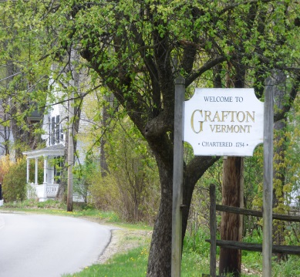Grafton has benefitted from the relocation of adults who are at or approaching retirement age and desire a quieter, rural lifestyle. These new full-time or seasonal residents are financially independent and with this self-sufficiency they are able to purchase homes, shop locally, and participate in local events. As an economic development strategy, the ‘Grafton Brand’ is a great concept and needs to be more fully developed. The Town should actively market itself online and to pursue collaborations with the local lodging industry to advertise Grafton to groups that serve young, middle, and older aged individuals. Attracting people to first visit the Town on vacation, may lead to greater relocations.

## Grafton’s Economy and Vermont’s Public Utility Commission

Public utility power and communications systems are regulated by the Vermont Public Utilities Commission and are exempt from local land use regulations. However, as a party of interest the Town has a consultation role and can give recommendations to the Public Utilities Commission to guide their permitting process.[13]

The desire to preserve Grafton’s culture and environment can conflict with the need for continued economic growth. Two public utilities of specific interest to Grafton’s economy that could also have potential consequences are Communication Systems (cell towers) and Power Generation.

### Communication Systems

‘Clean businesses’, including telecommuters, could be a partial solution to growing the economy while preserving the environment. These businesses require reliable high-speed internet and widely available cell service. Most residents now have access to high-speed internet, but reliable access to cell service is lacking.

Grafton strongly supports Town-wide access to multiple carrier cellular services, but full-sized cell towers would have a negative impact on the scenic ridgelines. Multiple shorter towers that minimally clear the tree canopy would be preferred. Grafton further emphasizes that any installed tower system must provide opportunities for co-location of other carriers. Finally, if a tower must extend beyond the tree canopy, effective camouflaging to demonstratively reduce their visibility must be used.

### Power Generation

With power generation and transmission related infrastructure, the Town strongly discourages locating these facilities within areas that demonstratively impact Grafton’s historic village. This includes aesthetic impacts to historic structures, scenic view shed impacts, and increased local/regional traffic generation. The economic viability of the village greatly depends on preserving its historic aesthetic and function.

## Goals, Policies & Recommendations

### Goals

1. To develop a stable economy in the Town of Grafton in order to provide a range of employment opportunities and an adequate tax base.
2. To encourage and strengthen agricultural and forest industries.

### Policies

1. Encourage varied economic activity in the Town, including diversified agriculture, small entrepreneurship, home industries, and commercial operations.
2. Ensure that new enterprises do not pollute the environment or overtax the highway systems, emergency services, and schools.
3. Collaborate with the Vermont State Tourism, Ski Vermont, and other regional and state tourism industry partners to enhance Grafton’s online presence.
4. Oppose development that would detract from Grafton’s unique assets, including its ridgeline.
5. Require that primary agricultural soils be devoted to farming or to uses which will maintain the potential of such soils for agricultural use.
6. Propose that secondary agricultural and forest soils be planned for uses that will not materially reduce the productivity of these soils, or preclude their future use for forestry or specialized agriculture.
7. Require that any non-agricultural development proposed, including residential uses, to be located on important agricultural lands, be designed to minimize any undue adverse impact on existing or potential agricultural uses.
8. Require that construction or extension of public services and utilities by the Town (e.g. roads, recreation areas), State (highways), and private companies (energy generation or transmission corridors) be permitted only where such construction or extension will not discourage agricultural activities or will be compatible with important agricultural land.

### Recommendations for Action

1. Consider the establishment of a resource center, including both physical and on the web, for disseminating technical and financial assistance to local residents who are undertaking new businesses.
2. Consider the establishment of a committee to identify suitable sites, consistent with land use policies, for larger industrial and commercial enterprises and, if possible, seek out such enterprises.
3. Consider a professional marketing plan through the services of a marketing director or service as a sales tool to promote Grafton as a welcoming community for small business, tourism and a great place to raise families.
4. Proactively promote additional entertainment functions and recreational activities that will draw regular day and weekend visitors such as bus tour promotions with guided tours.
5. Encourage the private development of a self-generating fund available to entrepreneurs to bring their ideas for business or enterprise to fruition in Grafton.
6. Continue to study water/wastewater quality in the village to continue the good quality of the current water and disposal systems, and explore future needs, including economic viability of the village, and solutions if need be. Utilize grants available for such infrastructure necessary to meet state standards.
7. Consider offering tax incentives for businesses that are moving to Grafton, attempting to remain in Grafton but enduring financial hardships, or expanding operations within town. The priority is on businesses that advance the Local Economic Priorities outlined in this chapter.
8. Participate in regional organizations that encourage a coordinated economic development strategy for the Windham/Windsor County region.
9. Apply for publicly funded grants that may support business relocation or development, marketing, and outreach.
10. Conduct a town-wide inventory of all commercial and industrial businesses.
11. Facilitate marketing and business outreach for businesses operating in Grafton.
12. Encourage the establishment of licensed childcare facilities in the Town through individual entrepreneurship, collective business collaboration, or community volunteering efforts as a way to recruit young, working families relocating to town.
13. Consider establishment of a committee to investigate how to expand diversified agriculture and forestry.
14. Continue to study water/wastewater quality in the village to continue the good quality of the current water and disposal systems, and explore future needs, including economic viability of the village, and solutions if need be. Utilize grants available for such infrastructure necessary to meet state standards.

# 4. ROADS AND TRANSPORTATION

## Public Roads System

Grafton has just under 50 miles of maintained Town roads. There are no State Roads. but State aid is available for Class 2 and Class 3 roads. In general, Class 2 roads are paved and Class 3 roads gravel. There are also footpaths throughout the Village and Village Park. The Grafton Selectboard and State Assistant District Engineer classify current Grafton roads as follows:[14]

* Travelled Highways (maintained and in use)
* Class 2 Roads 18.3 miles
* Class 3 Roads 30.83 miles
* Total Travelled Highways 49.13 Miles
* Untraveled Highways (discontinued or unmaintained roads, legal trails)
* Class 4 Roads 9.42 miles
* Legal Trails 4.79 miles

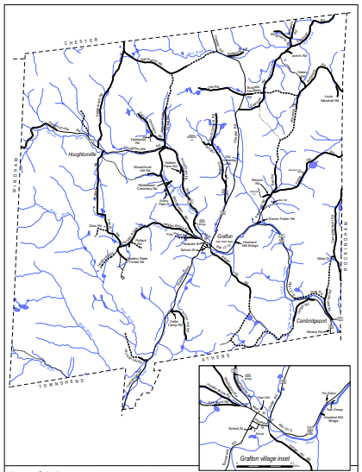Grafton’s four traffic corridors are:

* From the North - Route 35 between the Village and Chester
* From the South - Townshend Road between the Village and the West River Valley.
* From the East - Routes 121 between the Village and Bellows Falls
* From the West – Route 121 between the Village and Londonderry

The present network of Town roads serves the needs of residents, provides access to buildable land, and leaves unmolested forested and open space, which should be conserved for scenery, recreation, and forest products.[15] Minor Town roads are used for access to residences and bordering properties and for sightseeing by those who choose back roads for quiet drives by car, bike or horse. The procedures for laying out, reclassifying, and discontinuing Town roads can be found in Chapter 7 of Title 19 V.S.A. as amended.

### Private Road Standards

Grafton’s subdivision regulations provide development standards for transportation infrastructure. This assures that the burden of costs associated with the subdivision of land fall upon the landowner or developer and not the taxpayer. Private roads must be built to town specifications if the intent is to petition the Selectboard to accept that road as a public highway. In addition to meeting Town standards, the road shall also be designed so as to demonstratively minimize flood risk and maintenance obligations. Strategies include laying out roads to avoid steep road grades, installing adequately sized culverts and ditching, utilizing a cluster styled development to minimize road lengths needed to access individual lots, and locating roads well outside of flood prone areas.

Although Class 4 roads may be moved up to Class 3, and thereafter maintained by the Town if the Selectboard finds that action is in the best interests of the Town, the Selectboard at the present time will not approve the rebuilding at Town expense of any Class 4 roads to accommodate new housing, or for any other purpose. Anyone wishing to build a new house on a Class 4 road may rebuild the road to Town specifications at his or her own expense, and the Town may then consider accepting it. Anyone contemplating the purchase of land on an unused Town right-of-way is urged to consult the Selectboard before closing on the property.

### Bridges

Grafton has a total of 43 bridges, many of which were built in 1939 after the hurricane. Eighteen have a span of 20 feet or more, and are inspected by the State every two years. There are 25 bridges between 6 and 20 feet. Under new Federal regulations, any bridge 20 feet or over is eligible for Federal funding assistance. This funding is necessary particularly when emergency flood events critically damage these structures. Grafton has one functioning covered bridge, the Kidder Hill Bridge.

## Public Transportation

Southeast Vermont Transit, called the Current, coordinates and provides service to residents of Grafton in three forms, bus, van, and volunteer driver. The Current is utilized by commuters, elderly, the disabled, shoppers, and those who need transportation to medical appointments. In addition, Grafton Cares volunteers deliver meals to those-in-need and provide Town residents with transportation to and from scheduled medical appointments.

## Transportation and Economic Development

Grafton’s transportation system is a scenic resource enjoyed by residents and visitors alike. Traveling our roads is an enjoyable experience that can be viewed as an economic asset for our community. Visitors can arrive by vehicle, motorcycle or bicycle and contribute to our businesses and lodging establishments.

## Goals, Policies & Recommendations

### Goals

1. Continue to maintain the current public road system, providing residents of Grafton with safe and passable roads at all seasons of the year, while respecting the integrity of the natural environment.
2. Increase availability of public transportation in Grafton.
3. Maintain the present traffic volumes and patterns throughout the Town.
4. Continue to ensure that parking facilities and speed limits be adequate for the safety of the residents and visitors.

### Policies

1. Require that the scenic value of the Town roads and the impact of greater, faster traffic burden be carefully evaluated when improvements on Town roads must be undertaken.
2. Ensure that roads are widened or paved only when necessary for safety and year-round maintenance and incorporate traffic calming design in any new road construction. Narrow roads help traffic maintain safe speeds while at the same time preserving the traditional appearance of the roads of Grafton.
3. Ensure that healthy trees are removed from the right-of-way only when necessary to improve visibility, to maintain utility corridors, to provide necessary plowing room and to allow sunlight to help reduce maintenance or for the purposes of safety.
4. Ensure the availability of aggregate for gravel roads.
5. Ensure that road cuts and embankments are properly graded and seeded to minimize erosion and to maintain their scenic character.
6. Require that guardrails are installed where necessary for safety.
7. Preserve access and provide for future growth, by retaining all existing public rights-of-way whether or not they are presently being maintained by the Town.
8. Require that no tract of land be allowed to become “land locked” by the relinquishment of a public right-of-way.
9. Require any new parking areas that are provided within the Village be selected and designed so that they will not impair the visual, architectural, or historical significance of the Village.
10. Continue to maintain functional and safe roads that are aesthetically pleasing and respectful of local character.
11. Whenever gravel or paved roads are reconstructed require incorporation of roadbed drainage techniques such as utilizing geotextiles to prevent infiltration of fine particles within the drainage gravel per VT Agency of Transportation standards.
12. Maintain road ditches, bridges and culverts for roadbed drainage, storm water capacity, and prevention of roadside erosion.
13. Support public transportation services for Grafton residents.
14. Ensure all subdivision permits include provisions that require private roads are either maintained privately in perpetuity or the private road is designed and built to Town standards before it can be accepted as a public roadway.
15. New roads and highway structures shall comply with Grafton’s Road and Bridge Standards adopted July 18, 2019 and as amended.
16. In maintaining current roads and structures or developing new ones Grafton shall comply with the Better Back Roads Handbook current and as amended.

### Recommendations for Action

1. Continue the timely maintenance of Grafton's roads and bridges through capital planning and budgeting.
2. Consider designating and protecting scenic roads as provided by the Scenic Highway Law (Public Act No. 38 of 1977).
3. Pursue transportation and economic development projects that enhance the Route 121 East corridor as a scenic corridor for vehicles, motorcycles, and bicyclists.
4. Encourage expansion of transportation services for the elderly and residents with mobility limitations.
5. Develop safe footpaths in the Village.
6. Maintain and amend local road and bridge standards that reflect the Town Plan and are compliant with state and federal regulations.
7. Study speed limits, traffic calming measures, e.g., pedestrian cones, speed indicators, etc.
8. Cooperate with neighboring towns in developing rational traffic patterns for trucking and high-speed east-west and north-south traffic.
9. Investigate ways to better accommodate pedestrians, children, bicyclists, horses, and farm equipment.

# 5. ENERGY

## Introduction

Note: All of the data cited in this Energy Chapter has been provided by the Windham Regional Commission staff, which obtained the base data from various sources. The current electricity consumption by Grafton comes directly from Efficiency Vermont, under Vermont Energy Investment Corporation, known by the acronym VEIC, reporting 2016 data. The Future Usage assumptions were obtained by using the VEIC’s LEAP model, which was funded by the Department of Energy’s Sunshot Solar Market Pathways program. The data sources for the model: Vermont’s Total Energy Study (2014), Vermont Utilities’ Committed Supply, and stakeholder input.

Energy is essential to our quality of life, but we recognize that energy procurement and consumption is a local, state, national and global issue and that Grafton must do what we can to contribute to a solution. This plan will address three areas of concern for the Grafton community.

* Heating – Grafton’s long, cold winters require significant energy to heat homes and other buildings in the Town.
* Transportation – Because of Grafton’s isolated geographic location, transportation energy use and costs can be considerable for its residents.
* Electric Consumption – Virtually all of today’s technologies rely on electricity to operate and all projections indicate that our electrical consumption needs will continue to increase.

### Energy and the Local Economy

The cost of energy in Grafton, including residential, commercial and governmental use for heating, transportation and electricity was estimated to be $2.36 million in 2014. This Energy Plan will be used as part of the larger effort to continually improve economic conditions in Grafton, thereby improving the quality of life for its residents. The town can accomplish this by reducing energy costs through energy conservation and by localizing energy sources. Because a large majority of energy is imported from outside of the Town and Windham Region, most of the money spent on energy does not directly benefit the local economy. Reducing the use of energy sources from outside the Town, and shifting reliance to locally produced power, can improve household financial security and stabilize the local economy.

### Energy and the Environment

While Grafton can do little to shift the broader state or federal policies, we can do our part to decrease energy usage and increase local power production, both of which will have a positive impact on the environment. This chapter will identify Grafton’s local plans for increasing our energy efficiency and promoting local power generation as a way to do our part to help solve the global situation.

Energy sources can be classified as infinite (i.e. solar & wind), finite (i.e. fossil fuels & uranium), or renewable (i.e. ethanol & fire wood). Every energy source has both advantages and disadvantages, but because of the multiple, significant, negative environmental impacts of fossil fuels, the Town will make all reasonable efforts to reduce fossil fuel consumption. Fossil fuel-dependent energy systems are a significant cause of localized and global environmental damage. From the point where the fuels are produced and refined, to the emissions generated during their use, fossil fuels are responsible for human-induced climate change, related climate-change disasters, and ecological degradation. Reducing the use of fossil fuels and shifting to more environmentally sustainable energy sources will benefit the town’s environment.

## Grafton’s Estimated Current Energy Use

Current-use estimations provide a starting point from which the town can develop informed energy policies that directly address its current context and opportunities going forward. Current use will be analyzed by three sectors; heating, transportation and electric energy consumption.

Figure #1

### Current Electricity Demand

Commercial electricity is supplied from Green Mountain Power for the residents of Grafton. Electricity consumption data from Efficiency Vermont is the primary source of this information. This data set combines the energy supplied from all potential electricity providers to that town. It also separates the usage for both the residential and commercial or industrial sectors. Unlike many larger towns, where commercial and industrial sectors use the majority of electrical energy, in Grafton, residential use is historically about twice that of commercial and industrial use.

Figure #2

To translate this energy demand into dollar amounts, we can estimate a cost of $0.1435/KwH, based on VT state average for December 2016 end-use costs, from U.S. Energy Information Administration. The total cost of electricity in Grafton was approximately $716,625 in 2016.

|  |  |  |
| --- | --- | --- |
| **Sector** | **KwH Used in 2016** | **Total Cost** |
| **Residential** | 3,560,066 KwH | $ 510,869 |
| **Industrial/Commercial** | 1,433,839 KwH | $ 205,756 |
| **Total** | 4,993,905 KwH | $ 716,625 |

Table #1

### Current Transportation Use

Grafton’s isolated location makes personal vehicles the primary source of transportation. Below are the calculations showing Grafton’s transportation fuel consumption for 2014.

* Estimated number of fossil-fuel burning vehicles 537 vehicles
* Estimated total distance traveled by Grafton vehicles per year 6,712,500 miles

*(Based on an estimated average annual distance of 12,500 miles travelled/vehicle)*

* Estimated total amount of fossil fuel consumed annually by Grafton vehicles 277,871 gallons

*(Based on an estimated average fuel economy of 22 mpg per vehicle minus an average of 9% ethanol)*

* **Grafton’s estimated annual fossil fuel cost for transportation $664,111/year**

*(Based on regional average cost per gallon of $2.39/gallon; fall, 2017)*

* **Estimated total annual energy consumption of internal combustion vehicles** **33,694 MBtu’s**

*(Based on 121,259 Btu’s in one gallon of 95% gasoline, 5% diesel)*

### Current Heating Demand

To account for the different building types and their respective uses, the following estimates divide thermal energy demand by residential buildings (primary residence), seasonal, or commercial use (industrial building thermal demand is not included). As Figure #3 below shows, the large majority of energy usage for heat is for primary residential homes. It should be noted that, although ‘Seasonal Homes’ account for 36% of the ‘Residential Homes’ in Grafton, the Btu calculations assume 15% energy usage for a ‘seasonal home’ compared to a ‘primary residence’.

1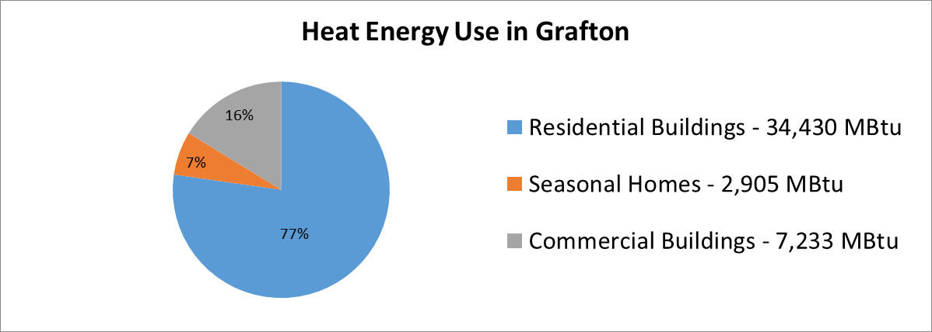

Figure #3

For residential buildings, it was assumed that average annual heating load per residence is 110 million Btu per year, for both space and water heating (Vermont state average). With 313 primary housing units in the town, this arrives at an estimated 34,430 MBtu annual total heat consumption. This translates to an estimated $650,000 spent in home heating in Grafton during 2014 (roughly $570,000 from primary residence owners and $82,000 from seasonal home owners).

90% of Grafton’s heating source is either from fossil fuels or wood. Wood is an abundant, locally grown energy source. Many residents own their own woodlots and processing and selling firewood is part of Grafton’s economy.

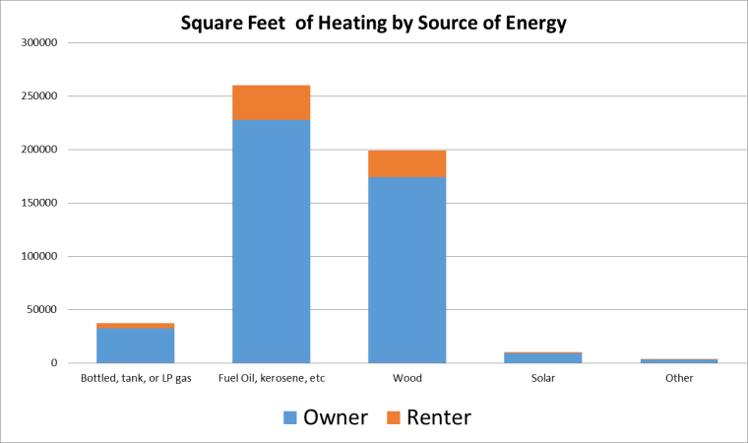

Figure #4

Our data source identified only seventeen (17) commercial buildings in Grafton. It is estimated that the average heating load of these establishments is 425 MBtu per year per building, which is well below the state average range of 700 MBtu to 750 MBtu per year per building. Based on these numbers, we estimate that commercial establishments use approximately of 7,225 MBtu’s per year in Grafton. There was no data on the annual heating costs for commercial buildings.

### Total Energy Costs

In sum, Grafton pays a staggering amount in energy across the three use sectors. The total estimated cost to the town for electricity, heating, and transportation is roughly $2.3 million per year. There are significant financial incentives for the town to move toward energy efficiency, on behalf of both the residents and its business owners.

|  |  |  |
| --- | --- | --- |
|  | **Total Energy Consumption** | **Total Energy Expenditures** |
| **Electricity** | 17,040 MBtu | $716,625 |
| **Heating** | 44,568 MBtu | $994,584 |
| **Transportation** | 36,818 MBtu | $650,996 |
| **Totals** | **98,426 MBtu** | **$2,362,206** |

Table #2

Figure #5

## Grafton’s Energy Resources, Constraints, & Potential for Power Generation

Energy resources available in Grafton include wood, solar, wind and hydro energy. There is significant data available to make informed decisions about wind and solar energy, but there is less data available in regards to wood and hydro energy. Grafton’s most used local energy resource is wood, which is renewable; almost 40% of the heat produced in Grafton is generated from wood. Continued burning of wood, along with the use of high efficiency wood stoves will be encouraged by the Town.

As new power generation sites are considered, care must be taken not to significantly alter both the village and the surrounding scenic landscape, because Grafton’s most valuable resource is its dense historic village surrounded by its rugged, scenic landscape, including its undeveloped ridgelines.

Wind energy has been a controversial and often talked about subject in Grafton since 2012, when an international wind company proposed a 28 turbine facility to be located on a large ridgeline that spans the Grafton and Windham town line. On November 8, 2016, with a vote of 235 “No” votes to 158 “Yes” votes, the town voters rejected Article 1. “Shall the registered voters of the Town of Grafton support development of the Stiles Brook Wind Project, as proposed by Iberdrola Renewables, to be located on the Stiles Brook Forest, owned by Meadowsend Timberlands, LTD.?”

Finally, the rivers and streams that flow through Grafton have potential for hydroelectric energy generation. At this high elevation, Grafton lies in the headwaters of the Saxtons River watershed. These headwaters are delicate ecosystems and must not be disturbed. Flooding of the village, as well as surrounding areas is also a concern. Any development of hydroelectric power should utilize run-of-river diversion with no significant impoundment of water.

### Resource Mapping Process and Policy Tool

The maps[16] referred to in this chapter were developed using state-wide GIS data that modeled resource potential for solar and wind energy and identified potential constraints on renewable energy development. They will provide future energy planners and developers with a “coarse screen” method to roughly identify areas in Grafton that may have energy generation potential. They are not siting maps. Further site analysis would need to be done to determine if a proposed generation facility is appropriate and comports with Grafton’s Town Plan policies. The maps were used by the Grafton Planning Commission to help determine Land Areas and to develop Goals, Policies and Recommendations. Maps included are:

##### **Possible Constraints for Energy Maps**

##### **Map 1** includes Hydric Soils, FEMA Special Flood Hazard Areas, Protected Land (state fee lands and private conservation lands), Deer Wintering Areas, and Vermont Conservation Design Highest Priority Forest Blocks

##### **Map 2** includes Agricultural Soils and Act 250 Soil Mitigation Areas

##### **Known Constraints for Energy Generation Map** shows Vernal Pools, Class 1 and 2 Wetlands, DEC River Corridors and/or FEMA Floodways, National Wilderness Areas, State-Significant Natural Communities, and Rare, Threatened, and Endangered Species

##### **Solar Resource Map** shows land generally suitable for solar energy generation, excluding slopes steeper than 15%

##### **Wind Resource Map** shows land generally suitable wind for residential generation, small scale commercial generation, and large scale commercial generation.

##### **Solar Energy Potential Map** shows Prime and Secondary Solar Energy areas.

##### **Wind Energy Potential Map** shows Prime and Secondary Wind Energy areas.

### Solar Resources

The Solar Resource Map indicates that the Town of Grafton has similar modeled solar resource availability as compared to other towns in the region. The Town supports solar facilities that are properly sited, where development conforms to the siting policies outlined in this Town Plan.

* Total acres in Grafton 24,456 acres
* Total acres available for prime solar with no constraints 659 acres
  + *Percentage of Grafton land available for prime solar 2.7%*

Large scale solar projects require access to three phase transmission lines. Grafton has limited access to three-phase power, with lines only along Route 121 from Cambridgeport to the village and along Fisher Hill Road. Grafton also has a high voltage transmission line cutting across the southern and western corner of the town. This greatly limits viable locations for large scale solar projects.

### Wind Resources

The Wind Resource Map indicates that the mountains on the western border of the Town and several isolated ridges within town are the only commercially viable location for “generally suitable wind for large scale commercial generation”. Residential Wind facilities may be acceptable as long as they conform to regulations for that respective land use, and do not adversely affect the surrounding landscape, forest blocks, habitat connectivity, or communities through the diminishment of the natural environment, economics, or human health.

|  |  |  |
| --- | --- | --- |
| **Description** | **Area** | **Percentage** |
| Total acres in Grafton | 24,456 acres | 100% |
| Total acres in Grafton available for wind with no constraints | 1,568 acres | 6.41% |
| * + - Residential Wind (under 40 meters tall) | 1,210 acres | 4.95% |
| * + - Small Commercial Wind (between 40 and 70 meters tall) | 289 acres | 1.17% |
| * + - Utility Wind (over 70 meters tall) | 69 acres | 0.28% |

Table #3 (Source: Vermont Center for Geographic Information (VCGI)

**Grafton’s Preferred Locations**

Grafton supports locally sourced and power generation facilities in a manner that supports existing and proposed land use designations, does not adversely affect the landscape pattern or character of the Town, and supports positive community development.

Grafton supports power generation development in locations that are previously disturbed and do not offer significant opportunities for future development. These areas may include former gravel pits, former and existing parking lots, landfills, etc. Consideration should be given to these under-utilized and previously disturbed areas that exist within the areas modeled to have prime resource potential,[17] and do not conflict with existing and proposed designated land uses.

Areas of special consideration should be all publicly owned lands and buildings. Solar is a particular asset that can directly supplement the electric power requirements of municipal facilities. Solar sited on public lands provides an educational value for citizens and landowners considering solar power generation.

Other areas that are highly desirable for energy production are lands located on or adjacent to agricultural and forestry lands. Grafton understands it must work to preserve its agricultural heritage and facilitate commercial agriculture. Farms that utilize renewable energy generation to augment their farm revenue may be highly desirable. While energy generation must be clearly subordinate to the agricultural land use, energy income will bolster existing farms and create an impetus to open new farms in our community.

Effective land use planning can promote energy conservation. Targeting new power generation development toward areas located close to the community's major roads and existing settlements will minimize the energy consumed by residents commuting, and will reduce the energy required to deliver essential services to residents and businesses.

Factors that the Town would look favorably upon in determining a preferred site designation would include:

* Proximity to 3-phase power – this means a solar facility does not need to have a line upgrade
* Located near the end of utility distribution lines – this helps support the electric grid
* Aesthetic considerations – ensuring viewsheds are not impacted by the appearance of renewable energy facilities.
* Existing roads – important to have existing access without requiring a developer to upgrade roads.
* Minimal impact of agriculture and agricultural soils – this is the path of least resistance for energy companies and we should not endanger our future ability to produce food.
* No obstruction of wildlife and habitat corridors as well as riparian buffers.

South facing slopes with low quality agricultural soils. These areas have high solar value, but otherwise low value as working landscapes.

**Areas Unsuitable for Renewable Energy Siting**

##### As shown in the Known Constraints for Energy Generation Map[18], there is a suite of geographic characteristics that are deemed to exclude any energy generation development. They are mapped vernal pools, Class 1 and 2 wetlands, DEC River Corridors and/or FEMA floodways, and State-significant Natural Communities and Rare, Threatened, and Endangered species.

The Possible Constraints are a set of data layers that don’t necessarily exclude energy development, but give a signal to potential developers and planners that more site analysis may be required. These layers include steep slopes, hydric soils, FEMA Special Flood Hazard Areas, Protected lands, deer wintering areas, Vermont Conservation design highest priority forest blocks, habitat connectivity, and agricultural soils. If generation facilities are proposed in these areas, due diligence is required in the siting of those facilities to ensure there are no adverse impacts.

In addition to these state-identified constraints, power generation facilities may not be suitable along high elevation lands, ridgelines, and any areas immediately viewable from our historic village and hamlets. Installations are not suitable if they have undue adverse impacts to cultural or historical resources including state or federally designated historic districts, and structures. These constraints do not prohibit the Town’s ability to reach the energy generation targets identified in the resource acreage analysis above.

## Grafton’s Energy Targets and Conservation Goals

##### The Windham region was given an overall renewable energy generation target, as determined by the Department of Public Service, based on its percentage of the state’s population (which directly affects its share of statewide consumption). The Windham Regional Commission (WRC) then determined energy generation targets for each of their member-towns, based on both the resource availability in town and its population. The resulting town generation targets are an average between those two characteristics.

### Power Generation Targets

According to Vermont’s 2016 Comprehensive Energy Plan, in order to meet the state’s overall goals, Grafton should be generating approximately 949 megawatt-hours (MWh) of power per year by 2050. This goal is based on averaging the following two calculated numbers:

##### The Town’s Share of the Regional Population 854 MWh/year

##### Share of Regional Resource Availability 1,043 MWh/year

##### Average 949 MWh/year

This goal includes the following benchmark targets:

##### **Year Energy Generation/Year**

##### 2018 (present generation) 85 MWh

##### 2025 263 MWh

##### 2035 422 MWh

##### 2050 949 MWh

As the following table and graph shows, even if Grafton meets the energy production goal above, it will have minimal impact on the overall amount of energy we will still need to import. That said, we believe that, as a Town, we must do our part, no matter how small to contribute to the larger cause.

|  |  |  |  |  |
| --- | --- | --- | --- | --- |
| **Energy Source** | **2017** | **2025** | **2035** | **2050** |
| Imported | 32,144 MWh | 31,966 MWh | 31,808 MWh | 31,281 MWh |
| Local | 85 MWh | 264 MWh | 422 MWh | 949 MWh |

Table #4

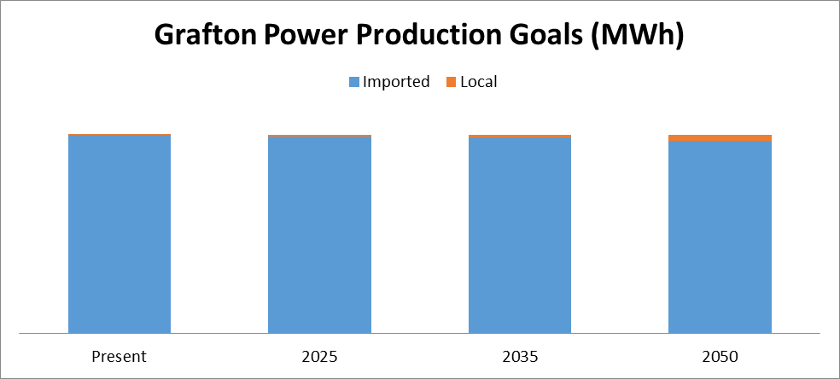

Figure #6

Grafton believes this goal can be met through the installation of a series solar photovoltaic arrays. In order to meet the goal of 949 MWh of electricity per year, 730 KW of solar photovoltaic will need to be installed. Using 60 acres of land per megawatt of electricity as an extreme high estimate, it will require the identification of 44 acres of solar capable land to be set aside as a "safety net". On average, solar installations actually require about eight acres per megawatt, which means Grafton will need approximately six acres of land for solar photovoltaic panel installation to meet the goal.[19]

Although localized power generation can occur in the town and supply its residents with reliable, affordable, and clean power, the town is also challenged by the current amount of energy being used. In order to minimize the amount of energy generation required, the town must also develop strategies to reduce the amount of energy consumed.

### Projected Energy Use: LEAP Model Results

To help inform the town’s policies on energy conservation measures, the town used guidance from the Long-Range Energy Alternatives Planning (LEAP) system model, conducted by the Vermont Energy Investment Corporation as part of the state’s comprehensive energy planning initiative.

The LEAP model is used to guide the state’s regions towards reducing the amount of greenhouse gas emissions and consuming 90% renewable energy by 2050 (referred to as the “90x50” goal). To accomplish the state’s energy goals, there are several interim benchmarks built into the LEAP model which ensure a progressive pace in attaining that “90 x 50” goal. The state energy goals are:

1. Reduce greenhouse gas by 50% from 1990 levels by 2028 and by 75% by 2050.
2. Supply 25% of energy through renewable resources by 2025 (25 x 25)
3. Increase building efficiency of 25% of homes (80,000 units) by 2020.

Incorporating those goals into the model produced power generation, conservation, and fuel conversion targets for benchmark dates for all regions in the state, and is informed by the region’s current energy profile. The WRC received the results from this model and was tasked with making those results relevant to its member-towns. The WRC therefore divided its region-wide benchmark targets among its towns based on a number of factors including population, types of residences, and number and type of commercial buildings.

The following paragraphs and figures show Grafton’s LEAP model results, and how much energy could be conserved in order to reduce the burden of energy generation facilities in the region.

### Residential Heating Conservation & Fuel Conversion

In order to determine how much energy would have to be conserved, combined with fuel conversion to renewable energy, the LEAP model produced both a “Reference” and “90x50” scenarios. The Reference scenario is meant to depict energy use over decades if no major changes were made in Grafton’s energy profile. The “90x50” scenario shows the pathway that Grafton will adopt in order to reduce greenhouse gas emissions, conserve energy, and generate renewable energy so as to meet the state’s goals. It is another data estimate that serves to help inform the Town to develop its own policies for energy conservation and fuel conversion.

Figures #7 & #8 show the LEAP results for Grafton’s residential and commercial heating sectors. In both the Reference and 90x50 scenarios, energy consumption is modeled to decrease (because of technological improvements, building innovation, and home efficiency improvements). However, the 90x50 scenario shows a sharper increase in the amount of energy conserved in residential heating.

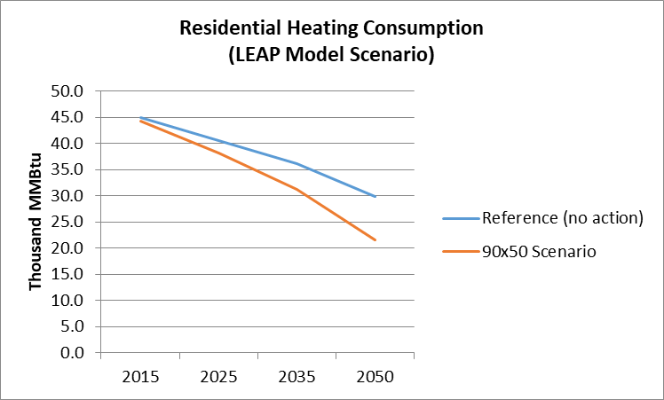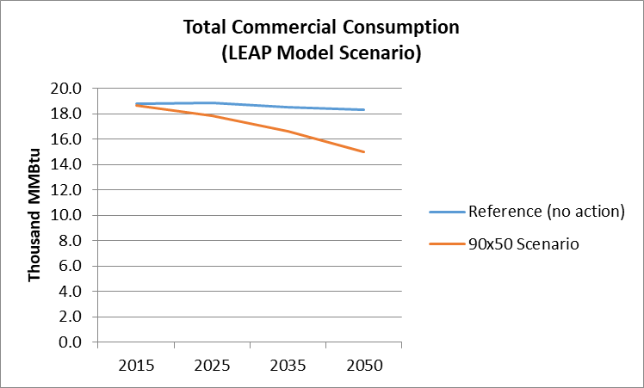

Figure #7 Figure #8

Figures 9 & # 10 show Grafton’s energy conservation targets through 2050. Not only will energy need to be solely conserved by building efficiency measures, but fuel conversion to more efficient energy sources will be promoted.

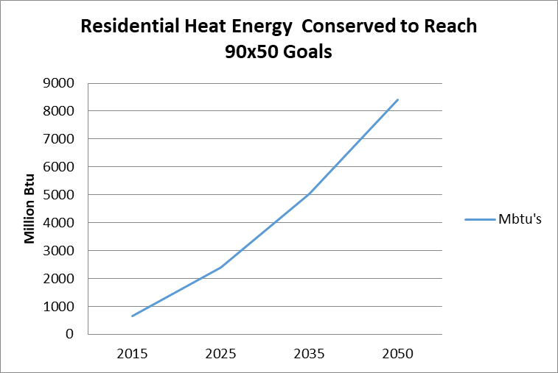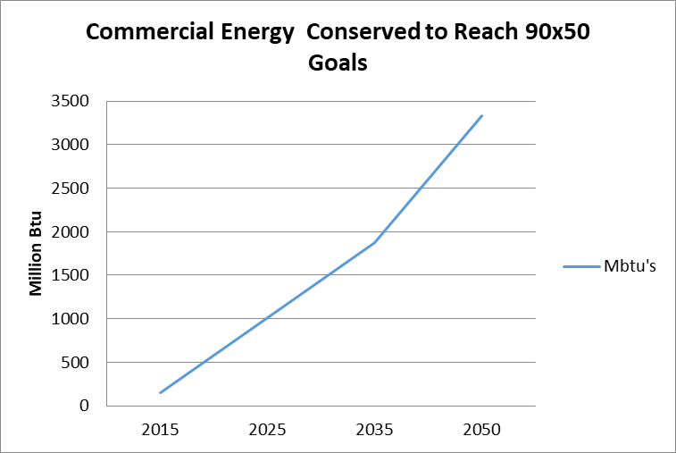

Figure #9 Figure #10

In order to attain the overall energy goals, the following energy efficiency targets have been established for Grafton.

**Grafton Weatherization and Energy Efficiency Improvement Goals**

|  |  |  |  |
| --- | --- | --- | --- |
| **Residential Thermal** | | | |
| **Sector/Use** | **2025** | **2035** | **2050** |
| Estimated number of municipal households to be weatherized. | 69 | 134 | 276 |
| Percent of municipal households to be weatherized | 14% | 28% | 57% |
| **Commercial Thermal** | | | |
| **Sector/Use** | **2025** | **2035** | **2050** |
| Estimated number of commercial establishments to be weatherized. | 2 | 4 | 7 |
| Percent of commercial establishments to be weatherized. | 9% | 16% | 30% |
| **Electricity** | | | |
| **Sector/Use** | **2025** | **2035** | **2050** |
| Electrical energy to be conserved, annually. | 307,500 KwH | 502,500 KwH | 735,000 KwH |
| Percentage of homes and buildings to be upgraded with electric efficiency improvements. | 42% | 68% | 100% |

Table #5

Additionally, the LEAP 90x50 scenario has set the following ‘Fuel Switching’ goals for Grafton between now and 2050.

**Grafton Fuel Switching Goals**

|  |  |  |  |
| --- | --- | --- | --- |
| **Residential and Commercial Thermal Fuel** | | | |
| **Sector/Product** | **2025** | **2035** | **2050** |
| New high efficiency wood stoves | 169 | 156 | 146 |
| New wood pellet systems only (in units) | 36 | 39 | 49 |
| **Residential and Thermal Fuel** | | | |
| **Sector/Product** | **2025** | **2035** | **2050** |
| New heat pumps (in units) | 64 | 126 | 178 |

Table #6

### Transportation System Changes

Transportation-related efficiency strategies are a very significant part of Grafton’s efforts, since transportation represents a significant portion of the energy demand. Simple changes, such as ride-sharing, combining trips and using alternative transportation, will conserve fuel and reduce wear and tear and maintenance costs on individual vehicles. Fuel efficient and electric cars will use less gasoline and emit less pollution.

The LEAP model created benchmark targets for both light and heavy duty vehicles, assuming a difference in residential and industrial energy needs and changes over time. Below are the two interpretations of these sector’s efficiencies over time.

### Light Duty Vehicles

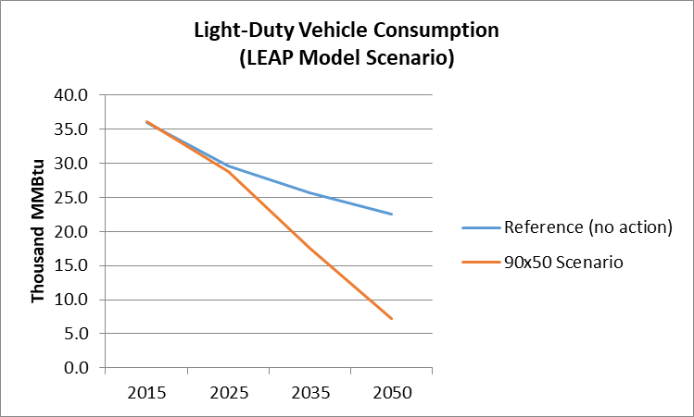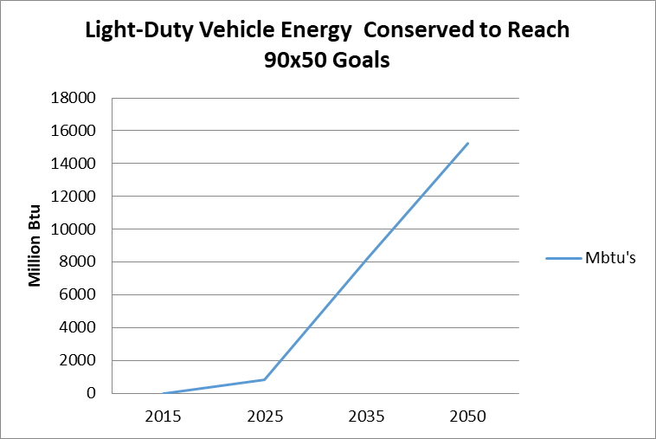

Figure #11 Figure #12

### Heavy Duty Vehicles

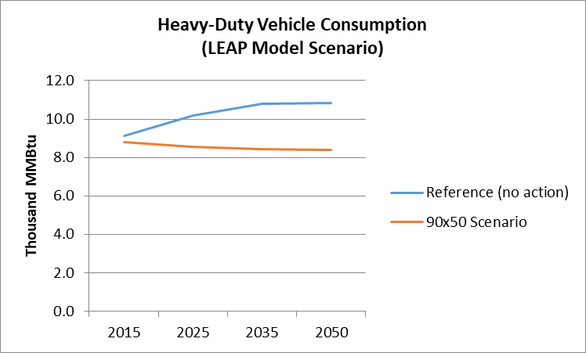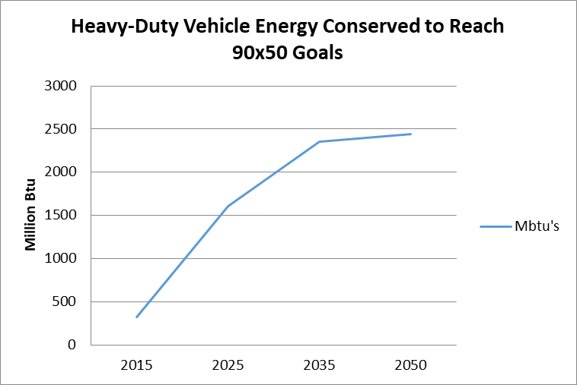

Figure # 13 Figure # 14

Light-duty vehicle consumption represents a larger portion of the total amount of energy consumed by the transportation sector, and there is a large amount of energy conservation required. The LEAP model projects much of this conservation of energy comes from the electrification of the vehicle fleet, especially as market demand changes and technology improves. This reduction in gasoline consumption and electrification of the car motor comes in addition to increased cluster developments and other land use changes that improve the efficiency of our community’s transportation network. The following goals are identified by the 90X50 model for the town’s transportation fuel conversion:

Figure #15

Heavy-duty vehicle consumption doesn’t show the same curves as per light-duty vehicles, since commercial and industrial applications for this vehicle fleet isn’t anticipated to change as much. However, efficiency in this sector is achieved by changing the fuel type for these vehicles from diesel to bio-diesel.

### Electricity Conservation

In the “Reference Scenario’ electricity rates are anticipated to increase over the benchmark years, due to a combination of more amenities, appliances, and motors being supplied by electric power, and an increase in the number of people using those products. The 90x50 scenario promotes electricity conservation in the form of energy-efficient appliances, lighting, and heating/cooling. Pursing these upgrades, the town is targeted to save the following through electrical conservation measures:

|  |  |  |  |  |
| --- | --- | --- | --- | --- |
| **Goals** | **2015** | **2025** | **2035** | **2050** |
| **Number of Buildings to be Upgraded** | 21 | 69 | 134 | 276 |
| **Energy Savings Goals** | 161 MWh | 599 MWh | 978 MWh | 1,431 MWh |

Table #7

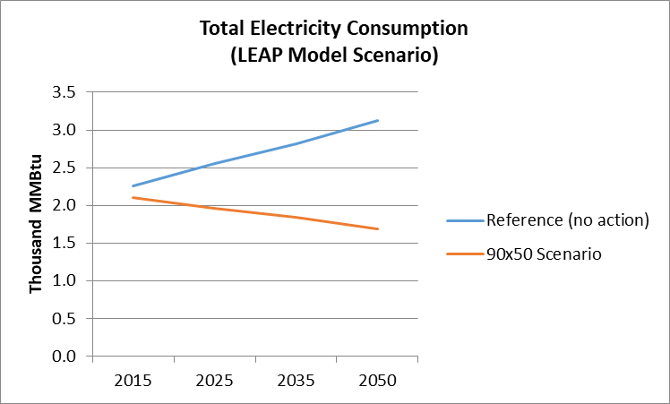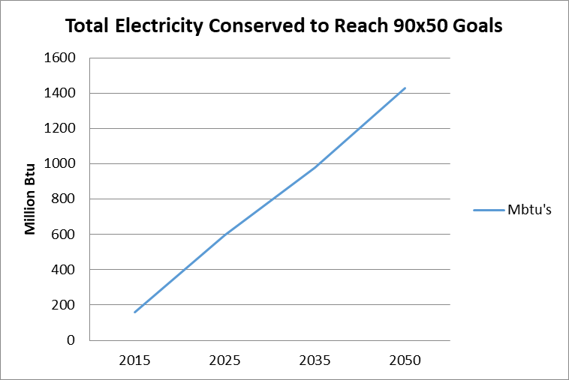

Figure # 16 Figure # 17

### Conservation and Efficiency Strategies

With total annual energy expenditures in the Town of approximately $2.36 million, there is considerable opportunity for savings from various energy conservation and improved efficiency measures. Because most of the energy use in Grafton is for private uses (home heating, commuting, etc.), savings would accrue primarily to residents. Public education is one of the most effective strategies to bring about savings through energy conservation and improved efficiency, though there are some specific policies that can also move the community in that direction.

Most new residential and commercial construction in Grafton is guided by the Vermont Building Energy Standards through the use of air sealing, insulation, heating systems, and weatherproof windows and doors. Current building codes provide basic energy efficiency standards for buildings; however, technology advancements have generated higher standards such as net-zero energy construction standards in which buildings generate as much energy as they consume. Green construction and LEED Construction (Leadership in Energy and Environmental Design) standards promote the use of natural, recycled and durable building materials, as well as energy efficiency. These efficiency standards are also applied to landscaping, advocating for native plantings that are low maintenance.

The siting, design, and construction of buildings strongly influences the amount of energy needed for heating as well as the amount of electricity needed for lighting. Proper subdivision design, building orientation, attention to solar access by easement, construction and landscaping provide opportunities for energy conservation such as less vehicular travel, and by designs incorporating passive solar space and domestic hot water heating, natural lighting and photovoltaic electricity production.

Energy savings can be realized by retrofitting existing buildings with air sealing insulation, installing high-performance windows and doors to reduce heat loss, weather-stripping, replacing incandescent lights with LED’s, and using energy efficient appliances.

### Programs and Organizations Available to Support Grafton’s Energy Goals

Southeastern Vermont Community Action (SEVCA) is the service provider in Windham County that runs the Weatherization Assistance Program. Weatherization services, which include an energy audit, diagnostic tests, analysis and installation measures, are available at no cost to income-eligible homeowners and renters. SEVCA is also available to help in the event of a heating emergency. They can help purchase oil, kerosene, propane or wood. In addition, they also work with electric companies in order to prevent disconnection and help negotiate payment plans.

Efficiency Vermont is the State’s provider of energy efficiency services. They provide technical and financial assistance to electrical consumers for the purpose of improving the efficiency of existing and new facilities.

ENERGY STAR Home Rebates are available for homes that meet strict energy efficiency guidelines set by the U.S. Environmental Protection Agency and U.S. Department of Energy. Efficiency Vermont provides free financial, design, and technical assistance to help build an ENERGY STAR qualified home. Benefits of being an ENERGY STAR home include financial incentives such as product rebates; utility savings; higher resale value; increased comfort and air quality; and other environmental benefits.

Vermont Housing Finance Authority’s Energy Saver Loan Program, administered by Windham Housing Trust, offers low interest loan funding for homeowners for an energy audit and improvements specified in the audit.

## Goals, Policies & Recommendations

### Goals

1. Residents of Grafton will have access to a reliable, sufficient, and economical energy supply for heating, transportation and electrical use without causing undue adverse impacts to humans and the environment.
2. The Town of Grafton will increase its overall energy conservation and efficiency annually in line with the 2050 LEAP goals through a variety of means including, but not limited to: weatherization, installation of fuel efficient heaters, including heat pumps, and wood and pellet stoves.
3. Residents will have access to safe, convenient, economical, and energy efficient transportation systems including options such as public transit and paths for pedestrians and bicyclists, where appropriate. Future land development will consider transportation needs of future residents.
4. Appropriately scaled and sited energy generation technology will be planned and constructed as Grafton does its part to help the state meet the 2050 energy goals.

### Policies

1. The Town of Grafton will reduce total energy use by promoting energy conservation and efficiency measures and a shift toward renewable energy sources.
2. The Town of Grafton will work to reduce transportation energy demand and single-occupancy vehicle use, and encourage the use of renewable or lower-emission energy sources for transportation.
3. The Town of Grafton will promote appropriate land use patterns and development densities that result in the conservation of energy.
4. The Town of Grafton will locate zones and/or areas appropriate for renewable energy generation based on resource potential and development constraints. With regard to all energy generation, transmission, and distribution projects:
   1. Adhere to a high environmental standard that includes avoiding negative environmental impacts to the extent possible and adequately minimizing and mitigating those that cannot be avoided;
   2. Conduct thorough and proper studies and analyses of all anticipated socioeconomic and environmental impacts, both positive and negative;
   3. Adequately address all areas of concern regarding proposed developments; and
   4. Effectively and adequately address all issues related to facility operation and reliability.

### Recommendations for Action

1. The Energy Coordinator, in conjunction with the Selectboard, the Planning Commission and others, should
   1. facilitate the retro-fitting of existing structures with energy saving measures such as air sealing insulation, energy efficient windows, heating equipment, and energy efficient appliances.
   2. encourage appropriate energy conservation and efficiency measures and alternative energy generation by individuals and organizations through public education, awareness, and engagement. Activities might include:
      1. providing resources to residents on energy conservation, efficiency, and renewable fuel options.
      2. working with the Grafton Elementary School to develop an energy awareness curriculum.
      3. educating residents of state energy codes.
   3. locate public lands that are appropriate for renewable energy generation.
   4. encourage the reduction of outdoor lighting costs by the use of energy-efficient lighting fixtures and motion sensitive security lighting.
   5. examine opportunities for providing home energy audits for resident and property owners so that they may take action to conserve energy and reduce related costs.
   6. promote Go! Vermont (www.connectingcommuters.org) on the town website and examine ways to facilitate car and van pools and ride-sharing.
2. Alternative Fuels
   1. Promote switching to wood, liquid biofuels, biogas, geothermal, and air sourced heat as fuel sources, when applicable.
   2. Promote other suitable devices such as advanced wood heating systems and cold-climate heat pumps, or other energy efficient heating systems.
   3. Identify potential locations for, and barriers to, deployment of biomass district heating systems preferably configured as combined heat and power systems.
3. Conservation
   1. Support the use of energy efficient appliances, heating units, lighting, and other powered devices.
   2. Support programs for insulation and weatherization of new and existing dwellings, especially for low and moderate-income households.
   3. The Town’s Administrative Officer should inform homebuilders about the Vermont Residential Building Energy Code and encourage contractors to file certificates of compliance upon completion of construction.
   4. Commit to energy conservation in all Town properties, facilities, and vehicles by conducting energy audits on all town properties and other facilities and prepare an energy efficiency improvement plan that emphasizes energy reduction and efficiency as facilities are upgraded, replaced, or expanded.
4. Transportation
   1. Examine the feasibility of creating a park-and-ride facility within walking distance of Grafton Village
   2. Investigate locating additional electric vehicle charging stations in Grafton Village.
   3. Encourage the increased use of public transit, as appropriate.
   4. Promote a shift away from single-occupancy vehicle trips through strategies identified in the Transportation chapter.
   5. Encourage, through transportation policies, opportunities for walking, and cycling, or other energy efficient alternatives to the automobile. The Town should consider implementing improvements that encourage safe and convenient walking and biking.
   6. Examine the creation of bicycling corridors between Grafton and Bellows Falls and between Grafton and Chester to promote seasonal commuting and tourism. This will include prioritizing design of highway and bridge upgrades to include space such as safe shoulders and separate lanes, when space allows, enhancing safety when bikers are passed by motorists.
   7. Promote the individual use of electric vehicles over fossil fuel vehicles.
   8. Consider current and future technological advancements for fuel efficiency as part of the decision-making process during the purchase of future Town vehicles.
5. Land Patterns
   1. Protect the Town’s historic settlement pattern of thickly settled villages and hamlets and open landscapes from undue adverse impacts associated with commercial energy generation and new transmission facilities.
   2. Minimize the need for new facilities and reliance on the private automobile by directing development to designated concentrated development and limiting such development in the least accessible areas of the community.
   3. In conformance with Act 171, promote land use and conservation policies that protect forest blocks and habitat corridors. Encourage ongoing forest management to maintain a local source of fuel-wood harvested no faster than regeneration. Encourage local farms to maintain and increase the supply of locally produced food.
6. Energy Generation and Distribution
   1. Support appropriate energy generation, including biomass using local wood supplies, solar, and dispersed residential wind, solar and hydro-power sources in Preferred Areas in Town. The Selectboard and Planning Commission should clearly identify the criteria for these areas.
   2. Small-scale active and passive solar installations, specifically on rooftops, rather than larger scale ground mounted utility installations should be prioritized.
   3. Support residential wind generation facilities where there are no adverse wildlife, ecological, or sound effects to nearby residences.
   4. Support small-scale micro-hydro systems along small streams where there are no adverse impacts on natural resources.
   5. Discourage utility-scale and commercial-scale wind energy generation.
   6. Encourage any potential commercial generation facilities to be within the areas deemed most suitable as described in this Enhanced Energy Element and within the Energy Generation Potential maps, and maximize potential for those facilities in these preferred areas.
   7. Support residential and commercial sized net-metering energy production projects where siting constraints are favorable.
   8. When considering upgrades to or expansion of transmission infrastructure or 3-phase power lines, encourage the strategic development of energy generation facilities so that community centers and local businesses may benefit from the infrastructure upgrades, thereby maximizing positive community development overall.
   9. Promote the siting of renewable energy generation facilities within compatible Land Use districts, namely within Productive Rural Land in such a manner that minimizes site disturbance and development, reduces impacts on local roads and infrastructure, and maximizes energy resource availability so as to provide the most benefit.
   10. Encourage energy generation facilities in existing or prospective agricultural areas where the energy generation installations conform to, complement, or add value to the agriculturally-productive landscape or to the surrounding ecosystem services. The design of these facilities should complement existing agricultural operations.
   11. Discourage any renewable energy generation facilities in areas identified as unsuitable.
   12. Town of Grafton will demonstrate leadership by example with respect to the deployment of renewable energy by promoting energy generation facilities to offset the energy consumption of all Town buildings.
   13. Encourage an economically competitive energy conservation through increased operation efficiencies, technology upgrades, and availability of low-cost fuels,

# 6. EDUCATION

## K-12 Education System



Grafton Elementary School

Grafton values its local public educational system and the traditions of involving children in our community. The local school is the heart of the community. Keeping Grafton alive and well and sustaining high standards to meet the needs of a demanding and ever-changing society requires a commitment to an excellent educational system. The success of Grafton community’s school depends on meeting the needs of children early and providing the best possible educational resources. A quality school system is more likely to attract young and vibrant families to settle and remain as part of Grafton’s future.

Because of a combination of tax laws and a history of supervisory unions, Grafton students are offered their K-12 public education through a somewhat convoluted organizational structure, with multiple school districts and different school boards. Along with Rockingham, Athens and Westminster, Grafton is one of four towns in the Windham Northeast Supervisory Union (WNESU). The WNESU has one superintendent and seven school boards including one for each of the four towns, one for the Grafton/Athens Joint Contract, one for Bellows Falls High School, and one for the overall supervisory union. A recent state law (Act 46) required supervisory unions to merge and become ‘union districts’. This would eliminate the seven existing school boards and create one K-12 school board. Grafton voted against this merger at the 2017 Town Meeting, as did the other three towns in the WNESU. The Vermont State Board of Education voted in October 2018 to force the merger of three of the four WNESU towns; Grafton, Athens, and Westminster. Rockingham was not included because it has a different operating structure.

At this point the supervisory union is one of a very few in the State that has been given a waiver and are not required to merge, but the future of the organizational structure and its impact on Grafton is unclear.

Although Grafton students attend a variety of educational institutions throughout their K-12 experiences, students can most clearly be represented by three groups, Elementary (Grades Pre-K through 6), Middle (Grades 7 & 8), and High School (Grades 9 through 12).

### Elementary School (Grades Pre-K through 6)

WNESU offers Pre-K services to all Grafton students in one of three locations around the supervisory union. The Towns of Grafton and Athens offer K-6 education at the Grafton Elementary School (the building) through the Athens/Grafton Joint Contract District (the school district). The Joint Contract District has three board members from Athens and five from Grafton and is part of the Windham Northeast Supervisory Union. Although Grafton students can attend any elementary school of their choice, the Town of Grafton only pays for tuition for those attending Grafton Elementary School.

The Grafton Elementary School houses 6 classrooms, a library, a gym/cafeteria, administrative space, nursing office, and counselor’s space. Each classroom is equipped with its own private bathroom and an emergency exit. The building is equipped with high-speed wireless internet service and each child has a Google Chromebook for educational uses, including but not limited to research-based projects, online tutorials in academics, submission of work via Google Classroom, writing/editing/publishing and even online games to bolster math and reading comprehension skills. Many of the educators utilize modern educational technology such as interactive touch display systems that replace traditional blackboards.

Grafton Elementary School serves breakfast, lunch, and snack to its students daily. Food services are contracted by WNESU through Café Services of Westminster. Menu options follow Federal Guidelines for a “Qualifying Meal” and include multiple servings of whole fruits and vegetables at each meal. When possible, the choices include local produce or other goods: the maple syrup served is from Plummer Farm!

##### The Grafton Elementary School building is also a multi-use building for other organizations in town. The building is also used for meeting space by town administrative offices, practice space for recreational sports teams and other youth groups within Athens and Grafton.

### Middle School (Grades 7-8)

##### Seventh and eighth grade students are allowed to attend virtually any middle school of their choice, including private and out-of-state schools. Tuition is paid for by Grafton taxpayers, with a maximum per student set by the State. Bellows Falls Middle School is part of the Windham Northeast Supervisory Union and provides transportation for Grafton students, but only hosts about one third of the students. Most of the other two thirds attend either Green Mountain Union High School in Chester and Leland and Gray Middle and High School in Townshend. Other middle schools attended in the recent past have also been The Compass School and The Putney Grammar School.

### High School (Grades 9-12)

##### As part of the Windham Northeast Supervisory Union, Bellows Falls Union High School is Grafton’s assigned high school. The town has a representative on the high school Board and provides transportation for Grafton students attending the high school. Because of Vermont’s ‘school-choice’ law though, Grafton high school students can attend any one of 14 high schools in the southeastern Vermont region. This does not include private or out-of-state schools. As with middle school, Grafton high school students are about equally divided between Bellows Falls High School, Green Mountain High School, and Leland and Gray High School.

##### During eleventh and twelfth grades students can also attend one of two regional career and technical centers as part of their high school experience. Students attending Green Mountain High School can attend the River Valley Technical Center (RVTC) in Springfield; students attending Leland and Gray High School can attend the Windham Regional Career Center (WRCC) in Brattleboro; and students attending Bellows Falls High School can attend either. The Vermont legislature passed Act 46 in 2015, creating a variety of additional pathways to graduation including early college entrance (VAST Program), online-courses, dual enrollment in college and work-based learning opportunities. Act 46 also changed high school graduation requirements from ‘credit-based’ to ‘proficiency-based’, which requires students to reach specific levels of proficiency in all subject matter before graduation.

### Student Enrollment

Although past data can show enrollment data for Grafton students, it is more difficult to disaggregate Grafton data from Athens data when making projections. The first of the two graphs below shows just Grafton students; the second graph includes both Grafton and Athens students. Until recently Grafton has had significantly more student-aged residents than Athens, but because of a combination of Grafton’s recent reduction in this age group and Athens’ recent increase, there are now more Athens students attending Grafton Elementary School than there are from Grafton.

## Educational Opportunities for Adults

Vermont's Adult Education and Literacy Programs – These programs are offered through Learning Works, Vermont’s Adult Education & Literacy system. Brattleboro and Springfield are the centers closest to Grafton. These programs offer services ranging from beginning to advanced literacy in math, reading, writing, interpersonal skills, workplace skills, general educational development, adult diploma programs, commercial driver's licensing, and basic computer instruction. Through the Adult Diploma Program, adults may earn a high school diploma from a local high school.

Community College of Vermont (CCV) – CCV is part of the State of Vermont College system, offering associate degrees, career-related certificates, and credit and non-credit training programs. Their curriculum includes liberal arts, business, human services, technology, and allied health. Grafton residents can take advantage of the advance study programs in Springfield and Brattleboro without the need to commute long distances. Currently there are sixteen associate degree programs and seven career certificates.

Howard Dean Center – The Howard Dean Center has a wide range of educational programs that are presented by businesses and colleges. The Center, located in Springfield, is a 90,000 square foot building that has a range of spaces and facilities to support educational programs. Classrooms, technology facilities, and even kitchen spaces have been created for educational uses.

Parks Place Resource Center in Bellows Falls – Parks Place provides adult education programs to include life skills training, vocational rehabilitation, and adult tutoring for preparation with the GED and High School Completion Program.

Distance Learning – These opportunities are available to everyone with access to a computer and high speed internet connection. Online programs require some on-campus commuting and so degrees and certificates offered by the New Hampshire and Vermont Community College System and State College External Degree Programs, University of Vermont and University of New Hampshire, and Norwich University Online provide a reasonable option for Grafton residents to further their education.

Other Opportunities – There are additional post-secondary educational opportunities that are accessible to Grafton residents. Multiple higher education scholarship opportunities exist including those sponsored by the Grafton Women’s Community Club, the Grafton Improvement Association and the Grafton Fire Auxiliary.

## Goals, Policies & Recommendations

### Goals

1. Provide effective and efficient educational facilities and programs for Grafton residents.
2. Develop a process for responding to changing educational needs and for assessing progress toward meeting those needs, in keeping with the values and aspirations of the Grafton community.
3. Help each student realize his/her potential, lead a successful and satisfying life, and making a meaningful contribution to our local and global communities.

### Policies

1. Assure that Town residents have input into the decision-making process and be aware of actions being considered by the Windham Northeast Supervisory Union (WNESU), the Union District #27 High School Board and the Athens/Grafton Joint Contract School Board.
2. Make certain that all Town students have an educational program, which motivates and equips them to become self-supporting and participating members of a democratic society.
3. Promote total literacy for all Town adults.
4. Encourage Grafton residents to apply for educational programs, which will equip them for new job opportunities.
5. Work to assure that all elementary school graduates are literate, mathematically competent, and emotionally prepared for the next level of education.
6. Work with regional educational organizations to encourage adult education at all levels and to make all adults aware of available courses.
7. Encourage Grafton Library and other community groups, including businesses, to be partners with the school to make full use of the human and organizational resources in Grafton.
8. Integrate technology into appropriate classroom activities and instruction.

### Recommendations for Action

1. The School Board should continue its efforts to maintain enrollment in the elementary school at an optimum class size through arrangements with neighboring school districts or by recruiting tuition students from outside the District.
2. Develop communication between the elementary school and both pre-school and childcare programs.
3. Continue using school facilities for adult education, informational programs, Town functions, and physical fitness opportunities.

# 7. HOUSING

An adequate supply of year-round housing which offers a variety of size, cost and location is essential to the economic and social health of the Town. It is a benefit to the Town when residents, new and long-time, can work in Town, their children are able to buy or rent a home in the Town, and elderly residents are able to remain in the Town with their families and friends. The social fabric of a community is stronger when work, home and family are within that community. Providing safe, affordable and convenient housing for all is a priority for Grafton and its neighboring Towns.

Because Grafton does not have zoning regulations, the requirements of 24 VSA 4412, as it addresses affordable housing, including mobile homes and accessory structures, do not negatively impact development in Grafton. The only limitation is the Town Plan, and only when there is a procedure, such as Act 250 hearings, where the Town Plan is a relevant development-regulating document. Thus, the opportunity and potential to develop affordable housing in Grafton is unlimited, except in Act 250 proceedings.

## Home Ownership

### Seasonal Housing

In 2010, seasonal/recreational housing accounted for 30% of all housing, up from 24.4% in 2000, and 7.7% in 1990. But the percentage dropped significantly by 2015. From 2000 to 2010, the number of housing units in Grafton increased by 12%, from 434 to 486 units, while total households rose by 8%, from 291 to 313.

Approximately 90% of Grafton’s housing stock is single family homes. Grafton has few manufactured homes (9%) and very few multifamily homes (1%). Based on Grafton’s January 2016 grand list, 29.5% of residential homes are valued at less than $150,000 which is a purchase price that is affordable for households earning an income of $47,614.

|  |  |  |
| --- | --- | --- |
| **Grafton Housing Values** | | |
| **Market Value** | **Number** | **Percentage** |
| **$50k or less** | 28 | 6.1% |
| **50-75K** | 26 | 5.6% |
| **75-100k** | 28 | 6.1% |
| **100-125k** | 24 | 5.2% |
| **125-150k** | 30 | 6.5% |
| **150-175k** | 29 | 6.3% |
| **175-200k** | 35 | 7.6% |
| **200-250k** | 74 | 16% |
| **250-350k** | 92 | 19.9% |
| **350-500k** | 50 | 10.8% |
| **$500k or more** | 46 | 9.9% |

### Housing and Income Analysis

According to the 2014 American Community Survey there were 319 households[20] in Grafton. The Median Household Income (MHI) in Grafton ($47,614) was lower than the MHI of Windham County ($50,526).[21] Approximately 46% of the Grafton households are at or above the county MHI.

|  |  |  |  |  |
| --- | --- | --- | --- | --- |
| **Grafton Household Incomes** | | | | |
| **Income** | **Households** | **Families** | **Married-Couple Families** | **Nonfamily Households** |
| Less than $10,000 | 20 | 14 | 7 | 6 |
| $10,000 to $14,999 | 21 | 8 | 8 | 13 |
| $15,000 to $24,999 | 23 | 9 | 2 | 17 |
| $25,000 to $34,999 | 48 | 35 | 29 | 13 |
| $35,000 to $49,999 | 58 | 36 | 31 | 22 |
| $50,000 to $74,999 | 36 | 23 | 23 | 10 |
| $75,000 to $99,999 | 61 | 45 | 45 | 16 |
| $100,000 to $149,999 | 33 | 25 | 23 | 8 |
| $150,000 to $199,999 | 7 | 4 | 4 | 3 |
| $200,000 or more | 12 | 12 | 12 | 0 |
| **Total** | **319** | **211** | **184** | **108** |

Source: U.S. Census Bureau, 2010-2014 American Community Survey 5-Year Estimates

### Selected Monthly Owner Costs

Approximately 34.3% (85) of the homes in Grafton don’t have mortgages. Of the 163 households with mortgages, approximately 87 (53%) spend $1,500 or less on their monthly mortgage.

|  |  |  |  |
| --- | --- | --- | --- |
| **Mortgage and Selected Costs Per Month** | | **Number of Households** | **Percentage** |
| **With a Mortgage** | **$0 to $499** | 0 | 0.0% |
| **$500 to $699** | 2 | 1.2% |
| **$700 to $999** | 37 | 22.7% |
| **$1,000 to $1,499** | 48 | 29.4% |
| **$1,500 to $1,999** | 27 | 16.6% |
| **$2,000 or more** | 49 | 30.1 % |
| **No Mortgage** | | 85 | 34.3% |
| **Totals** | | 248 | 100.0% |

2010 Census Data

The monthly mortgage is only one part of ownership costs. Many government agencies consider Selected Monthly Owner Costs (SMOC)[22] as an accurate measure of overall ownership costs. Selected Monthly Owner Costs that exceed 30 % of household income are considered excessive. Using this federal model, over 40% of Grafton residents have Selected Monthly Ownership Costs over 30% of their monthly household income. However, the model does not take into consideration Vermont’s Property Tax Adjustment for lower income households.

|  |  |  |  |  |  |  |
| --- | --- | --- | --- | --- | --- | --- |
| **Home Affordability Analysis** | | | | | | |
| **Home Value** | **Number of properties available at or below this valuea** | **Monthly mortgageb** | **Monthly taxesc** | **Other home related monthly expensesd** | **Minimum Household Income (MHI) needed to afford the home** | **Estimated percent of households able to afford the homee** |
| **$200,000** | 166 | $761 | $306 | $430 | $59,560 | 36% |
| **$150,000** | 101 | $571 | $230 | $429 | $48,960 | 46% |
| **$125,000** | 74 | $594 | $191 | $400 | $47,200 | 46% |
| **$100,000** | 55 | $380 | $149 | $375 | $36,200 | 60% |

*a Based on Grand List as of July 2016 from Town Of Grafton*

*b Calculation based on 80% mortgage, 30 yrs., 4% interest*

*c Based on 2015-16 Town Property Tax Rate, including School. Note that there is a Property Tax Adjustment based on income; this has a positive impact on some Grafton property owners.*

*d Insurance, fuel, electricity, water, sewer, estimated, as there is no hard data in the Census*

*e Based on 2010 Census of Median Household Income (MHI) for Windham County and 30% of MHI available for housing. Highlighted row is at the 30% monthly MHI of $1,224.*

|  |  |  |  |
| --- | --- | --- | --- |
| **Percentage Costs/Income** | **Number** | **Percentage** | **Percentage at or below this level** |
| **Less than 20.0%** | 51 | 31.3% | 31.3 |
| **20.0 to 24..9%** | 30 | 18.4% | 49.7 |
| **25.0 to 29.9%** | 15 | 9.2% | 58.9 |
| **30.0 to 34.9%** | 7 | 4.3% | 63.2 |
| **35.0% or more** | 60 | 36.8% | 100.0 |
| **Totals** | 163 | 100.0 | - |

Selected monthly owner costs as a percentage of Household Income (SMOCAPI) – 2010 Census Data - 163 owner-occupied units, excluding units where SMOCAPI cannot be calculated.

## Rental Properties

Gross Monthly Rent  
Gross Monthly Rent is similar to Selected Monthly Owner Costs and includes the monthly rent plus the estimated average monthly cost of utilities (electricity, gas, and water and sewer) and fuels (oil, coal, kerosene, wood, etc.) if these are paid for by the renter (or paid for the renter by someone else). Gross Monthly Rent is intended to eliminate differentials which result from varying practices with respect to the inclusion of utilities and fuels as part of the rental payment.

Grafton’s median Gross Monthly Rent for the period 2008-2012 was $930/month. In comparison, Windham County’s median Gross Monthly Rent was $771/month. According to the 2010 Census, more than 60% of residential units rented in Grafton cost less in Gross Monthly Rent than $1,224, which is 30% of the monthly Median Household Income for the County of Windham.

|  |  |  |
| --- | --- | --- |
| **Gross Rent per Month** | **Number**  **(63 total)** | **Percent** |
| **< $499** | 0 | - |
| **$500 to $749** | 25 | 39.7% |
| **$750 to $999** | 15 | 23.8% |
| **$1,000 to $1,499** | 23 | 36.5% |
| **$1,500 or more** | 0 | - |
| *(Median Monthly Rent - $881/Month)* | | |

2010 Census, Gross Rent on household units in Grafton (excluding units where GRAPI cannot be computed)

##### According to the 2010 Census, 44.4% of Grafton’s renter households had Gross Monthly Costs under 30% of the Median Household Income.

|  |  |  |
| --- | --- | --- |
| **Gross Rent as a % of Household Income** | **Number** | **Percent** |
| **Less than 15.0 percent** | 2 | 3.2% |
| **15.0 to 19.9 percent** | 5 | 7.9% |
| **20.0 to 24.9 percent** | 4 | 6.3% |
| **25.0 to 29.9 percent** | 17 | 27.0% |
| **30.0 to 34.9 percent** | 16 | 25.4% |
| **35.0 or more percent** | 19 | 30.2% |
| **Totals** | 63 | 100.0% |

2010 Census

## Conclusion

As for the State Goals for housing set forth in 24 VSA 4302, the Town of Grafton now by its daily practices meets and exceeds those goals. However, housing is still very expensive for people wanting to move into this community.

The Town encourages economic diversity of housing, single, multiple-family, rental units, accessory units, modular and mobile homes, as well as unfettered choices of location.

## Goals, Policies & Recommendations

### Goals

1. Continue to ensure the availability of safe and adequate housing.
2. Increase housing developments in Grafton of varying structural types to meet the needs of the elderly, disabled, low and moderate income working families, and those who, based on economic setbacks, need temporary and/or short-term housing.

### Policies

1. Encourage multi-family housing or higher density development of single family housing in some areas of town in order to provide for the housing needs of low and moderate-income residents.
2. Continue to monitor and review the housing needs of Grafton.

### Recommendations for Actions

1. Continue to review, promote, and support the promotion of the region and Grafton and their desirability as a place to bring business.
2. Promote residential development that meets the needs of diverse social, cultural and income groups.
3. Explore the possibilities of constructing senior housing in Grafton.

# 8. RECREATION

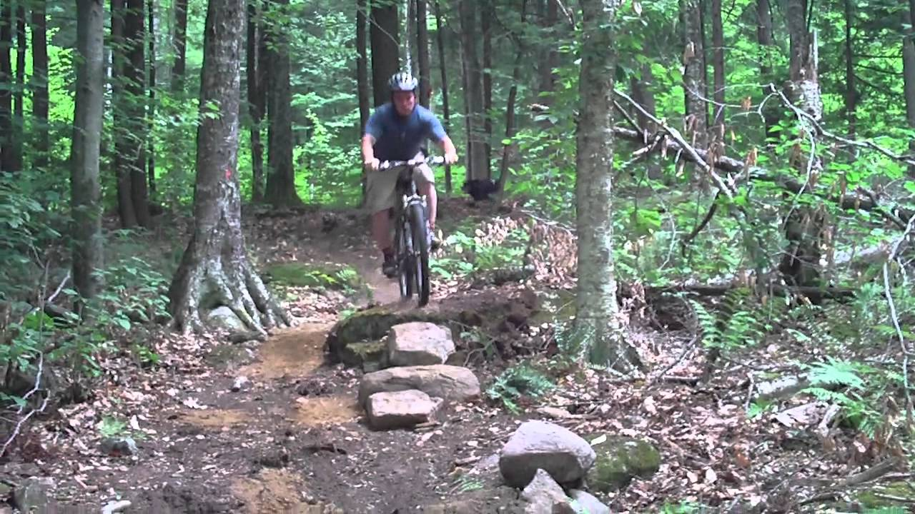The public recreation facilities in Grafton include the ball field, a natural swimming pond, and a 55-acre village park with footpaths and picnic sites. There are also miles of trails, unpaved roads, and forests used for hiking, biking, hunting, fishing, skiing, and horseback riding. Three state forests also exist within Grafton, they consist of the Mollie Beattie State Forest, the Putnam State Forest, and the John Dorand State Forest. These public facilities are used by schools, residents, and tourists. The Vermont Association of Snow Travelers (VAST) currently maintains over 30 miles of trails through these State Forests and privately-owned properties for snowmobiling.

The Windham Foundation provides recreational facilities, most of which are open to the residents, including a fitness center and tennis courts. Grafton Trails is a year-round outdoor recreation center run by the Windham Foundation. In the winter it offers 30 kilometers of Nordic skiing, snowshoeing, ice skating, and a 600-foot hill for snow tubing. In the summer, Grafton Trails offers more than 2,000 acres of mountain biking and hiking as well as paddle boats, disc-golf and weekly summer camps for kids. Equipment rentals, guided tours and lessons are also available. There are also walking paths starting in the village and ending at Grafton Trails that are maintained by the Windham Foundation as well. Along these paths, a sheep exhibit and blacksmith shop can be visited. For the 3rd of July, the Windham Foundation annually hosts the Vermont Symphony Orchestra followed by a fireworks display at the Grafton Ponds.

The Grafton Recreation Committee, a volunteer group, organizes many programs for children such as basketball, pee-wee baseball, Little League baseball, girls’ softball, and soccer.

In 1919 Doctor Gilbert deeded to the Grafton Improvement Association (GIA) 3.1 acres of land and a right-of-away next to his house for use as a town playground. It’s now used as a ball field and for other recreational events. The GIA supports the community in a variety of ways including providing portable restrooms for the town pool and Winnie Park, developing a hiking trail map of the area for residents and tourists, and financially supporting a variety of community events such as the Annual Town Picnic and the Trinity Riders horse shows and oxen pulls.

The Grafton Outing Club is recognized as an official snowmobile club operating under VAST, the statewide non-profit organization based in Berlin. The Grafton Outing Club grooms and maintains all the local area snowmobile trails. Contact information on the Grafton Outing Club can be found by visiting the VAST website

Grafton’s culture and recreational assets include an award winning history museum, the educational Nature Museum at Grafton, The Grafton Public Library, the Town Hall and the Grafton Cornet Band founded in 1867. There are a variety of privately owned art galleries and antique shops throughout the town. The Grafton Community Church (White Church) in Grafton, noted for its fine acoustics, attracts a number of excellent musical events each year. Other activities and events include Grafton Cares weekly community luncheon and suppers, Grafton Band concerts, as well as Grange and Church sponsored Sugar on Snow and Strawberry Suppers.

The Bellows Falls Area Senior Center and the Brattleboro Senior Center offer a range of social and recreational services for the senior population. Popular activities include lunches and dinners, lectures on special topics, and out-of-town trips. These regional senior centers augment the social, health, and recreational services provided by Grafton Cares.

The Windmill Hill Pinnacle Association is a nonprofit trails organization that operates in Grafton, Rockingham, and Athens. This group hosts trail hikes, provides trail building and ecology educational workshops, and provides maps for regional hiking trails. Groups like the Pinnacle Association can play a role organizing individual towns to plan, design, and build regional trail systems.

## Goals, Policies & Recommendations

### Goals

1. To maintain and develop recreational opportunities and facilities for youth and adults alike.
2. With the cooperation of the Grafton Improvement Association and others, upgrade and maintain the public recreational facilities in Grafton.

### Policies

1. Protect recreational lands and water areas whether used for sports, biking, hiking, fishing or hunting from being developed.
2. Ensure that there is access to these areas through existing Town right of ways or through the ancient road system.
3. Make sure that state laws and local ordinances are enforced in recreational areas concerning the use of snowmobiles and all-terrain or off road vehicles.

### Recommendations for Action

1. Encourage the groups already established to continue to maintain and upgrade the recreational facilities and explore new opportunities for residents and visitors alike.

# 9. TOWN GOVERNMENT AND SERVICES

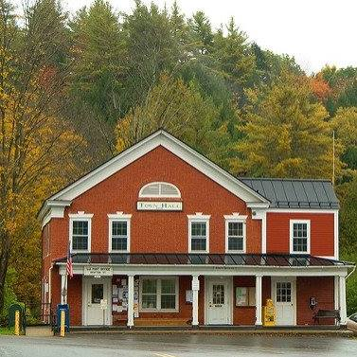

## Town Government

The majority of official business of the Town is conducted on the first Tuesday of each March at Grafton’s Annual Town Meeting. Additional Special Town Meetings have been called in the past as needed. All elected officials are chosen by Australian ballot, but the other items on the Warning are voted on at the Town Meeting. The five Selectboard members conduct most of the regular business of the Town between Town Meetings. In addition, the Selectboard appoints various subordinate committees and officials to focus on specific areas of Town governance.[23]

### Taxation

##### There are two types of property taxes in Vermont: local property taxes and the state education tax rate. Local property tax rates are determined by vote at Grafton’s Annual Town Meeting and used for town roads and other municipal expenses. For education funding, all real property is classified as either Homestead or Non-Residential. The Homestead tax is assessed to those living on the property they own. The rate is set based on a variety of factors including the over-all budget voted on at the Annual Town Meeting, the per-pupil spending in the local schools, and the state-determined common level of appraisal (CLA). Non-Residential Education Tax Rates are set by the state and are the same state-wide. The amount of municipal and educational taxes the individual property owner pays is determined by the assessed value of the property. Property values are determined by the Town’s listers, who are elected by the voters.

##### While residential properties can carry more than one third of the tax burden, vacation homes, woodland and commercial taxpayers have also shared significantly in the overall taxing structure. Non-residential homes and commercial timberland operations own a large portion of Grafton lands. Although subdivision and development of these large timber properties would increase the tax income to the Town, it would also add a heavy burden to the Town’s facilities and services, and change the culture of the town and therefore is not considered to be in the best interest of the Town.

##### Tax rates in Windham County are the highest in Vermont, and Vermont’s overall tax burden is the eighth highest in the country[24]. While commercial taxpayers may be able to pass increased tax costs along to their customers, at some point these increases make businesses less competitive and unprofitable, and may discourage businesses from expanding or locating within the Town.

Under state law, non-profit organizations may request special tax treatment and the Town may vote to reduce or fix assessments at a specific level for a specific period of time. The townspeople are, understandably, reluctant to grant special tax status unless the benefits to the Town as a whole are clear. At present the following non-profit organizations own real estate in the Town: Grafton Community Church, Grafton Improvement Association, Nature Museum at Grafton, Grafton Firefighter’s Association, Grafton Library, Grafton Historical Society (Museum Building), Faerie Camp Destiny, and the Windham Foundation.

### Capital Investment

Capital facilities include buildings, land, bridges, roads (not including annual maintenance), highway equipment, and other equipment valued over $5,000 with a life of seven years.

It was voted at the 1992 Town Meeting to establish a Capital Program. In August of the same year the Selectboard appointed Grafton’s first Capital Budget Committee. Reappointed annually, the committee is responsible for providing the Selectboard with the recommendation for a capital budget for the ensuing fiscal year and to update five-year Capital Program projections. The committee also studies the means of financing the Town’s capital expenditures and recommends the best methods of providing for such expenditures that are timely, cost-effective and avoid large year-to-year fluctuations in the tax rate. Sources of potential funding include reserves accumulated in prior years, current tax appropriations, State and Federal Aid, and grants-in-aid from private sources. The Committee is strictly advisory; the ultimate responsibility for decisions on capital investment and large-scale developments along with associated impact fees remains with the Selectboard and voters at Town Meeting.

Over the years Grafton has used the Capital Program to make significant improvements in its buildings and roads. Almost all Town bridges have been replaced or repaired in the last twenty years.[25] Other expenditures in the Capital Budget include computers and software for the Town Hall, some maintenance expenses of the Town Hall and Town Garage, and the Grafton Fire Truck Fund. Special projects such as the communications upgrade may also be funded at the request of the Selectboard.

Some scraping and painting of bridge steelwork remains to be done to selected bridges. Critical future Capital Budget needs include replacing Walker Bridge and some large culverts. Bank stabilization of gravel roads to ensure the safety of the traveling public is also an ongoing need.[26]

## Protective Services

### Fire Protection Services

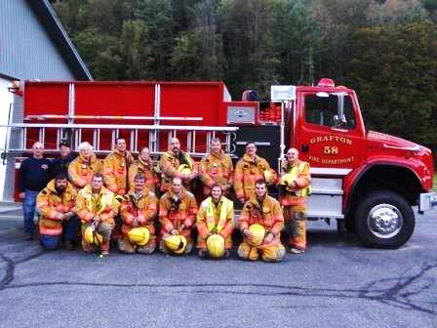The intent of the Grafton Firefighter’s Association is to provide the Town with the best level of fire protection that its resources will allow. First it protects lives and then property. It will work with any and all other emergency services in or out of Grafton to mitigate any emergency to which it is called.

The Village of Grafton has a fire pond and a gravity-fed system of hydrants that service the Village area.

The Fire Department is a small, totally volunteer department consisting of two fire trucks and approximately a dozen firefighters. They own the fire station building and the land it is on.

The personnel of the Fire Department consist of some who have been in the fire service for more than thirty years and others who have been volunteers for a matter of weeks. Some are trained to enter burning buildings and to perform rescues and interior firefighting. Others are learning the basics. It is the hope that the new volunteers will become fully trained. It is getting difficult to find people who are interested in going through the arduous and time consuming training that is required to become interior-qualified.

The Fire Department is dispatched through the Southwestern N.H. District Fire Mutual Dispatch Center located in Keene, N.H. and cooperates with neighboring towns in mutual aid. The chain of command in the fire department is headed by the chief who is responsible for the day-to-day operations as well as command at the fire scene. The chief is assisted by the assistant chief, the captain, and two lieutenants, who take over in the chief’s absence.

The Fire Department is funded by allocations from Town taxes and by private contributions. The Grafton Firefighter’s Association is responsible for overseeing the financial aspects of the department and has recently developed a financial plan for the funding of the fire trucks. This private association consists of a president, vice president, treasurer, secretary, trustees and the fire department line officers. The firehouse is located on land donated by the Windham Foundation and supported through funds contributed by members of the community. As of 2016 the department has replaced its main attack pumper with a new vehicle.

The Fire Warden is appointed by the state on the recommendation of the Selectboard and has major responsibility for forest fires and controlled burn of acreage. One responsibility of the Fire Warden or Deputy Warden is to issue permits for brush burning.

### Emergency Medical Services

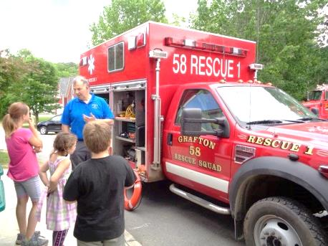The Grafton Rescue Squad is a volunteer organization that provides emergency medical services to the Town of Grafton and other surrounding communities when called for mutual aid. The service is licensed by the Vermont State Department of Health and is staffed by unpaid volunteers who are trained to standards and certified by the State of Vermont. The service is a first response unit that performs initial patient treatment. Squad members are on call 24 hours a day and are dispatched by the Southwestern N.H. District Fire Mutual Dispatch Center located in Keene, N.H.

Patient transport to the hospital is provided by Golden Cross, a commercial ambulance service under contract with the Town of Grafton.

Squad members also play a major role in public education for the care and prevention of illness and injury (e.g. CPR training).

### Police Protection

Grafton is served by an appointed part-time constable. This is the law enforcement officer for the Town (24 VSA § 1031). The State Police are on call for emergencies from the Westminster Barracks. Additionally, the Town has contracted with Windham County Sheriff’s Department for speed enforcement and other law enforcement.

### Emergency Planning and Disaster Preparedness

Grafton has a Town Emergency Planning Committee. The Selectboard Chair or appointee serves as Director and is assisted by an Emergency Management Coordinator. Preparation for disasters also continues in local organizations such as the fire department, search and rescue, Vermont Agency of Transportation, the County Sheriff and the State Police. These are strong organizations, and as responders they continue to provide excellent service; however, preparedness is not only about response to emergencies, but preparing for emergencies, recovering from emergencies, and finding ways to successfully mitigate the impact of future emergencies and disasters.

The Town encourages emergency planning and disaster preparedness because it can help reduce the risk to life and health, the damage to public and private property, and the environmental damage that often occurs during a disaster. Emergency planning encourages the Town to prepare calmly and realistically for likely emergencies, to know the location of resources and equipment that will be needed, to inform residents of the potential dangers and the ways to avoid these potential dangers, and to quickly arrange for help when it is needed. Disaster preparedness will be augmented by a Town pre-disaster mitigation plan, which has been developed by the Emergency Planning Committee with assistance of the Windham Regional Commission.

The Town participates in the National Flood Insurance Program and in 2007 adopted new flood damage and prevention regulations. The Town adopted a FEMA approved Local Hazard Mitigation Plan on September 17, 2014.

The Town voted in 2007 to fund the purchase of a generator to be used during an emergency. This generator is at Grafton School. Additionally, by agreement with the Windham Foundation, power during utility outages is provided by the Homestead generator to the Town Hall. Our new Town Highway Garage (2015) has been outfitted with a meeting room suitable for an Emergency Operations Center and a standby generator.

### Health Services

The Grafton Town Health Officer is appointed by the Vermont Department of Health on the recommendation of the Selectboard and has the major responsibility of making certain sanitary inspections and responding to complaints regarding public health hazards.

At the present time, there is no doctor with office hours in Grafton. There are three emergency health services providers in the area; Grace Cottage Hospital in Townshend is 10 miles from the Village center, Rockingham Health Center in Bellows Falls is 12 miles from the Village and Springfield Hospital is located 15 miles from the Village center. Springfield and Grace Cottage Hospital have full-time emergency room services.

Grafton is not immune from rising opioid abuse trends. In our small community, Grafton citizens and local officials can identify community problems and advocate for education, information, and access to services. Often as the potential first contact, Grafton officials are in a unique position to advocate substance abuse prevention and/or treatment.

## Other Services

### Town Water Supply and Liquid Waste Disposal (domestic)

Essentially all Town parcels are served by their own on-site water supply wells. The Town also has an existing 10-inch and 8-inch diameter non-potable water distribution system from the Fire Pond to most of the Village. In the absence of a public sewer system, domestic waste disposal is dependent on private parcel waste water disposal systems.

In 2007 the Town completed a survey of the Village area on the need, feasibility and cost of a water supply and/or community wastewater disposal systems. Most village water supply wells have at least one wastewater disposal system within the minimum regulatory isolation range. Such a concentration of wastewater disposal systems and water supply wells could cause contamination of drinking water supplies. The 2007 study found soils in the Village area to be classified as rapidly permeable with no current evidence of significant contamination problems with existing on-site wastewater disposal systems. The survey deemed feasible both water supply and wastewater collection, treatment and disposal systems. The study estimated a cost of $3.7 million for a community wastewater disposal system and $2.1 million for a community water supply system.

The 1999 Village Septic Pumping Ordinance remains in force. In addition, effective July 2007 any replacement, expansion or modification of any on-site wastewater disposal system requires State review and a State permit.

There is a limited capability of existing systems in the Town to handle additional septic capacity. This will restrict future growth in the Village area and force development into the surrounding rural areas. Consideration of a water supply and or centralized wastewater disposal system for the Village may still be necessary in the future. The Windham Regional Commission is studying ways to provide resources to member towns for the solution of water and waste water problems.

### Solid Waste Disposal

Grafton is currently a member of the Southern Windsor/Windham Counties Solid Waste Management District.

Grafton residents and businesses either haul their own solid waste or contract with private haulers to transport the trash for fee-based disposal to District Town Transfer Stations in Westminster, Springfield, Cavendish, Ludlow or Weathersfield. Some facilities also accept items for no-fee recycling, as do several area recycling and redemption centers.

### Communications

Broadband and cellular access are essential parts of economic development, educational access, information systems, and overall quality of life. Under Act 172 (Access for All) of the 2005-2006 Vermont Legislature, the State of Vermont established a goal of universal availability of broadband and cellular services by 2010. As of 2015, the communications infrastructure in the Town of Grafton supports landline telephone, fiber-optic and DSL internet, satellite television and emergency radio, but only limited cellular telephone, cable television and broadband cable and wireless internet connectivity.

A cellular voice and data communications network is considered essential to the public welfare. At the same time, cell towers can negatively impact scenic and cultural resources. Cellular services are provided by several carriers whose coverages areas extend into the Town of Grafton. The primary provider is AT&T which operates a cell tower in Grafton Village.

Communication facilities may be regulated by the Vermont Public Utilities Commission under 30 V.S.A. § 248a and are exempt from local land use controls. Therefore, the following standards are provided in the Town Plan to guide Vermont’s Public Utilities Commission in reviewing these projects.

Grafton’s primary concern is tower height, siting, and camouflaging. Towers can alter mountaintops and ridgelines in ways that negatively impact scenic and natural resources vital to the Town’s economic future and cultural identity. It is preferable to allow multiple shorter towers that barely clear the tree canopy rather than a single very tall tower that is difficult to disguise. For towers that protrude above the canopy, effective camouflaging must be installed to demonstratively reduce the visibility of the installed tower. The use of ‘monopine’ towers, with painted antennae and asymmetric natural looking branch configurations are the ideal standard. ‘Monopole’ towers that are not camouflaged should be avoided.

## Goals, Policies & Recommendations

### Goals

#### Town Government

1. Continue to provide necessary public services and adequate facilities at a reasonable and stable tax rate to the residents of Grafton.
2. Provide for necessary capital investments with special attention to the impact on property taxes.

#### Protective Services

1. In cooperation with the Rescue Squad, provide timely emergency medical care by qualified personnel.
2. Ensure adequate police services for the Town.
3. Promote emergency planning and build a disaster-resistant community.
4. In cooperation with the Grafton Firefighter’s Association, maintain an effective fire protection and fire prevention system.
5. Research solution for recruitment and staffing of Fire and Rescue Departments.

#### Other Services

1. Provide ways of disposing solid waste, which are legal, affordable and ecologically safe and to encourage waste reduction, recycling and reuse to reduce total waste.

### Policies

#### Town Government

1. Maintain strong local government, based on broad citizen participation and voluntary elected and appointed officials.
2. Maintain fair and up-to-date assessments of property, consistent with Vermont law, as the basic source of Town funding.
3. Ensure that growth and development fit the capacities of local facilities and services and assess appropriate impact fees on any new development that necessitates additional public services or facilities.
4. Participate in Act 250 proceedings on new developments affecting the Town, both within the Town and in neighboring communities.
5. Participate in Section 248 and 248a proceedings for projects when Town of Grafton is granted party status.
6. Require that special tax considerations only be granted to non-profit organizations as an equitable adjustment in exchange for significant benefits to the Town as a whole.
7. Require that the lost revenue in reduced taxes be carefully balanced against the short and long-range advantages and benefits to the Town if an offer is made to give property to the Town for recreation or conservation purposes.
8. Ensure that funding of capital improvements is planned in such a manner as to maintain tax appropriations for such improvements at as stable a level as possible.
9. Capital improvements should be planned to maintain Town facilities appropriate to the existing level of population and activity in the Town and the current growth rate.
10. Require that any capital improvements over and above the Capital Improvement Budget must be financed by impact fees and/or special action by the voters.
11. Require that the Capital Improvement Budget cover all tax-supported capital expenditures, including the roads, bridges, highway equipment, municipal facilities, emergency services and debt service associated with capital projects. Regarding the capital expenditures for the Town School District, only a major addition to the school building would be funded by the Capital Budget.

#### Protective Services

1. Keep all Town officials and first responders trained in emergency management.
2. Require that all new public and private roads and driveways be properly constructed so that they do not contribute to the damage of Town or State roads from run-off.
3. Encourage the improving of existing roads, and design culverts and bridges to carry a 25-year flood event without damage.
4. Encourage the development of additional fire ponds.
5. Require that fire ponds and dry hydrants be maintained by their owners.
6. Encourage landowners to maintain year-round access to properties to provide ingress and egress- in case of emergencies.
7. Continue the development and improvement of emergency evacuation plans.
8. Require that the Town maintain its Local Emergency Operations Plan and update it annually.
9. Require that the Town continue to participate in the National Flood Insurance Program.
10. Encourage provisions in the Town’s disaster planning for the protection of domestic animals.

#### Other Services

1. Require that proposals for large-scale development be accompanied by economic impact statements prepared by the developer or responsible agency.
2. Deny acceptance of any privately owned municipal-type facilities or services such as private water or sewage system by the Town unless the cost of maintaining such facility is in conformity with the Town’s capital construction program.
3. Require adequate surety from a developer be provided to assist the Town in the event that the Town is required to assume responsibility for any facility.
4. Require that developments and major subdivisions be responsible for providing adequate water sources such as dry hydrants and fire ponds.
5. Require that proposals for large-scale development, particularly of seasonal residences, include a statement of impact on the existing police services and of measures, which will be taken to minimize the additional burden on available police protection.
6. Eliminate existing potential sources of ground and surface water contamination
7. Prevent future potential sources, including development on lands where soil conditions and topography may cause failure of waste disposal systems or contamination of ground and surface waters.
8. Promote the use of the Southern Windsor/Windham Counties Solid Waste Management District, which provides disposal and recycling for most residential and industrial waste.
9. Support recycling and reuse activities, as well as any waste reduction strategies appropriate to the situation.
10. Provide access to disposal facilities for any components of the waste stream not suited to local transfer stations.
11. Keep recycling and reuse disposal free-of-charge and pay for any actual costs through the charges for disposal of non-recycled trash.
12. Encourage the use of tipping fees to support various recycling efforts.
13. Any proposed wireless communications facilities must:
    1. Utilize existing towers before new towers are considered.
    2. If co-location is not feasible, new towers will not protrude more than 20 feet above the average elevation of the tree line, unless it is reasonably necessary to provide adequate coverage or to facilitate tower co-location.
    3. Towers shall blend into the surrounding landscape by utilizing the most appropriate stealth technology.
    4. Towers must have provision for their immediate removal should they be replaced by another technology.

### Recommendations for Action

#### Town Government

1. Under the direction of the Selectboard, continue to evaluate and strengthen the local government with technical assistance from appropriate agencies.
2. Continue continuity of operations and continuity of government planning to ensure services in the event of extended emergencies of any kind.
3. Hold joint meetings of Town boards and Town officers to facilitate communication on issues and matters of mutual interest.
4. Publish in standardized format all Town ordinances, regulations, and standards, other forms of communication and make digital copies available to all town residents. Regularly maintain the Town web site with news and records of current government activities and additionally provide public access to select Town documents.
5. Consider offering time-limited tax incentives to new or growing enterprises providing jobs and ultimately adding to the tax base.
6. Consider the formation of a committee to look into other sources of revenue for the Town.
7. Continue to appoint a Capital Budget Committee annually to receive from the Selectboard the capital expenditures desired in the next fiscal year as well as the following five years and to make recommendations for funding those expenditures. Include in the Capital Budget land acquisition, municipal buildings, roads and bridges and highway equipment.
8. Establish the mechanism for determining impact fees for new capital improvements.
9. Plan for new gravel supply. The town’s supply of gravel for crushing is exhausted. Plans need to be made for a new supply because Grafton has so many miles of gravel roads.
10. Renovate the Town Hall and other public facilities to preserve their historical significance while improving energy efficiency.

#### Protective Services

1. Continue to support the Grafton Firefighters’ Association through annual appropriations and include its capital requirements in the Capital Budget.
2. Develop an effective communication between the Firefighter’s Association and the Selectboard.
3. Assist the Rescue Squad in meeting its capital costs and contribute to operating expenses.
4. Ensure adequate ambulance services for the Town and ensure communication with neighboring communities regarding ambulance services.
5. Obtain regular reports from the State Police in Westminster on calls received from Grafton in order to be aware of trends.
6. Consider taking the initiative to establish volunteer community patrols if there is an increase in criminal activity.
7. Retain the option of employing, on an as-required basis, the Windham County Sheriff’s Department to monitor enforcement of the speed limits and other law enforcement in the Town.
8. Maintain a volunteer to keep the Selectboard informed about the changes taking place in health services in Bellows Falls, Springfield, Chester and Townshend. Grafton needs to participate actively in assuring adequate access to health services and communicating relevant information to the public.
9. Seek services to help residents with addiction problems.
10. Work to identify at-risk populations.
11. Support health and human services in information outreach and education for Grafton residents.

#### Other Services

1. Retain the Village Septic System Pumping Ordinance that applies to the designated village areas including Cambridgeport and Houghtonville.
2. Encourage use of new individual septic system technology that will minimize contamination.
3. The Selectboard, through the Town’s appointed representatives, should encourage responsible management of the Solid Waste Management District primarily in the financial, ecological, and public communications areas.
4. The Town should provide financial support and volunteer labor to local recycling programs, to allow Grafton residents to participate in recycling/reuse activities as equal partners and to demonstrate commitment to the growth and success of these activities.
5. The Town should keep track of and provide information to residents on disposal options for all types of waste, to include regular trash, recyclables, hazardous waste, and special categories such as batteries, metals, tires, construction and demolition debris, etc.
6. Information, education, and ideas about waste reduction, and local recycling/reuse options need to be shared in Town.
7. Post reported illegal dumping sites.
8. Investigate the options for hosting a Town recycling center.
9. Work to protect the Town’s historic assets from disasters.
10. Evaluate flood hazard areas at least every two years.
11. Adopt an all hazards mitigation plan.
12. Work with State and local emergency preparedness organizations.

# 10. FLOOD RESILIENCY

## Background

Flood resiliency is the ability to adapt to changing conditions and be prepared to withstand, and recover from, disruptions due to emergencies. Recognizing the need for all communities to address the increasing likelihood of extreme weather including more frequent flooding, the state legislature passed Act 16 in 2013, an act relating to municipal and regional planning and flood resilience. This law requires that all local and regional plans adopted after July 2014 address flood resilience.

|  |  |
| --- | --- |
|  |  |
| Tropical Storm Irene in Grafton, August 28, 2011 | |

## History of Flooding

##### Floods have been the most common and costly hazard to affect the Town. Flooding can occur anytime of the year as a result of heavy rains, a thunderstorm, tropical storm, hurricane or Nor’easters. It can result from the overflow of major rivers and their smaller tributaries, or inadequate local drainage. Historically, floods have been a factor in over 80 percent of all federally declared disasters. People living in close proximity to bodies of water including rivers, ponds and streams are at risk from flooding. There is a 26 percent chance of experiencing a flood during the life of a 30-year mortgage compared to a 4 percent chance of a fire. Grafton is a member of the National Flood Insurance Program (NFIP) and maintains a Flood Hazard Area Bylaw. Significant flood related events in the past include:

* **Aug. 28, 2011** – The Tropical Storm Irene event in August 2011 was the most damaging flood event that has happened in Grafton in several decades. The Federally Declared Disaster, DR 4022 VT, Tropical Storm Irene, tracked northeast across eastern New York and western New England during Sunday, August 28th, producing widespread flooding and damaging winds across the region. Grafton experienced constant rain fall from this storm event that caused severe flooding. Forty-five out of fifty-five miles of road were out of service with multiple sections either damaged or destroyed and 24 structures were flooded and substantially damaged. At one point all roads leading into and out of Grafton were cut off. Route 121 both east and west was impassable with some sections completely gone. Several culverts in Grafton, south toward Townshend, and toward the north to Chester, were destroyed. The Town received $3.5 M from FEMA PA, and $1.5 M from Federal Aid Highways.
* **April, 2007** - A flooding event occurred which was associated with flash floods and inundation flooding over a period of several days in the spring (April 15-21). Rain and snow caused damage to roads and utility lines across Windham County and Grafton. Across the State nearly 3.6 million dollars was obligated as part of the FEMA Public Assistance Program.
* **August 2004** - A severe period of flooding and thunderstorms, which lasted from the period of August 12- September 12 engendered Presidential Disaster Declaration DR – 1559.
* **August, 2003** - Nearly constant rain and thunderstorms affected Grafton from the period of July 21 through August 18. FEMA Declaration DR – 1488 was associated with this event.
* **1996 Floods** – Flash flooding occurred. The debris from the erosion went straight through a house in the Village.
* **1973 & 1976** - Major flooding events.
* **Sept. 21, 1938** - Hurricane Igor hit our region, paralyzing it for weeks. As it was coming, packing winds over 100 miles an hour, authorities were unaware of the magnitude so no evacuation procedures were instituted and very few precautions were taken. As a result over 600 people lost their lives and tens of thousands were left homeless. Wind, rain and flash flooding wiped out trees, church steeples and buildings.
* **November 3, 1927** - After a wet October, rivers were swollen and the ground was saturated. Nine inches of rain fell in a thirty-six hour period and horrendous flooding began. Though all of New England was affected, Vermont was devastated. The state flooded from Newport to Bennington, with the Winooski River Valley the hardest hit. Eighty-five people died and 9,000 were left homeless. Many of Vermont’s roads and over 1,200 bridges were washed away. The great Flood of 1927 would change Vermont forever as communities turned to the state, and the state turned to the federal government for assistance.

## Regions of Vulnerability

##### Any area along almost any stream or river has the potential for some flooding, but the concern is when life and property become at risk. Because of the natural development of the Town, the majority of roads and homes have been developed along those streams and rivers. With two branches of the Saxtons River converging into the main river, one of the most vulnerable areas in Town is the Village itself. Based on damage done by Tropical Storm Irene, [27] some areas of specific concern include:

##### Route 121 *(The Main Branch of the Saxtons River and its tributaries)*

##### Image result for Grafton vt ireneMain Street Bridge area

##### Route 121 on the west side of the Saxtons River in Cambridgeport

##### Route 121 and Parker Hill on the east side of the Saxtons River in Cambridgeport

##### The area in and around where Cabell Road meets 121

##### The area in and around where Middletown Road meets Route 121

##### Townshend Road *(The South Branch of the Saxtons River and its tributaries)*

##### Bottom of Turner Hill

##### Zeller Camp Road

##### Willie Brook

##### Kidder Hill Road *(The South Branch of the Saxtons River)*

##### Fisher Hill and Bell Road *(upstream on an unnamed tributary of the Saxtons River)*

##### Hinkley Brook Road *(Hinkley Brook)*

##### Eastman Road *(Hall Brook)*

##### Wright Orchard Road *(upstream on an unnamed tributary to the Saxtons River)*

## Vermont’s River Management Program

##### The Vermont Agency of Natural Resources’ River Management Program (RMP) promotes the planning, designing, and protecting of river corridors that will accommodate stream meander and floodplain processes as the most economically and environmentally sustainable river management alternative. A goal of the River Management Program is to manage toward, protect, and restore the fluvial geomorphic equilibrium condition of Vermont Rivers by resolving conflicts between human investments and river dynamics in the most economically and ecologically sustainable manner. River corridor planning is conducted in Vermont to remediate the river instability that is largely responsible for erosion conflicts, increased sediment and nutrient loading, and a reduction in river habitat. Impervious surfaces at higher elevations contribute to fluvial erosion hazards. Given the nature of a stream’s ability to shift over time, considerations may be given to creating meander belt setback.

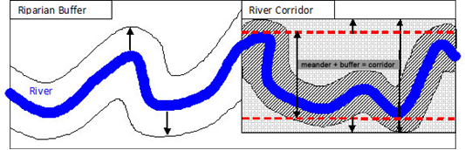

### Fluvial Erosion Hazard Mapping

##### By statutory definition, “fluvial erosion” means the erosion or scouring of riverbeds and banks during high flow conditions of a river. Much of the flooding damage experienced in Vermont is from the power of moving water causing the erosion of stream banks supporting roads and buildings.

##### The accurate mapping of fluvial erosion hazard areas is critical. The maps provided by The State of Vermont used Geographic Information Systems (GIS) data. That process, using best available spatial data, can result in mapping errors. Since many Grafton residents own land that will be within the river corridor, the Town will need to work to develop more accurate mapping.

##### In 2015/2016, the Town partnered with Fitzgerald Environmental Associates who had river scientists walk along the river making measurements and assessments. These river scientists brought all that field data into a Geographic Information Systems (GIS) database. They then created a set of maps[28] showing where the Saxtons River river-corridor is located. In many cases, these improved maps corrected errors in the State’s river corridor mapping. The next step is to incorporate the maps created by Fitzgerald Environmental Associates into the Town’s Flood Damage Prevention Regulations.

### Addressing Flood Resiliency

##### This plan identifies flood hazards as the special Flood Hazard Areas (SFHAs) shown on the NFIP FIRMSs and identifies fluvial erosion hazard areas as those shown on the ANR River Corridor maps pursuant to 10 V.S.A. §1428(a) or maps recommended by the Secretary of Natural Resources. Further, this Plan designates both those identified areas as areas to be protected, including floodplains, river corridors, and land adjacent to streams, wetlands, and upland forests, to reduce the risk of flood damage to infrastructure and improved property. In addition this plan incorporates by reference the Town’s Local Hazard Mitigation Plan approved under 44 C.F.R. § 201.6.

## Green Infrastructure / Low Impact Development

|  |  |
| --- | --- |
| bioretention |  |
| Vegetated swale, or infiltration trench | |

##### During a rainstorm, water hits the ground and either infiltrates the surface or flows overland. Flowing water can pick up and carry sediment and pollutants which can compromise water quality and habitat in surface waters. Excess runoff can also cause damage such as erosion on the land or in our streams. Excessive runoff conditions are intensified by impervious surfaces. Low Impact Development (LID), or Green Infrastructure (GI) Best Management Practices (BMPs) help to increase infiltration, filtration, and storage, while reducing pollutants. Small residential and large or small commercial sites, and subdivisions, new or existing, can use LID/GI practices to reduce the amount of runoff from their site which, in turn, reduces stress on water bodies and treatment systems.

## Goals, Policies & Recommendations

### Goals

1. Avoid new development in identified flood hazard, fluvial erosion, and river corridor protection areas. If new development is to be built is such areas, it should not exacerbate flooding and fluvial erosion.
2. Encourage the protection and restoration of floodplains and upland forested areas that attenuate and moderate flooding and fluvial erosion.
3. Continually prepare for flood emergencies through the response planning process.
4. Adhere to goals and priorities of the Town’s Local Hazard Mitigation Plan, particularly the flood hazard section.
5. Use scientific data to identify flood hazard and fluvial erosion hazard areas and designate those areas to be protected, including floodplains, river corridors, land adjacent to streams, wetlands, and upland forests, to reduce the risk of flood damage to infrastructure and improved property.
6. Protect the areas identified in Goal #5 and mitigate risks to public safety, critical infrastructure, historic structures, and municipal investments. Areas must also be protected to allow for continued recreational use and to provide valuable scenic resources.

### Policies

1. Developments or activities that would adversely affect the quality of the Town’s surface waters shall be discouraged.
2. Development with no net increase in volume occupying a floodway shall be considered to meet the NFIP requirement of no water rise within the floodway.
3. Encourage the use of conservation and river easements consistent with Act 171 guidance for the protection of habitat for wildlife and to promote flood resiliency.
4. Consider Green Infrastructure/Low Impact Development in site plans to manage storm water for infiltration rather than runoff.

### Recommendations for Action

1. The Town has adopted a Flood Hazard Bylaw to regulate development in floodplain areas. These bylaws need to be reviewed and a review cycle schedule should be considered in the future.
2. Use maps provided by the National Flood Insurance Program, Vermont Agency of Natural Resources, and others to identify flood hazard areas and inform revisions to Grafton’s Flood Damage Prevention Regulations. Such maps, to the extent possible, will be based upon scientific analysis of flooding risk and not based on arbitrary setbacks from land features, including public infrastructure. Refinement of maps, as new data becomes available, such as from LIDAR (Light Detection and Ranging), should continuously inform revision of flood hazard areas.
3. Develop Fluvial Erosion Hazard Area regulations to incorporate into the Flood Hazard Bylaw.
4. Where buffer planting is needed, protect the riparian areas through land acquisition or acquisition of easements to provide flood storage and to allow for the river to adjust laterally within the fluvial erosion hazard area.
5. Grafton has adopted the 2013 Agency of Transportation Town Road and Bridge Standards and should adopt updates as they are developed. Bridge and culvert repairs and replacements should be designed following hydraulic studies to avoid constrictions that would accelerate flow and to allow for passage by aquatic organisms.
6. Forested lands should be protected to assure that precipitation can be absorbed by forest soils and litter and the peak flow attenuated. Acquisition of land or easements or Current Use assessment should be used to protect these areas, especially along the tributaries.
7. Continually monitor and reevaluate capacities of culverts throughout the town. Make improvements and repairs as necessary.
8. Meet the requirements of Emergency Relief Assistance Fund for river corridor planning. Such compliance is limited by Goal 5 which requires a scientific basis for the areas defined as a river corridor.
9. Update the mapping and risk analysis of Fluvial Erosion flooding hazard zones as new data such as LIDAR become available.
10. Update Local Emergency Operations Plan annually.
11. Develop and review Local Hazard Mitigation Plan on a scheduled basis.
12. Get involved early and actively in any changes to National Flood Insurance Program (NFIP) flood maps.
13. Review the Town’s Flood Damage Prevention Regulations and consider incorporating the Saxtons River river-corridor mapping into the regulations.
14. Consider legal options for removal of debris hazards within class B waters inclusive of natural river debris hazards as may occur in order to protect town listed dwellings and property.
15. Encourage plantings of willows, dogwoods, sumac, and viburnum along the town’s waterways to strengthen river banks, improve flood control, and combat the spread of invasive plant species.
16. The Town will regulate any new development in identified flood hazard areas, fluvial erosion hazard areas, and/or River Corridors to ensure that development does not exacerbate flooding and fluvial erosion, and extend these provisions to development activities that might increase the amount and/or rate of runoff and soil erosion from upland areas.
17. The Town will further pursue a flood resilience management approach by implementing the Local Hazard Mitigation Plan and other strategies for restoring the stream geomorphic equilibrium conditions and enhancing the emergency preparedness that will mitigate the risks to public safety, critical infrastructure, historic structures, and municipal investments.
18. Continue working actively with the Saxtons River Watershed Collaborative in its efforts to increase flood resiliency in the watershed.

# 11. GRAFTON AND ITS NEIGHBORS

Because of Grafton’s isolated geography and limited commerce and industry, many of its residents rely on neighboring towns for employment as well as everyday products and services. Grafton shares common concerns and issues with its neighbors in regards to the economy, transportation, stream drainage systems, mutual aid for highway and emergency services, and land use issues. As an example of how Grafton works with neighboring towns, Grafton entered into a cooperation with the Saxtons River Watershed Collaborative along with the Towns of Windham, Rockingham, and Westminster, with the purpose of securing flood resilience in the Saxtons River watershed.

Commercial centers often accessed by Grafton residents for commerce and employment include:

|  |  |  |
| --- | --- | --- |
| **Commercial Center** | **Population** | **Distance from Grafton Village Center** |
| Chester, VT | 3,054 | 7 miles |
| Rockingham, VT (Bellows Falls) | 5,062 | 12 miles |
| Springfield, VT | 9,044 | 15 miles |
| Brattleboro, VT | 11,607 | 27 miles |
| Claremont, NH | 12,957 | 28 miles |
| Keene, NH | 23,406 | 31 miles |
| Rutland, VT | 15,601 | 44 miles |
| Lebanon, NH | 13,513 | 51 miles |

Grafton’s Fire and Emergency Medical Services are augmented through Southwestern New Hampshire District Fire Mutual Dispatch Center, which dispatches fire and emergency medical services from Keene, NH. Grafton is also part of an organized Mutual Aid network that coordinates fire services in case of larger emergencies. It includes the towns surrounding Grafton and extends into New Hampshire.

Law enforcement services are provided through a variety of avenues, with the State Police being the primary. The closest State Police barracks are in Westminster, 13 miles from the Grafton Village center. The Town has also contracts with the Windham County Sheriff’s office for limited services on speed enforcement and criminal activity. Grafton residents are served by courts in Newfane and Brattleboro.

The closest emergency medical facility is Grace Cottage Hospital in Townshend, 10 miles from the Grafton’s Village center. Other hospitals accessed by residents include Springfield Hospital, Brattleboro Memorial Hospital, Cheshire Medial Center in Keene, NH, and the region’s largest and most advanced center, Dartmouth Hitchcock Medical Center.

Grafton shares its borders with five towns; Windham, Townshend, Athens, Rockingham, and Chester. These towns are linked via roadways, waterways, contiguous forest and agricultural lands, and through sharing important community facilities and services. At the time this Plan was developed, the Towns of Windham, Townshend, Rockingham and Chester had Town Plans in effect; Athens did not. Consideration was taken to ensure that Grafton’s Town Plan, including the Future Land Use map was compatible with the four towns’ existing Plans. In addition, this Town Plan is generally compatible with the Windham Regional Plan, both in terms of overall Regional Policies and general recommendations for Regional Land Use. Such consistency and compatibility afford Grafton special status because all state agency actions and programs that affect land use must be based on agency plans developed in consultation with communities and regions which have prepared “consistent and compatible plans”.

## Goals, Policies & Recommendations

### Goal

1. To cooperate with neighboring towns in addressing mutual concerns and in planning regional development.

### Policies

1. Participate actively in the Windham Regional Commission
2. Participate actively in the Windham Northeast Supervisory Union.
3. Participate fully in all proceedings under Act 250 whether in Grafton or in a neighboring Town, which may impinge on objectives of the Grafton Town Plan.
4. Participate in all proceedings under 30 V.S.A. §246 and §248 regarding permitting of energy facilities.
5. Participate in all proceedings under 30 V.S.A. § 248a regarding permitting of communications facilities.
6. Work with neighboring towns to secure grant funding from State, Federal, and private sources.
7. Work closely with neighboring towns and law enforcement on issues of crime and drug and alcohol abuse.
8. Work closely with neighboring towns on environmental issues such as insect infestation and invasive plant species.
9. Work closely with neighboring towns on energy issues.
10. Work with neighboring towns to implement new State recycling laws.
11. Participate in the Southern Windsor/Windham Counties Solid Waste Management District.
12. Keep open lines of communication with neighboring towns on matters of mutual concern, including roads, electoral redistricting, educational facilities, state aid, economic development, waste disposal, and recycling.
13. Consult regularly with Town, county and state on emergency services.

### Recommendations for Action

1. Develop good working relationships with the other adjacent Towns which share Routes 30, 35, 103 and 121 that effect transportation to and from Grafton.
2. Develop a mechanism for support of the recycling programs based in neighboring towns: Westminster and Springfield.

# 12. RESPONSE TO VERMONT PLANNING GOALS

1. **Vermont Planning Goal # 1** – To plan development so as to maintain the historic settlement pattern of compact village and urban centers separated by rural countryside.
   1. Land Use Chapter
      1. Goals – 1
      2. Policies - 1, 2, 3, 5, 6, 7
      3. Recommendations – 1, 2, 3
   2. Historic, Cultural and Natural Resources Chapter
      1. Goals – 1, 4
      2. Policies – 1, 2, 3, 4, 5
      3. Recommendations – 1, 2, 3, 4
   3. Economy Chapter
      1. Goals – 1, 2
      2. Policies – 1, 2, 4, 5, 6, 7, 8
      3. Recommendations – 13, 14
   4. Roads and Transportation Chapter
      1. Goal – 1
      2. Policies – 8, 10
      3. Recommendations – 2, 3, 4
   5. Energy Chapter
      1. Policies – 2, 3
      2. Recommendation - 4
2. **Vermont Planning Goal # 2** – To provide a strong and diverse economy that provides satisfying and rewarding job opportunities, that maintains high environmental standards, and to expand economic opportunities in areas with high unemployment or low per capita incomes.
   1. Land Use Chapter
      1. Goal – 2
      2. Policy - 4
      3. Recommendations – 1, 2, 7
   2. Economy Chapter
      1. Goals – 1, 2
      2. Policies – 1, 2 3
      3. Recommendations – 1, 2, 3, 4, 5, 6, 7, 8, 9, 10, 11, 12, 13, 14
   3. Road and Transportation Chapter
      1. Recommendations – 2, 3
   4. Education Chapter
      1. Goal – 1
      2. Policies – 2, 4, 6, 7
   5. Housing Chapter
      1. Recommendation - 1
3. **Vermont Planning Goal # 3** – To broaden access to educational and vocational training opportunities sufficient to ensure the full realization of the abilities of all Vermonters.
   1. Education Chapter
      1. Goals – 1, 2, 3
      2. Policies – 1, 2, 3, 4, 5, 6, 7, 8
      3. Recommendations – 1, 2, 3
4. **Vermont Planning Goal # 4** – To provide for safe, convenient, economic, and energy efficient transportation systems that respects the integrity of the natural environment, including public transit options and paths for pedestrians and bicyclers.
   1. Land Use Chapter
      1. Goal - 1
      2. Policies – 1, 3
   2. Economy Chapter
      1. Policies – 8
   3. Road and Transportation Chapter
      1. Goals – 1, 2, 3, 4, 6, 8
      2. Policies – 1, 2, 3, 4, 5, 6, 8, 9, 10, 11, 14, 15
      3. Recommendations – 1, 2, 3, 4, 5, 6
   4. Energy Chapter
      1. Policies – 2, 3
      2. Recommendation – 4
   5. Recreation Chapter
      1. Policy – 2
5. **Vermont Planning Goal # 5** – To identify, protect, and preserve important natural and historic features of the Vermont landscape, including significant natural and fragile areas; outstanding water resources, including lakes, rivers, aquifers, shore lands, and wetlands; significant scenic roads, waterways and views; important historic structures, sites, or districts, archaeological sites and archaeologically sensitive areas.
   1. Land Use Chapter
      1. Goals –1, 2
      2. Policies – 2, 5, 6, 7
      3. Recommendations – 1, 3, 4, 5
   2. Historic, Cultural and Natural Resources Chapter
      1. Goal - 1
      2. Policies – 1, 2, 3, 4, 5, 6, 7, 8, 9, 10, 11, 13, 17, 18, 19, 21, 22, 23
      3. Recommendations – 1, 2, 3, 4, 5, 6, 7, 8, 9, 10, 12, 13, 14
   3. Economy Chapter
      1. Goal – 2
      2. Policies – 1, 2, 4, 5, 6, 7, 8
      3. Recommendation – 14
   4. Roads and Transportation Chapter
      1. Goals – 1, 4
      2. Policies – 1, 2, 3, 4, 8, 10, 11, 12, 13
      3. Recommendations – 2, 3, 6
   5. Recreation Chapter
      1. Policy – 1
6. **Vermont Planning Goal # 6** – To maintain and improve the quality of air, water, wildlife, and land resources.
   1. Land Use Chapter
      1. Goal – 3
      2. Policies – 1, 5, 6, 7
      3. Recommendations – 1, 3, 4, 5
   2. Historic, Cultural and Natural Resources Chapter
      1. Goals – 3, 4
      2. Policies – 1, 2, 3, 4, 5, 6, 7, 8, 9, 10, 11, 12, 13, 14, 15, 16, 17, 18, 19, 20, 21, 22, 23
      3. Recommendations – 1, 3, 4, 5, 6, 7, 8, 9, 10, 11, 12, 13, 14
   3. Economy Chapter
      1. Goal – 2
      2. Policies – 1, 2, 4, 5, 6, 7, 8
      3. Recommendations – 8, 14
   4. Roads and Transportation Chapter
      1. Goals – 1, 4
      2. Policies – 1, 3, 4, 13
      3. Recommendations – 2, 6
   5. Energy Chapter
      1. Goals – 1, 2, 3, 4
      2. Policies – 1, 2, 3, 4
      3. Recommendations – 2, 3
7. **Vermont Planning Goal # 7** – To encourage the efficient use of energy and the development of renewable energy resources.
   1. Land Use Chapter
      1. Goals – 1, 2
      2. Policy – 2
      3. Recommendation – 1
   2. Historic, Cultural and Natural Resources Chapter
      1. Policies – 14, 15, 16
   3. Roads and Transportation Chapter
      1. Policies – 14
      2. Recommendations – 3, 4, 5
   4. Energy Chapter
      1. Goals – 1, 2, 3, 4
      2. Policies – 1, 2, 3, 4
      3. Recommendations – 1, 2, 3, 4
8. **Vermont Planning Goal # 8** – To maintain and enhance recreational opportunities for Vermont residents and visitors.
   1. Land Use Chapter
      1. Policy – 2
      2. Recommendation – 4, 5, 8
   2. Historic, Cultural and Natural Resources Chapter
      1. Goal – 2
      2. Policies – 1, 2, 3, 4, 8, 10, 20, 22, 23
      3. Recommendations – 1, 2, 5
   3. Economy Chapter
      1. Policy – 3
      2. Recommendations – 2, 3, 4
   4. Road and Transportation Chapter
      1. Policies – 10, 11
      2. Recommendations – 2, 3, 5
   5. Recreation Chapter
      1. Goals – 1, 2
      2. Policies – 1, 2, 3
      3. Recommendation – 1
9. **Vermont Planning Goal # 9** – To encourage and strengthen agricultural and forest industries.
   1. Land Use Chapter
      1. Goal – 3
      2. Policies – 3, 5, 6, 7
      3. Recommendations – 4, 7, 8
   2. Historic, Cultural and Natural Resources Chapter
      1. Policies – 1, 7, 8, 11, 12, 14, 18, 19, 21, 22, 23
      2. Recommendations – 3, 10, 12
   3. Economy Chapter
      1. Goal – 2
      2. Policies – 1, 5, 6, 7, 8
   4. Roads and Transportation Chapter
      1. Policy – 11
10. **Vermont Planning Goal # 10** – To provide for the wise and efficient use of Vermont's natural resources and to facilitate the appropriate extraction of earth resources and the proper restoration and preservation of the aesthetic qualities of the area.
    1. Land Use Chapter
       1. Goals – 3, 4
       2. Policies – 3, 4, 7
       3. Recommendations – 4, 7, 8
    2. Historic, Cultural and Natural Resources Chapter
       1. Goal - 1
       2. Policies – 7, 11, 12, 13, 22, 23
11. **Vermont Planning Goal # 11** – To ensure the availability of safe and affordable housing for all Vermonters.
    1. Land Use Chapter
       1. Recommendation – 1
    2. Housing Chapter
       1. Goals – 1, 2
       2. Policies – 1, 2
       3. Recommendations – 1, 2
12. **Vermont Planning Goal # 12** – To plan for, finance and provide an efficient system of public facilities and services to meet future needs.
    1. Land Use Chapter
       1. Goal – 1
       2. Policies – 2, 3, 5
       3. Recommendations – 2, 3
    2. Economy Chapter
       1. Policies – 2, 8
       2. Recommendation – 14
    3. Roads and Transportation Chapter
       1. Goals – 4, 5 7, 8
       2. Policies – 2, 4, 6, 8, 11, 12, 13, 15
       3. Recommendations – 1, 3, 6
    4. Energy Chapter
       1. Goals – 1, 2, 3, 4
       2. Policies – 1, 2, 3, 4
       3. Recommendations – 1, 3, 4
    5. Education Chapter
       1. Goal – 1
       2. Policies – 1, 7
       3. Recommendation – 1
    6. Recreation Chapter
       1. Goals – 1, 2
       2. Policies – 1, 2
       3. Recommendation – 1
    7. Town Government and Services Chapter
       1. Goals – 1, 2, 3, 4, 5, 6, 7
       2. Policies – 1, 2, 3, 6, 7, 8, 9, 10, 11, 13, 14, 20, 22, 23, 26, 29
       3. Recommendations – 5, 6, 7, 8, 9, 10, 11, 13, 14, 22, 29, 30
13. **Vermont Planning Goal # 13** – To ensure the availability of safe and affordable child care and to integrate child care issues into the planning process, including child care financing, infrastructure, business assistance for child care providers, and child care work force development.
    1. Economy Chapter
       1. Policy – 2
       2. Recommendations – 8, 12
    2. Education Chapter
       1. Recommendation – 2
14. **Vermont Planning Goal # 14** – To encourage flood resilient communities.
    1. Land Use Chapter
       1. Policies – 2, 3, 5, 6, 7
       2. Recommendations – 1, 5
    2. Historic, Cultural and Natural Resources Chapter
       1. Goals – 3, 4
       2. Policies – 4, 5, 6, 7, 8, 9, 10, 11, 22, 23
       3. Recommendations – 6, 7, 8, 9, 10, 11, 12, 13, 14
    3. Transportation Chapter
       1. Goal – 1
       2. Policies – 3, 4, 12, 13, 15
       3. Recommendations – 1, 6
    4. Flood Resiliency Chapter
       1. Goals – 1, 2, 3, 4, 5, 6
       2. Policies – 1, 2, 3, 4
       3. Recommendations 1, 2, 3, 4, 5, 6, 7, 8, 9, 10, 11, 12, 13, 14, 15, 16, 17, 18

# APPENDICES

## Appendix I – Grafton Population

**Table 1 – Change in Grafton Population**

|  |  |  |  |  |  |  |  |
| --- | --- | --- | --- | --- | --- | --- | --- |
| **Year** | **Population** | **Year** | **Population** | **Year** | **Population** | **Year** | **Population** |
| 1791 | 561 | 1850 | 1241 | 1910 | 719 | 1970 | 465 |
| 1800 | 1149 | 1860 | 1241 | 1920 | 476 | 1980 | 604 |
| 1810 | 1365 | 1870 | 1008 | 1930 | 451 | 1990 | 602 |
| 1820 | 1482 | 1880 | 929 | 1940 | 393 | 2000 | 649 |
| 1830 | 1439 | 1890 | 800 | 1950 | 415 | 2010 | 679 |
| 1840 | 1326 | 1900 | 804 | 1960 | 426 |  |  |

Source US Census 2010 http://www.census.gov/2010census/

**Table 2 – Population of Grafton Compared to Surrounding Towns**

|  |  |  |  |  |  |
| --- | --- | --- | --- | --- | --- |
|  | **1990** | **2000** | **2010** | **% Change 1990-2000** | **% Change**  **2000-2010** |
| **Grafton** | **602** | **649** | **679** | **8%** | **5%** |
| Rockingham | 5,484 | 5,309 | 5,282 | -3% | -1% |
| Athens | 313 | 340 | 442 | 9% | 30% |
| Townshend | 1,019 | 1,149 | 1,232 | 13% | 7% |
| Windham | 251 | 328 | 419 | 31% | 28% |
| Chester | 2,832 | 3,044 | 3,154 | 7% | 4% |
| **Regional Total** | **10,501** | **10,819** | **11,208** | **1%** | **1%** | |

Source US Census 2010 http://www.census.gov/2010census/

**Table 3 - Age of Grafton Population**

|  |  |  |  |  |  |
| --- | --- | --- | --- | --- | --- |
| **Age** | **1990** | **2000** | **2010** | **% change 1990-2000** | **% change 2000-2010** |
| **Total population** | 602 | 649 | 679 | +8% | +8% |
| **Median Age (years)** | 38 | 46 | 51.4 | +21% | +12% |
| **Younger than 18** | 152 | 118 | 127 | -22% | +7% |
| **18 - 64yrs** | 356 | 413 | 388 | +16% | -6% |
| **64yrs and older** | 94 | 118 | 164 | +26% | +39% |

Source US Census 2010 http://www.census.gov/2010census/

## Appendix II – Grafton Property Taxes

**Table 1 - Grand List Summary as of June 30, 2018**

|  |  |  |  |  |
| --- | --- | --- | --- | --- |
| **Category** | **No. of Parcels** | **Taxable Education Property Value** | | |
| **Total (Homestead+ Non-Residential)** | **Homestead** | **Non-Residential** |
| Residential Homes | 347 | $122,776,200 | $53,553,266 | $69,222,934 |
| Mobile Homes | 28 | $1,646,300 | $676,900 | $969,400 |
| Vacation (Seasonal) Homes | 82 | $22,485,700 | $762,900 | $21,722,800 |
| Commercial | 32 | $15,251,000 | $0 | $15,251,000 |
| Industrial | 0 | $0 | $0 | $0 |
| Utilities | 2 | $3,740,700 | $0 | $3,740,700 |
| Farm | 2 | $1,388,200 | $0 | $1,388,200 |
| Woodlands | 21 | $1,822,400 | $0 | $1,822,400 |
| Miscellaneous | 93 | $10,401,500 | $122,700 | $10,278,800 |
| Subtotals | 607 | $179,512,000 | $55,115,766 | $124,396,234 |
| Personal Property - Cable Added to Education Total | n/a | $171,403 |  | |
| **Total Listed Value of Taxable Property** | **607** | **$179,683,403** |

**Table 2 - Grafton Parcel Values**

|  |  |  |  |  |  |
| --- | --- | --- | --- | --- | --- |
| Year | Under $80,000 | $80,000 - $99,999 | $100,000 - $149999 | $150,000 - $249,999 | $250,000 & Over |
| 2007 | 180 | 33 | 89 | 133 | 83 |
| 2013 | 121 | 32 | 61 | 134 | 275 |

**Table 3 - Tax Rate and Taxes Generated**

|  |  |  |
| --- | --- | --- |
| **Year** | **Tax Rate/$100** | **Taxes Generated** |
| **2009-10** | $1.9787 | $1,601,340 |
| **2010-11** | $2.033 | $1,594,291 |
| **2011-12** | $1.8682 | $1,608,814 |
| **2012-13** | $1.8165 | $1,603,841 |
| **2013-14** | $1.8624 | $1,596,273 |
| **2014-15** | $1.8406 | $1,614,364 |
| **2015-16** | $1.9207 | $1,587,227 |
| **2016-17** | $1.8435 | $1,599,475 |
| **2017-18** | $1.8220 | $1,590,665 |
| **2018-19** | $2.0052 | $1,587,795 |

## Appendix III - Town Officials

**Elected Town Officials**

* Moderator
* Town Clerk
* Town and School Treasurer
* Selectboard (5)
* Auditors (3)
* Listers (3)
* Collector of Delinquent Taxes (1)
* Justices of the Peace (5)
* Town Agent (1)
* Grand Juror (1)
* Trustees of Public Funds (3)
* Trustees of Library (5)
* School Directors (5)
* Representative to Union High School #27 (1)
* Trustees of Campbell and Woolson Funds (3)
* Agent of Campbell and Woolson Funds (3)

**Town Officials Appointed by the Selectboard**

* Town Administrative Officer
* Town Administrative Assistant
* Constable
* Cemetery Agent
* Emergency Management Coordinator
* Energy Officer
* Road Foreman
* Representatives to Windham Regional Commission (2)
* Fence Keeper
* Pound Keeper
* Inspector of Lumber
* Representative to NH/VT Solid Waste Project
* Planning Commission (7)
* Zoning Board of Adjustment (7)
* Capital Budget Committee
* Septic Officer

**Officials Appointed by the State of Vermont**

* Fire Warden
* Deputy Fire Warden
* Town Health Officer
* Town Service Officer

## Appendix IV – List of Historic Sites

### Grafton Sites on The National Historic Register

1. Brick Church
2. Chapel
3. The Kidder Hill Bridge
4. Milldean and Eaglebrook, (the two brick houses across from the Village Store)
5. Library
6. The old post office
7. The second Fire Station on Main Street,
8. The Park Homestead on Middletown Road

### Grafton Sites on The Vermont State Register of Historic Places

1. Fire House
2. Grafton Historical Society
3. Twin Houses (East House)
4. Twin Houses (West House)
5. Stowell House
6. Cambridge House
7. Post Office - Town Hall
8. The Homestead
9. Windham Cottage
10. White Church
11. Woolley House
12. Brick School House
13. Daniels - Gelfan House
14. Brick Church
15. Chapel
16. Ingraham House
17. Brown House
18. Howland House
19. Minister's House
20. Robinson House
21. Grafton Tavern
22. Barrett House
23. Goodfellow House
24. Crawford House
25. Grafton Village Store
26. Stout House
27. Phoebe Frost House
28. Grafton Public Library
29. The Doll House
30. Old Mason Walker House
31. Grafton Grange
32. Pettingill House
33. Barrett House
34. Gabriel House
35. Karpin House
36. Pettingill School
37. Gargas House
38. Oddey House
39. Wilson House
40. Wilson Dam
41. Moseley House
42. Ellsworth House
43. Grafton Historic District
44. Mechanicsville Historic District
45. Houghtonville Historic District
46. Messier House
47. Plummer House
48. Yaw House
49. Bidwell House
50. Vodel House
51. Edwards House
52. Pacguin House
53. T Macenthum House
54. Forbes House
55. Toomey House
56. Johnson House
57. Parks House
58. Desrocher House
59. Warren House
60. Merrill House
61. Ruschell House
62. Walker Farm
63. Moore House
64. Herrlich House
65. Middletown Historic District

## Appendix V - Maps

A portfolio of land capability and resource maps, prepared by the Windham Regional Commission under contract with the Town of Grafton, uses GIS data and other information provided by the Grafton Planning Commission. Together with the Town Plan policies, these maps will be used by the Planning Commission as a guide to implement the Town Plan.

Users of these maps (town officials, other authorities, or private individuals) should take into account their general accuracy and allow for the refinement of data and interpretation, based on more detailed studies of particular sites in question.

Maps included in this Town Plan are:

* Existing Land Use
* Resource Areas – Water and Wildlife
* Resource Areas – Land
* Flood Hazards
* Community Facilities
* Transportation Systems
* Known Constraints for Energy Generation
* Possible Constraints for Energy Generation *(Map 1 of 2)*
* Possible Constraints for Energy Generation *(Map 2 of 2)*
* Solar Resource
* Solar Energy Potential
* Wind Resource
* Wind Energy Potential
* Proposed Land Use

*The Vermont Department of Housing and Community Development (DHCD) awarded the Town of Grafton Municipal Planning Grant funds to support the update of this Town Plan.*

1. ###### See Appendix II, Table 1; source: 2018 Town of Grafton Annual Report

  
2. ###### See Appendix V - Maps

  
3. ###### http://anrmaps.vermont.gov/websites/BioFinder2016/

  
4. ###### See Appendix V - Maps

  
5. ###### For more complete definitions go to Windham Regional Commission’s Regional Plan, page 70 at: http://www.windhamregional.org/images/docs/regional-plan/2014_Windham%20Regional%20Plan_complete.pdf;

  
6. ###### See Appendix V – Maps; Forest Blocks and Habitat Connectors Map

  
7. https://historicsites.vermont.gov/vt_history/african_americans
8. ###### http://tax.vermont.gov/property-owners/current-use

  
9. http://fpr.vermont.gov/sites/fpr/files/About_the_Department/Rules_and_Regulations/Library/  
   Riparian%20Final%20Guidelines%20%28signed%20copy%29_resized.pdf
10. ###### See Natural Resources by Skip Lisle to learn more about the natural benefit functions created by beaver habitat in Grafton. Available at <https://graftonvt.org/?page_id=271> which is the Grafton web site Town Plan page.

   
11. ###### See Chapter 10 – Flood Resiliency, for more information

   
12. The website is a collaboration between the University of Vermont Extension, the Vermont Department of Forests, Parks and Recreation, the Vermont Department of Environmental Conservation and the Vermont Chapter of the Nature Conservancy.
13. ###### 30 V.S.A. § 248

   
14. ###### As of February 10, 2018

   
15. ###### See Proposed Land Use Map in Appendix V

   
16.
17. See Appendix V - Maps
18. ###### See Appendix V - Maps

   
19. ###### Based on current technology, the presence of substantial wind generating facilities in southwestern Windham County allowed the renewable energy generation targets for the remainder of the region to be significantly less than would be required without wind generation. In the case of Grafton, our generation goals match about 20% of our consumption. As an example, 2016 electric energy consumption was approximately 5,000 MWh. If solar generation were to offset that on a net-metered basis then approximately 30 acres of land with good solar exposure would be required. This result can be computed from approximately 1.3 MWh of energy yield per year from 1 kW of well sited solar modules using the National Renewable Energy Laboratory program PVWatts and the approximate solar density of 1 MW of solar modules per 8 acres of land as cited by the Windham Regional Commission. Additional progress towards meeting our goals can be accomplished through conservation.

   
20. ###### A HOUSEHOLD is defined as including all the people who occupy a housing unit as their usual place of residence.

   
21. ###### The American Factfinder

   
22. The 2010 US Census calculates the “Selected Monthly Owner Costs” from the sum of payment for mortgages, real estate taxes, various insurances, utilities, fuels, mobile home costs, and condominium fees.
23. ###### See Appendix III – Town Officials, for a complete list of elected and appointed positions

   
24. ###### https://smartasset.com/taxes/vermont-property-tax-calculator

   
25. ###### According to the Vermont Agency of Transportation (VTrans)

   
26. ###### See 2017 Grafton Annual Report, P26 for more details. https://graftonvt.org/wp-content/uploads/2018/02/GRAFTON-report-2017-FROM-CRAIG.pdf

   
27. ###### See Flood Hazards map in Appendix V

   
28. http://feavt.maps.arcgis.com/apps/webappviewer/index.html?id=6d305cf17b4a4c3f9044dc288e7d4860