**REGULAR SELECTBOARD MEETING**

**@ Town Hall Upstairs and, as an**

**ADA accommodation, via Microsoft Teams. Further ADA Accommodation available, Call Town Hall during business hours.**

**6:00 PM, Monday, August 16, 2021**

**Link to meeting:** [Click here to join the meeting](https://teams.microsoft.com/l/meetup-join/19%3ameeting_YTcxZmI4YjQtYzIxMS00NjE5LTg5YjctODc5NmUyZGVjNTJk%40thread.v2/0?context=%7b%22Tid%22%3a%22ef1ee2de-322f-4530-b045-e3a14523d017%22%2c%22Oid%22%3a%22408cae20-3fe1-4244-9f06-e5df655a5c15%22%7d)

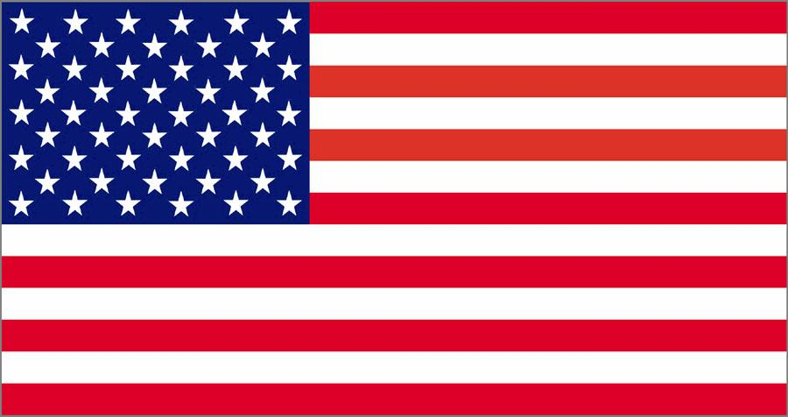

1. Call to order
2. Adopt Agenda
3. Minutes of Selectboard meeting July 30 and August 2, 2021
4. Highway Report
   * Update on Recovery Work
   * Route 121 E Bazin schedule
   * Other
5. Clerk/Treasurer
   * Other
6. Committee Reports:
   * Cemetery committee
   * Highway committee
   * Parks committee: Vermont FPR Grants for Trails and Recreation Infrastructure
   * Personnel committee
   * Buildings committees.
   * Water Wastewater committee
7. Public Comment
8. Next Regular Meeting – Tuesday September 7, 2021 @ 6:00 PM.
9. Adjourn

Meeting is viewable live at: Falls Area Community Access TV: <https://www.fact8.com/>