Matrixchem, now under investigation, operated without oversight
By Elizabeth Gribkoff
Jan 12 2020 | 8 reader footnotes
Share322
Tweet
Share
Email
322 Shares
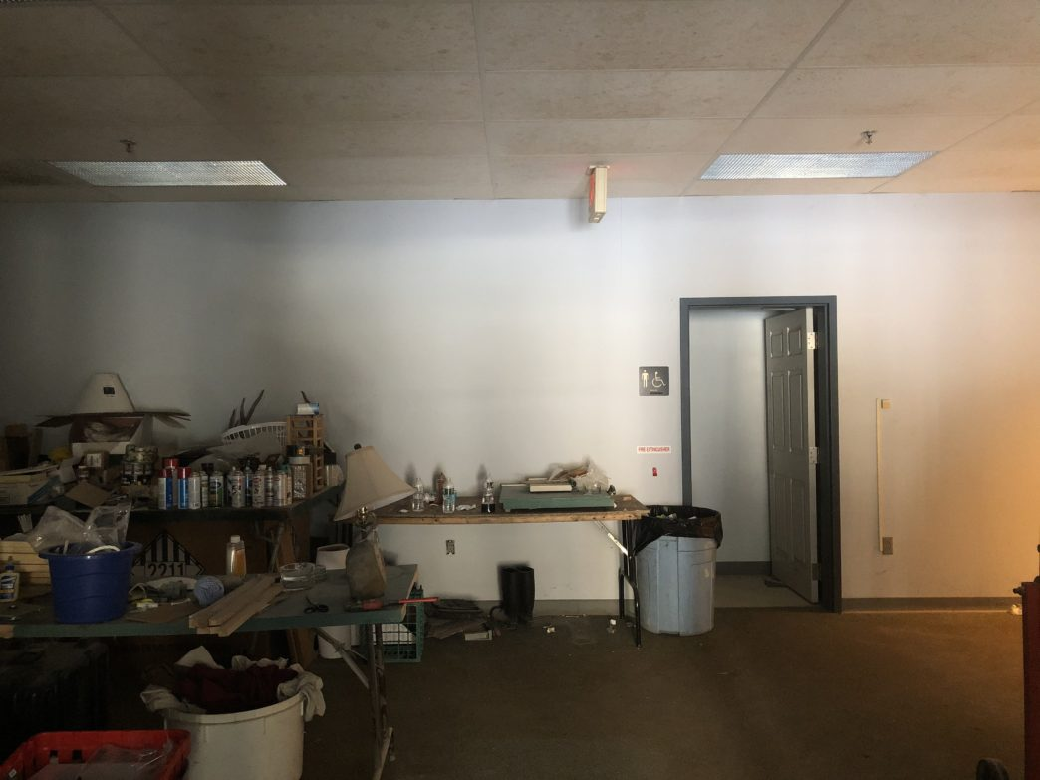The interior of 3992 Saxtons River Road, Grafton, where Matrixchem is located. Photo by Elizabeth Gribkoff/VTDigger
GRAFTON — State safety officials are investigating a Grafton chemical manufacturer that has operated for years without basic fire or hazardous material safety measures, putting workers and other building tenants at serious risk.
The company, Matrixchem, has supplied chemicals to clients, including the U.S. Department of Defense, from an industrial building along the Saxtons River since 2012. The site sits in the village of Cambridgeport in the sparsely populated town of Grafton in southeastern Vermont, best known as the home of the Grafton Inn and the Windham Foundation.
While there has been extensive state-supervised environmental testing at the Matrixchem site because of contamination by previous owners, several key agencies were unaware a chemical company operated at the brownfield until last month.

Get all of VTDigger's daily news.
You'll never miss a story with our daily headlines in your inbox.

In some cases, it appeared Matrixchem had not filed federally required paperwork with the state to work with and store hazardous chemicals.
A national fire safety expert told VTDigger that small chemical companies can sometimes operate “under the radar,” falling between the cracks of different agencies.
Grafton town officials alerted state officials in December after a neighboring tenant reported “unsafe and unhealthy” conditions. The complainant was particularly concerned about chemical processing the company was about to start.
In mid-December, Grafton Fire Chief Rich Thompson, who is also the town health officer, found the building housing the chemical company was “dilapidated” with “large chemical containers” stored haphazardly.
“The amount of some chemicals in there was of concern,” Thompson said in an interview last week.
Officials from the Vermont Occupational Safety and Health Administration, the Vermont Hazardous Materials Response Team, the Department of Environmental Conservation and the Department of Public Safety’s Division of Fire Safety all started looking into the company last month.

VTDigger is underwritten by:
VOSHA opened an official investigation into Matrixchem on Dec. 26. The company has been ordered by the fire safety division to stop operating until violations are addressed.
During a second visit in December, Thompson found a worker wearing a chemical protective suit and a respirator “engaged in activities,” according to a Dec. 14 email obtained through a public records request from William Irwin, radiological section chief of the Vermont Health Department and chief of the Vermont Hazardous Materials Response Team, to other state officials.
The worker told the fire chief he was doing classified government work and referred questions to his boss. Another employee, Thompson said, was eating lunch in the next room with the door open.
Thompson was worried about the exposure from his visit. “The Chief is taking a shower now because he is concerned about what he was exposed to as it left him feeling uneasy (a gritty taste in his mouth and skin),” wrote Irwin.
The chief said Matrixchem had “minimized investments on safety at the facility and that that would be obvious to anyone who visited the site,” according to an email from Irwin. He described the operation as sloppy but didn’t believe the actions to be criminal.
On Dec. 23, the state hazmat chief, an environmental analyst and Bruce Martin, regional manager for the state fire safety division’s Springfield office, went inside with the building’s owner, John McKay.
During that visit, they saw “a large quantity” of drums of the solvent ethyl acetate and denatured alcohol — both combustible — stored on pallets in a common area, according to a fire inspection report from that visit. The building also houses Vermont Stoneworks, an artisan stone workshop, and Cheap Tubes Inc., a nanotube manufacturer.
“Large quantities of flammable liquids must be stored in an area separated from other tenant spaces,” Martin wrote in his report.
Inspectors also saw other chemicals stored on the floor or on shelves in the common area, according to the inspection report. One of these chemicals was the potentially lethal poison acrylonitrile, which “can be ignited under almost all ambient temperature conditions” and “readily undergoes violent chemical changes at elevated temperatures and pressures,” according to its chemical datasheet. The federal government says it must must be handled and stored in a “closed system.”
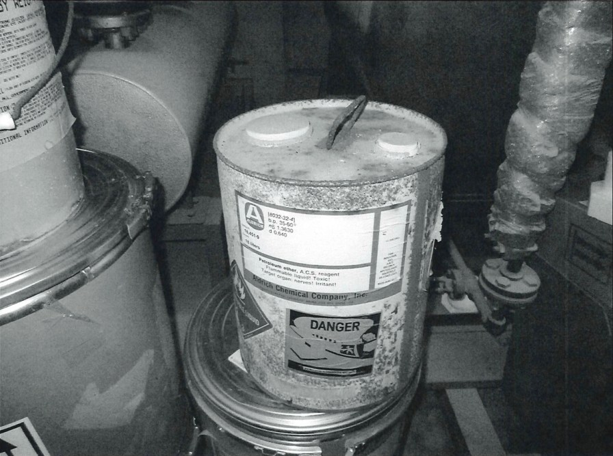
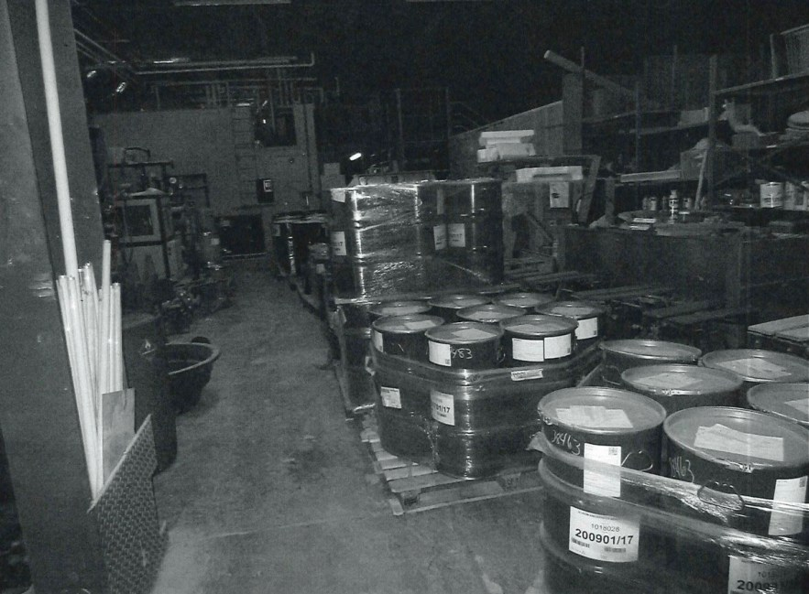
Other chemicals inspectors found in the common room included chlorodinitrobenzene, a poison with an “almond-like odor” that is “readily capable of detonation or explosive decomposition” under normal conditions and benzoyl chloride, a chemical with a “pungent odor” that can cause “serious or permanent injury.”
The common area also had “numerous unmarked and corroded chemicals.” The state fire safety division told Matrixchem officials they needed to find a hazardous waste management company to categorize and safely remove the chemicals.
The building’s fire alarm system was not working and had not been inspected since June of 2014; state law requires annual inspections. The building’s sprinkler system was also defunct and the fire pump was turned off, according to the inspection report.
State inspectors also saw several makeshift dividers made from two-by-fours and plastic sheets, which posed “an extreme fire hazard.” And they spotted “numerous portable, unvented heating units,” which are not allowed in an occupied building.
Martin, the state fire safety inspector, wrote that the building conditions represented a “significant risk to persons, property and the environment” and a “serious lack of awareness” of the risks of a chemical operation. The fire safety division ranked the property a four out of five on the hazard index, meaning “immediate action must be taken to reduce the risk to life safety.”

VTDigger is underwritten by:
He ordered that “no further chemical processing” could occur at the site until a complete inventory of chemicals was submitted and fire safety measures installed.
“No further operation, other than classification or removal of materials by legitimate, competent, approved personnel is permitted,” says the inspection report.
Companies that have a certain quantity of hazardous chemicals on-hand have to annually submit an inventory, known as a Tier II filing, to the state. Copies are provided to local fire departments and emergency management officials so they can safely respond to chemical spills and other emergencies.
Todd Cosgrove, state hazardous materials team chief, said in an email that Matrixchem has never done a Tier II filing. (He added that owner Andrea Linkin-Butler has now been advised she needs to do this.)
Steve Monahan, director of workers’ compensation and safety for the state Department of Labor, said in an interview Tuesday that he had “no reason” to believe VOSHA had ever inspected Matrixchem before last month. VOSHA does inspections based on complaints and at random from lists of hazardous industries and major construction sites provided the federal government.
“I don’t think we knew of their existence prior to referral from hazardous materials agents,” he said of Matrixchem. Little is known about the chemical manufacturer, which does not have a functioning website.
As VOSHA had deemed during a subsequent Dec. 26 inspection that there was not an “immediate hazard” to workers, which would be required to shut down a company, they did not order Matrixchem to stop operating, said Monahan. He stressed that he could not speak for what the fire safety division or other state agencies might have done.
“When we arrived, we did not see evidence of an immediate danger,” he said. “There may have been one earlier, there may have been one subsequently, but there wasn’t that at that time.”

Matrixchem received shipment after promise to cease operations
Matrixchem was founded in 1992 by Douglas Butler, who died of cancer in 2016. His wife, Andrea Linkin-Butler, took over the company. Linkin-Butler, who has a Bachelor of Arts in education and art from Boston State Teachers College, has worked for decades as a realtor for the Stratton Buyer Brokerage, according to her LinkedIn profile. Sources say she now lives in Maine.
The chemical company has been located in the Grafton commercial building since approximately 2012, according to an environmental site assessment of the property.
The Department of Defense has awarded Matrixchem at least two contracts, according to USA Spending: a $32,925 in 2011 for making ethyl alcohol — a flammable solvent — and a $12,200 one in 2014 for “all other basic organic chemical manufacturing.”
State officials went back on Dec. 26 and inspected the company with Linkin-Butler and the building’s owner, John McKay. Thompson requested an emergency Selectboard meeting that evening to fill Grafton town officials in on the situation.
Selectboard members learned that Linkin-Butler had told state officials earlier last month that she would be out of state until mid-January.
When state inspectors showed up on Dec. 26, she was there to sign papers for a waste management company, Clean Harbors, to remove some chemicals, according to meeting minutes.
Despite assurances that the business would cease operating, Selectboard members were told a truck had arrived that morning with a delivery of chemicals.
Thompson, as the town fire chief and health officer, has the authority to shut down the building if he deemed it a threat to public health. He decided not to because state officials had determined the site was not “imminently dangerous” or a threat to the surrounding community as long as no chemical processing was going on, which Linkin-Butler assured she would not do.
“We feel that there’s no immediate danger to the surrounding community and we are going through the state processes,” he said in an interview last week. “We feel that it’s a regulatory issue as opposed to a safety issue.”
Greg Jakubowski, a Pennsylvania-based fire protection engineer with 40 years of experience, told VTDigger after reviewing Matrixchem’s recent fire inspection report that the chemicals at the company posed a safety threat.
If the flammable liquids listed in the report were ignited, he said, a “fire will spread rapidly” without a functioning sprinkler system. He added the fire would likely engulf a “major portion of the building” before local firefighters would arrive at the scene.
“And not only would you have the potential for fire but you would also have the potential for chemical runoff,” Jakubowski added.
Jakubowski said it was not unusual that neither the state’s worker safety or fire safety programs knew the chemical company existed until last month. Nationally, state OSHA and fire safety programs have limited resources for inspections, explained Jakubowski.
“I don’t know about this particular company but sometimes there’s these small companies that kind of operate under the radar,” he added. “And maybe they started with one or two drums of stuff but they got busier and busier and they keep getting more and more drums. There’s nobody really tracking that.”

Matrixchem owner refuses to comment
In 1965, Unified Data Products bought the property, at the time used for farmland, and constructed a factory that now houses Matrixchem. The site was then used by Vermont Computer Products, who stored solvents, inks and other chemicals at the building. At various points, the building housed a machine shop and a tweezer manufacturing business.
Environmental testing done in the ’80s determined that a faulty drain in the machine shop had sent auto wash into soil and groundwater rather than an underground storage tank. Due to existing contamination, the site was designated a brownfield by the federal Environmental Protection Agency, meaning cleanup would need to occur before more development.
The shared 55,000-square-foot commercial building on winding Route 121 in Grafton that houses Matrixchem is just past the stone ruins of a former woolen mill still popular with photo-taking tourists.
During a site visit Tuesday morning, VOSHA inspector Deb Kingsbury was waiting outside the building. The only car out front besides hers was a black Porsche Cayenne.
The building was almost windowless with loading docks and doors on its western side. Chunks of stone, large sawhorses and tractor-trailer beds lined the accessible side.
A canvas sign above the double-glass entry doors read “Vermont Stoneworks: Custom and Dimensional Granite-Marble-Soapstone-Slate.”
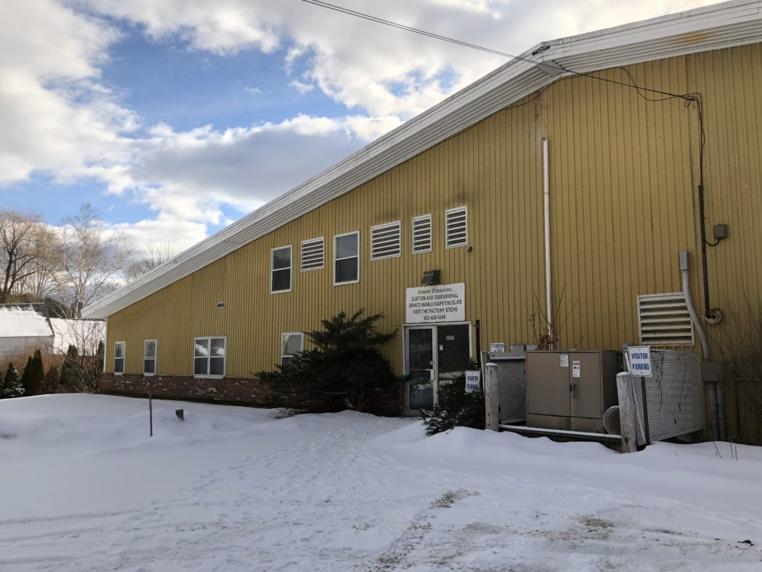The front entrance to 3992 Saxtons River Road, Grafton, where Matrixchem is located. Photo by Elizabeth Gribkoff/VTDigger
Inside, a large, dark room with green carpeting had tables strewn with lamps, half empty water bottles and spray paint cans. A large box with “fragile glass” tape near the entryway served as a makeshift trash can. There were milk crates stacked up and mismatched armchairs around one of the cluttered tables.
Linkin-Butler, a petite woman with pulled back dark blonde hair wearing a down puffer, told Kingsbury “I’m busy” and closed the door on her before heading back to a darkened office. She could be seen going back and forth between a back office and another room behind double lab doors.
A man who worked in another business in the building reported seeing Linkin-Butler moving “barrels” out of the building on Monday into a U-Haul. Waste drums stacked on pallets were visible in the warehouse space through double lab doors.
When Linkin-Butler emerged from the warehouse, she declined comment, saying she was “not speaking with anyone.” She walked away as a reporter asked questions about the VOSHA investigation.

No Act 250 permit
This December was not the first time state officials were alerted to potential safety and environmental violations at 3992 Saxtons River Road.
Environmental concerns were highlighted during debate over a proposed solar project at the site when Grafton officials told state officials in 2018 that Act 250 violations were ongoing. They complained about junk cars and other garbage at the site. The Selectboard requested that the contaminated parts of the site either be cleaned up before the solar array is built or be avoided entirely.
In a letter to the Public Utilities Commission, the Grafton Selectboard demanded commissioners halt review of the solar project until “all regulatory and statutory violations” at the site are addressed. The governor’s office, Agency of Natural Resources Secretary Julie Moore, Act 250 District 2 Coordinator Stephanie Giles, local lawmakers and other state officials were copied on both letters.
“It is ironic that the applicant and landowner asked us, and we agreed, to host a site that ultimately enhances the environment, while the owner trashes the very site that is host to it,” wrote the Selectboard. “Grafton hopes the State does not wish to be a party to this trashing of Grafton.”
The Selectboard spells out a range of activities going on at the site, including Matrixchem’s chemical purification, a stone cutting business, and the various cars, trash, construction debris stored outside in the Saxtons River floodway, that were, to the best of their knowledge, not permitted by Act 250.
There are pages of site photos attached to the letter, all of which have the same three sentence caption.
“There is no known permit for the chemical mixing use inside the building in the area that was the source of hazardous waste leaks years ago and the reason this is an EPA Brownfields site,” reads the last line of the caption.

