**SELECTBOARD MEETING**

**Monday, November 18, 2019 @ Town Garage 6:00PM**

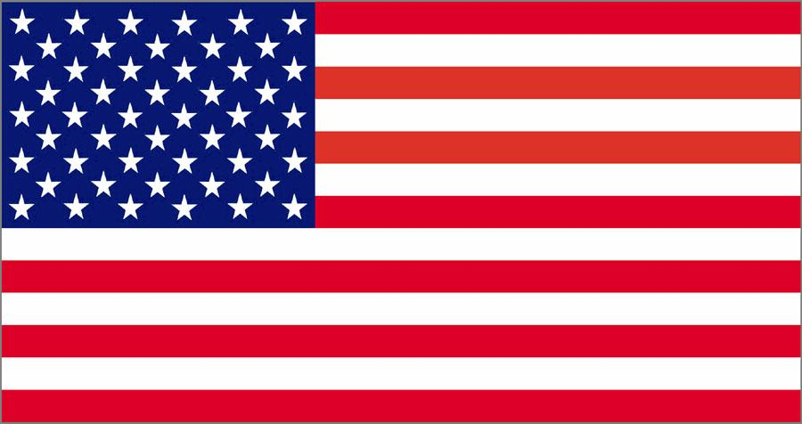

1. Adopt Agenda
2. Approve Minutes: November 4, 2019
3. Warrants, as signed, presented to Selectboard
4. Highway Report
5. Public Comment
6. Other Business
7. Date of Next Selectboard Meeting:
8. Executive Session – Personnel and receiving advice from attorney
9. Adjourn

As of October 31, 2019